**PMC**

**User manual**

**DOT Systems Sp. z o.o.**

**Ed 01 Table of Contents**

1. Email templates 14

2. Support for dynamic Email Templates in the PMC Email Client 16

3. Document Types 19

4. Document templates 22

5. Document packages 24

6. Condition syntax 28

7. Inserting a signature into a document 30

8. Placeholders 33

9. Docusign placeholders 35

10. Cases Workflows 35

10.1. Module: Cases, MANUAL 35

10.1.1. Assign a Case Manager to Shared with 35

10.1.2. Create Complaint Package 36

10.1.3. DOTS: Copy PDC Case ID to Case ID 36

10.1.4. Find County 36

10.1.5. Find Similar Cases 36

10.1.6. Recalculate from Claims 36

10.1.7. Set Court 37

10.2. Module: Cases, Section: Appeal 37

10.2.1. Appeal Status change to Notice of Appeal Filed 37

10.2.2. "Change of Appeal Status" 37

10.3. Module: Cases, Section: Appeal 38

10.3.1. On change of Attorney 38

10.4. Module: Cases, Section: Collections Summary 38

10.4.1. Case Collections Summary data changed 38

10.4.2. ON\_CHANGE\_CALCULATE\_TOTAL\_BALANCE 38

10.5. Module: Cases, Section: Complaint 39

10.5.1. 1 day after Ds Notice of Appearance Entered is set 39

10.5.2. 2 days after Complaint Status set to Filing Team 39

10.5.3. 3 day after Ds Notice of Appearance Entered is set 39

10.5.4. 90 days after Service of Process change (AOB) 39

10.5.5. Answer changed 40

10.5.6. Answer date (Complaint stage) changed (AOB) 40

10.5.7. Answer date (Complaint stage) changed (HO) 40

10.5.8. Answer Deadline changed 41

10.5.9. Answer field empty 7 days after after Answer Deadline 41

10.5.10. Change of Complaint Status 41

10.5.11. Complaint Status change to Case Filed (Total Balance >=15000) 42

10.5.12. Complaint Status change to Case Filed (Total Balance<15000) 42

10.5.13. Complaint Status change to Complaint Printed 42

10.5.14. Complaint Status change to Correction Queue - in Eportal 43

10.5.15. Complaint Status change to Dismissed - Failure to Appear PTC 43

10.5.16. Complaint Status change to Dismissed - Not Served 43

10.5.17. Complaint Status change to FWOP - need to set aside 43

10.5.18. Complaint Status change to LSOP Case - Pending Pmt 44

10.5.19. Complaint Status change to LSOP Case - Service Pending 44

10.5.20. Complaint Status change to LSOP Package Prepared 44

10.5.21. Complaint Status change to Motion to Compel Answer 45

10.5.22. Complaint Status change to Motion to Set Aside Dismissal - Filed 45

10.5.23. Complaint Status change to Motion to Set Aside Dismissal- Prepared 45

10.5.24. Complaint Status change to Need to Reissue or Pay for Summons 45

10.5.25. Complaint Status change to Pending Filing 46

10.5.26. Complaint Status change to Possible Paid Prior to Filing 46

10.5.27. Complaint Status change to Summons - Reissued 46

10.5.28. Complaint Status change to Summons - Reissued Miami Dade 46

10.5.29. "Complaint Status change to Voluntary Dismissal w/ Prejudice" 47

10.5.30. Complaint Status change to Voluntary Dismissal w/o Prejudice - No Fees 47

10.5.31. Complaint Status change to Voluntary Dismissal w/o Prejudice - Re-file 47

10.5.32. "Ds MFET to File Answer changed" 48

10.5.33. Ds Notice of Appearance changed 48

10.5.34. Ds Notice of Appearance changed to NULL 48

10.5.35. Empty Answer date and and Ds MFET to File Answer = current day + 120 49

10.5.36. Motion to Dismiss changed 49

10.5.37. PTC (Small Claims) changed 49

10.5.38. Service of Process date changed 50

10.5.39. Service of Process has changed 50

10.5.40. Summons Issued changed 50

10.5.41. Set Lock Automation when Complaint status changed to FIGA - Litigation Stay 51

10.6. Module: Cases, Section: Defendant Deposition 51

10.6.1. 1 day before Depo of Plaintiff Date create task for Attorney (User) 51

10.6.2. 1 day before Insured Depo Date create task for Attorney (User) 51

10.6.3. 1 day before Ps Engineer Depo Date create task for Attorney (User) 51

10.6.4. 1 day before Ps Insurance Expert Depo Date create task for Attorney (User) 52

10.6.5. 1 day before Ps Pricing Expert Depo Date create task for Attorney (User) 52

10.6.6. Change of Defendant Deposition Status 52

10.6.7. Defendant Deposition change to Plaintiff Depo - Requested (AOB) 53

10.6.8. Defendant Deposition change to Plaintiff Depo - Requested (HO) 53

10.6.9. Defendant Deposition Status change to Engineer Expert Depo - Requested 53

10.6.10. Defendant Deposition Status change to Ins Expert Depo - Requested 54

10.6.11. Defendant Deposition Status change to Insured Depo - Requested 54

10.6.12. Defendant Deposition Status change to Pricing Expert Depo - Requested 54

10.6.13. Depo of Plaintiff Date changed (AOB) 55

10.6.14. Depo of Plaintiff Date changed (HO) 55

10.6.15. Insured Depo Date changed 55

10.6.16. Ps Engineer Depo Date changed 56

10.6.17. Ps Insurance Expert Depo Date changed 56

10.6.18. Ps MPO (Engineer) changed 56

10.6.19. Ps MPO (Ins Expert) changed 57

10.6.20. Ps MPO (Insured) changed 57

10.6.21. Ps MPO (Plaintiff) changed 57

10.6.22. Ps MPO (Pricing Expert) changed 58

10.6.23. Ps Pricing Expert Depo Date changed 58

10.7. Module: Cases, Section: Defendant Discovery 58

10.7.1. Change of Defendant Discovery Status 58

10.7.2. Defendnat Discovery change to 1st Disco Set - Ds MTC Better Responses 59

10.7.3. Defendnat Discovery change to 1st Disco Set - Ds MTC Responses 59

10.7.4. Defendnat Discovery change to 1st Disco Set - Response Pending Review 59

10.7.5. Defendnat Discovery change to 1st Disco Set - Response Served 59

10.7.6. Defendnat Discovery change to 2nd Disco Set - Ds MTC Better Responses 60

10.7.7. Defendnat Discovery change to 2nd Disco Set - Ds MTC Responses 60

10.7.8. Defendnat Discovery change to 2nd Disco Set - Response Pending Review 60

10.7.9. Defendnat Discovery change to 2nd Disco Set - Response Served 61

10.7.10. Defendnat Discovery change to Expert Disco Set - Ds MTC Better Responses 61

10.7.11. Defendnat Discovery change to Expert Disco Set - Ds MTC Responses 61

10.7.12. Defendnat Discovery change to Expert Disco Set - Response Pending Review 61

10.7.13. Defendnat Discovery change to Expert Disco Set - Response Served 62

10.7.14. Ds 1st Disco Set - Received Date changed 62

10.7.15. Ds 2nd Disco Set - Received date changed 62

10.7.16. Ds Expert Disco Set - Received date changed 63

10.7.17. No date in Ds 1st Disco Set - Response Served within 25 days of Ds 1st Disco Set - Received 63

10.7.18. No date in Ds 2nd Disco Set - Response Served within 25 days of Ds 2nd Disco Set - Received 63

10.7.19. No date in Ds Expert Disco Set - Response Served within 25 days of Ds Expert Disco Set - Received 64

10.8. Module: Cases, Section: Defendant MSJ 64

10.8.1. Change of Defendant MSJ Status 64

10.8.2. Defendant MSJ Status change to Ds MSJ Denied 64

10.8.3. Defendant MSJ Status change to Ds MSJ Received 65

10.8.4. Defendant MSJ Status change to Ps Response to MSJ Drafted 65

10.8.5. Defendant MSJ Status change to Ps Response to MSJ Filed 65

10.8.6. Defendant MSJ Status change toDs MSJ Granted 66

10.8.7. "Ds MSJ Hearing Date changed" 66

10.9. Module: Cases, Section: Insurance Details 66

10.9.1. on change Insurance Company 66

10.10. Module: Cases, Section: Basic information 66

10.10.1. on change of Provider 66

10.10.2. On change of County set Court 67

10.11. Module: Cases, Section: Custom information 67

10.11.1. Assign to change 67

10.12. Module: Cases, Section: Mediation Arbitration 67

10.12.1. Arbitration - Deadline date changed 67

10.12.2. Arbitration Date changed (AOB) 68

10.12.3. Arbitration Date changed (HO) 68

10.12.4. Change of Mediation Arbitration Status 68

10.12.5. Mediation - Deadline changed 68

10.12.6. Mediation Arbitration change to Arbitration - Award Entered (ABO) 69

10.12.7. Mediation Arbitration change to Arbitration - Award Entered (HO) 69

10.12.8. Mediation Arbitration change to Arbitration - Mtn for Trial De Novo 70

10.12.9. Mediation Arbitration change to Mediation - Settled 70

10.12.10. Mediation Date changed (AOB) 70

10.12.11. Mediation Date changed (HO) 70

10.13. Module: Cases, Section: Other 71

10.13.1. "Add to Popup Message changed" 71

10.14. Module: Cases, Section: PFS CRN 57.105 71

10.14.1. Change of PFS CRN 57.105 Status 71

10.14.2. PFS CRN 57.105 change to CRN Filed 71

10.14.3. PFS CRN 57.105 change to CRN Ready 72

10.14.4. PFS CRN 57.105 change to PROVIDER PFS Ready 72

10.14.5. PFS CRN 57.105 change to PROVIDER PFS Served 72

10.14.6. PFS Received date changed (AOB) 72

10.14.7. PFS Received date changed (HO) 73

10.14.8. Safe Harbor Letter Received date changed (AOB) 73

10.14.9. Safe Harbor Letter Received date changed (HO) 74

10.15. Module: Cases, Section: Plaintiff Deposition 74

10.15.1. 1 day before Contractor Depo Date create task for Attorney 74

10.15.2. 1 day before Corp Rep Depo Date create task for Attorney 75

10.15.3. 1 day before Engineer Depo Date create task for Attorney 75

10.15.4. 1 day before FA Depo Date create task for Attorney 75

10.15.5. 1 day before Insured Depo Date create task for Attorney 75

10.15.6. 1 day Pricing Expert Depo Date create task for Attorney 76

10.15.7. Change of Plaintiff Deposition Status 76

10.15.8. Contractor Depo Date changed 76

10.15.9. Corp Rep Depo Date changed 77

10.15.10. Ds MPO (Contractor) changed 77

10.15.11. Ds MPO (Corp Rep) changed 77

10.15.12. Ds MPO (Engineer) changed 78

10.15.13. Ds MPO (FA) changed 78

10.15.14. Ds MPO (Insured) changed 78

10.15.15. Ds MPO (Pricing Expert) changed 79

10.15.16. Engineer Depo Date changed 79

10.15.17. FA Depo Date changed 79

10.15.18. Insured Depo Date changed 79

10.15.19. Plaintiff Deposition Status = CR Depo - Requested and no date has been entered within 7 80

10.15.20. Plaintiff Deposition Status = Insured Depo - Requested and no date has been entered within 7 80

10.15.21. Plaintiff Deposition Status = Contractor Depo - Requested and no date has been entered within 14 80

10.15.22. Plaintiff Deposition Status = Contractor Depo - Requested and no date has been entered within 21 81

10.15.23. Plaintiff Deposition Status = Contractor Depo - Requested and no date has been entered within 7 81

10.15.24. Plaintiff Deposition Status = CR Depo - Requested and no date has been entered within 14 81

10.15.25. Plaintiff Deposition Status = CR Depo - Requested and no date has been entered within 21 82

10.15.26. Plaintiff Deposition Status = Engineer Depo - Requested and no date has been entered within 14 82

10.15.27. Plaintiff Deposition Status = Engineer Depo - Requested and no date has been entered within 21 82

10.15.28. Plaintiff Deposition Status = Engineer Depo - Requested and no date has been entered within 7Status 83

10.15.29. Plaintiff Deposition Status = FA Depo - Requested and no date has been entered within 14 83

10.15.30. Plaintiff Deposition Status = FA Depo - Requested and no date has been entered within 21 83

10.15.31. Plaintiff Deposition Status = FA Depo - Requested and no date has been entered within 7 83

10.15.32. Plaintiff Deposition Status = Insured Depo - Requested and no date has been entered within 14 84

10.15.33. Plaintiff Deposition Status = Insured Depo - Requested and no date has been entered within 21 84

10.15.34. Plaintiff Deposition Status = Pricing Expert Depo - Requested and no date has been entered within 14 84

10.15.35. Plaintiff Deposition Status = Pricing Expert Depo - Requested and no date has been entered within 21 85

10.15.36. Plaintiff Deposition Status = Pricing Expert Depo - Requested and no date has been entered within 7Status 85

10.15.37. Plaintiff Deposition Status change to Contractor Depo - MTC Filed 85

10.15.38. Plaintiff Deposition Status change to CR Depo - MTC Filed 86

10.15.39. Plaintiff Deposition Status change to Engineer Depo - MTC Filed 86

10.15.40. Plaintiff Deposition Status change to FA Depo - MTC Filed 86

10.15.41. Plaintiff Deposition Status change to Pricing Expert Depo - MTC Filed 87

10.15.42. Pricing Expert Depo Date changed 87

10.16. Module: Cases, Section: Plaintiff Discovery 87

10.16.1. IF 7 days after Ps 3rd Disco Set - Agreed Due Date no date has been entered 87

10.16.2. "1 day before Ps 1st Disco Set - Ds MFET Hearing date create task for Attorney to " 88

10.16.3. 1 day before Ps 2nd Disco Set - Ds MFET Hearing date create task for Attorney 88

10.16.4. "1 day before Ps 3rd Disco Set - Ds MFET Hearing create task for Attorney" 88

10.16.5. 1 day before Ps Expert Disco Set - Ds MFET Hearing date create task for Attorney 88

10.16.6. 2nd Disco Set - Response Received changed 89

10.16.7. "45 days after Ps 1st Disco Set - Served" 89

10.16.8. 7 days after Ps 1st Disco Set - Agreed Due Date 89

10.16.9. 7 days after Ps 2nd Disco Set - Agreed Due Date no date has been entered 90

10.16.10. 7 days after Ps Expert Disco Set - Agreed Due Date no date has been entered 90

10.16.11. Change of Plaintiff Discovery Status 90

10.16.12. Expert Disco Set - Response Received changed 91

10.16.13. No date in Request for Disco Update - Received within 30 days of Request for Disco Update - Served 91

10.16.14. Plaintiff Discovery Status = 1st Disco Set - Served and no date has been entered within 60 91

10.16.15. Plaintiff Discovery Status = 2nd Disco Set - Served and no date has been entered within 45 92

10.16.16. Plaintiff Discovery Status = 2nd Disco Set - Served and no date has been entered within 60 92

10.16.17. Plaintiff Discovery Status = 3rd Disco Set - Served and no date has been entered within 45 93

10.16.18. Plaintiff Discovery Status = 3rd Disco Set - Served and no date has been entered within 60 93

10.16.19. Plaintiff Discovery Status = Expert Disco Set - Served and no date has been entered within 45 93

10.16.20. Plaintiff Discovery Status = Expert Disco Set - Served and no date has been entered within 60 94

10.16.21. Plaintiff Discovery Status change to 1st Disco Set - MTC Better Responses 94

10.16.22. Plaintiff Discovery Status change to 1st Disco Set - MTC Responses 95

10.16.23. Plaintiff Discovery Status change to 2nd Disco Set - MTC Better Responses 95

10.16.24. Plaintiff Discovery Status change to 2nd Disco Set - MTC Responses 95

10.16.25. Plaintiff Discovery Status change to 3rd Disco Set - MTC Better Responses 95

10.16.26. Plaintiff Discovery Status change to 3rd Disco Set - MTC Responses 96

10.16.27. Plaintiff Discovery Status change to Expert Disco Set - MTC Better Responses 96

10.16.28. Plaintiff Discovery Status change to Expert Disco Set - MTC Responses 96

10.16.29. Ps 1st Disco Set - Agreed Due Date changed 97

10.16.30. Ps 1st Disco Set - Ds MFET changed 97

10.16.31. Ps 1st Disco Set - Ds MFET Hearing date changed 97

10.16.32. Ps 1st Disco Set - Response Received changed 98

10.16.33. Ps 2nd Disco Set - Agreed Due Date changed 98

10.16.34. Ps 2nd Disco Set - Ds MFET date changed 98

10.16.35. Ps 2nd Disco Set - Ds MFET Hearing date changed 98

10.16.36. Ps 2nd Disco Set - Served changed 99

10.16.37. Ps 3rd Disco Set - Agreed Due Date changed 99

10.16.38. Ps 3rd Disco Set - Ds MFET date changed 99

10.16.39. Ps 3rd Disco Set - Ds MFET Hearing date changed 100

10.16.40. Ps 3rd Disco Set - Response Received changed 100

10.16.41. Ps 3rd Disco Set - Served changed 100

10.16.42. Ps Expert Disco Set - Agreed Due Date changed 100

10.16.43. Ps Expert Disco Set - Ds MFET date change 101

10.16.44. Ps Expert Disco Set - Ds MFET Hearing date changed 101

10.16.45. Ps Expert Disco Set - Served changed 101

10.16.46. Request for Disco Update - Received changed 102

10.17. Module: Cases, Section: Plaintiff MSJ 102

10.17.1. Change of Plaintiff MSJ Status 102

10.17.2. Plaintiff MSJ Status change to Ds Response to MSJ Received 102

10.17.3. Plaintiff MSJ Status change to Ps MSJ Denied 102

10.17.4. Plaintiff MSJ Status change to Ps MSJ Drafted 103

10.17.5. Plaintiff MSJ Status change to Ps MSJ Filed 103

10.17.6. Plaintiff MSJ Status change to Ps MSJ Granted 103

10.17.7. Ps MSJ Hearing Date changed 104

10.18. Module: Cases, Section: Pre-Litigation 104

10.18.1. 2nd Inspection Date changed 104

10.18.2. Change of Pre-Litigation Status status 104

10.18.3. EUO Scheduled date changed AOB 105

10.18.4. EUO Scheduled date changed HO 105

10.18.5. If Status = 10-Day Demand - Settled Awaiting Payment for 45 days for RECEIVABLES to Review if Payment Received 105

10.18.6. If Status = Mediation - Settled Awaiting Payment for 45 days create task for RECEIVABLES to Review if Payment Received 106

10.18.7. If status = Presuit - Settlement with fees for 45 days create task for RECEIVABLES to Review if Payment Received 106

10.18.8. If status = SPOL - Request Received for 45 days create task for HOS PRE-SUIT to Review file for completed SPOL 106

10.18.9. Inspection Date changed 107

10.18.10. Pre-Litigation change to 10-Day Demand - Error 107

10.18.11. Pre-Litigation change to 10-Day Demand - Missing info 107

10.18.12. Pre-Litigation change to 10-Day Demand - Non-Conforming AOB 107

10.18.13. Pre-Litigation change to 10-Day Demand - Partial Payment 108

10.18.14. Pre-Litigation change to 10-Day Demand - Possible Payment Rcvd - Review 108

10.18.15. Pre-Litigation change to 10-Day Demand - Requested Mediation 108

10.18.16. Pre-Litigation change to 10-Day Demand - Sent 108

10.18.17. Pre-Litigation change to 10-Day Demand Response - Denied (failure to cooperate) 109

10.18.18. Pre-Litigation change to 10-Day Demand Response - Offer pay in full 109

10.18.19. Pre-Litigation change to 10-Day Demand Response - Partial offer 109

10.18.20. Pre-Litigation change to 2nd Inspection Requested 110

10.18.21. Pre-Litigation change to Appraisal - Demanded HOMEOWNER 110

10.18.22. Pre-Litigation change to Appraisal - Demanded PROVIDER 110

10.18.23. Pre-Litigation change to EUO Request Received - HO 110

10.18.24. Pre-Litigation change to EUO Request Received - PROVIDER 111

10.18.25. Pre-Litigation change to Inspection Requested 111

10.18.26. Pre-Litigation change to Mediation - Demanded 111

10.18.27. Pre-Litigation change to New Case Entered - Missing info 112

10.18.28. Pre-Litigation change to NOI - Appraisal Requested 112

10.18.29. Pre-Litigation change to NOI - Information Requested 112

10.18.30. Pre-Litigation change to NOI - Inspection Requested 113

10.18.31. Pre-Litigation change to NOI - Offer Made 113

10.18.32. Pre-Litigation change to NOI – Mediation Requested 113

10.18.33. Pre-Litigation change to Presuit - Partial Offer 113

10.18.34. Pre-Litigation change to Record Statement Requested 114

10.18.35. Pre-Litigation change to Request for Documents Received 114

10.18.36. Pre-Litigation change to Request for Documents Responded 114

10.18.37. Pre-Litigation change to SPOL - Completed Received 115

10.18.38. Pre-Litigation change to SPOL - Request Received 115

10.18.39. Pre-Litigation change to SPOL - Sent to Ins Co 115

10.18.40. Pre-Litigation change to Voluntary Payment in Full - 10% HOMEOWNER 115

10.18.41. Pre-Litigation change to Voluntary Payment in Full -10-day - 10% 116

10.18.42. Pre-Litigation change to Voluntary Payment Offer - No fees 116

10.18.43. Pre-Litigation Status change to 10-Day Demand - No Fees 116

10.18.44. Pre-Litigation Status change to 10-Day Demand - Paid Through Client 117

10.18.45. Pre-Litigation Status change to 10-Day Demand - Payment Rcvd by Client 117

10.18.46. Pre-Litigation Status change to 10-Day Demand - with Fees 117

10.18.47. Pre-Litigation Status change to Contact Pending 118

10.18.48. Pre-Litigation Status change to Presuit - 2nd Demand Sent 118

10.18.49. Pre-Litigation Status change to Presuit - 3rd Demand Sent 118

10.18.50. Pre-Litigation Status change to Presuit - 4th Demand Sent 118

10.18.51. Pre-Litigation Status change to Presuit - Offer to Pay in Full 119

10.18.52. Pre-Litigation Status change to Presuit - Paid and Closed 119

10.18.53. Pre-Litigation Status change to Presuit - Paid No Fees 119

10.18.54. Pre-Litigation Status change to Ready for Litigation 120

10.18.55. Pre-Litigation Status change to Retainer Agreement - Received (LIT) 120

10.18.56. Pre-Litigation Status change to Retainer Agreement - Received (PRE-SUIT) 120

10.18.57. Pre-Litigation Status: 90 days have passed since FNOL 121

10.18.58. Pre-Litigation Status: New Case Entered - Not Ripe does not change within 10 days 121

10.18.59. Pre-Litigation Status: Presuit - 2nd Demand Sent does not change within 10 days 121

10.18.60. Pre-Litigation Status: Presuit - 3rd Demand Sent does not change within 10 days 121

10.18.61. Pre-Litigation Status: Presuit - 4th Demand Sent does not change 90 days since First Notice of Loss 122

10.18.62. Pre-Litigation Status: Presuit - Demand Sent does not change within 10 days 122

10.18.63. Pre-Litigation Status: Presuit - Settlement Negotiations does not change 90 days since First Notice of Loss 122

10.18.64. Pre-Litigation Status: Retainer Agreement - Pending not change within 3 days 123

10.18.65. Pre-Litigation: NOI - Filed does not change within 16 days 123

10.18.66. Recorded Statement Date changed 123

10.18.67. Status of Pre-Litigation change to New Case Entered - HO 124

10.18.68. Status of Pre-Litigation change to Presuit-Demand Sent 124

10.18.69. Status Pre-Litigation 10-Day Demand - Sent does not change within 16 days 124

10.18.70. Status UNDECIDED does not change within 14 days 125

10.18.71. Status UNDECIDED does not change within 90 days 125

10.19. Module: Cases, Section: Settlement Negotiations 125

10.19.1. ON\_CHANGE Settl. Negot. Demand 125

10.19.2. ON\_CHANGE Settl. Negot. Offer 125

10.20. Module: Cases, Section: Settlement 126

10.20.1. Change of Settlement Status 126

10.20.2. Copy AOB/DTP Attorney to Demand Attorney 126

10.20.3. Set Fees and Costs 126

10.20.4. Settlement Status change to Motion to Compel Settlement 127

10.20.5. Settlement Status change to SETTLED & PAID 127

10.20.6. Settlement Status change to SETTLED & PAID - Benefits Only - Pending Fees 127

10.20.7. Settlement Status change to SETTLED & PAID - Fees Only - Pending Benefits 128

10.20.8. Settlement Status change to SETTLED & PAID - Global 128

10.20.9. Settlement Status change to SETTLED & PAID - Presuit w Fees 128

10.20.10. Settlement Status change to SETTLED - Awaiting Release (AOB) 128

10.20.11. Settlement Status change to SETTLED - Awaiting Release (HO) 129

10.20.12. Settlement Status change to SETTLED - Executed Release Sent 129

10.20.13. Settlement Status change to SETTLED - Global Awaiting Release 129

10.20.14. Settlement Status change to SETTLED - Global Executed Release Sent 130

10.20.15. Settlement Status change to SETTLED - Global Release Sent to Client 130

10.20.16. Settlement Status change to SETTLED - Proposed Release Rcvd 130

10.20.17. Settlement Status change to SETTLED - Release Sent to Client 131

10.20.18. Settlement Status change to Settlement Negotiation - Demand Sent 131

10.20.19. Settlement Status change to Settlement Negotiation - Offer Received 131

10.20.20. Settlement Status change to Settlement Payment Reminder Letter 131

10.20.21. Settlement Status change to Settlement Payment Reminder Letter - 2 132

10.20.22. Settlement Status change to Settlement Payment Reminder Letter - Final 132

10.20.23. Status SETTLED - Executed Release Sent does not change within 45 days 132

10.20.24. Status SETTLED - Release Sent to Client does not change within 15 days 132

10.20.25. Status Settlement Payment Reminder Letter does not change within 14 days 133

10.20.26. Status Settlement Payment Reminder Letter - 2 does not change within 14 days 133

10.20.27. Status Settlement Payment Reminder Letter - Final does not change within 14 days 133

10.20.28. Update Total Settlement 134

10.21. Module: Cases, Section: Statuses 134

10.21.1. On change of Stage 134

10.21.2. ON\_CHANGE of Status 134

10.21.3. ON\_CHANGE\_STATUS\_DATE 135

10.21.4. Set Lock Automation = Yes when Final status change Closed 135

10.22. Module: Cases, Section: Trial 135

10.22.1. 1 day after Notice for Trial date 135

10.22.2. 1 day after Notice for Trial date 135

10.22.3. 45 day before Motion in Limine Deadline date create task for Scheduling Team - Hearings 136

10.22.4. Add task 30 days before Date Exhibit List Deadline 136

10.22.5. Add task 30 days before Date Fact Witness Deadline 136

10.22.6. Add task 30 days before Expert Witness Deadline 136

10.22.7. Add task 30 days before Motion Cut Off Date 137

10.22.8. Calendar Call changed 137

10.22.9. Change of Trial Status 137

10.22.10. Daubert Deadline changed 138

10.22.11. Discovery Cut Off Date changed 138

10.22.12. Exhibit List Deadline changed 138

10.22.13. Expert Witness Deadline changed 138

10.22.14. Fact Witness Deadline changed 139

10.22.15. Generate documents 45 days before Discovery Cut Off Date 139

10.22.16. Joint Pre-Trial Statement Due changed 139

10.22.17. Mediation Deadline changed 140

10.22.18. Motion in Limine Deadline changed 140

10.22.19. Pre-Trial Conference (Trial) changed 140

10.22.20. Trial Date changed 141

10.22.21. Trial Status change to Jury Instuctions/Verdict Form Filed 141

10.22.22. Trial Status change to Motion to Notice of Trial 141

1. Email templates

The *Email templates* form allows you to define email templates.

*Email templates* are defined for modules. They can be used to send an email directly from a record in a selected module, through workflow or used in directly the PMC Email Client (through "Compose", "Reply", "Forward" etc.).

To open the *Email template* form select *Configuration* from the menu, and then select *Email Templates*.

To add a new *Email Templates*:

* press the *+ Add record* button:

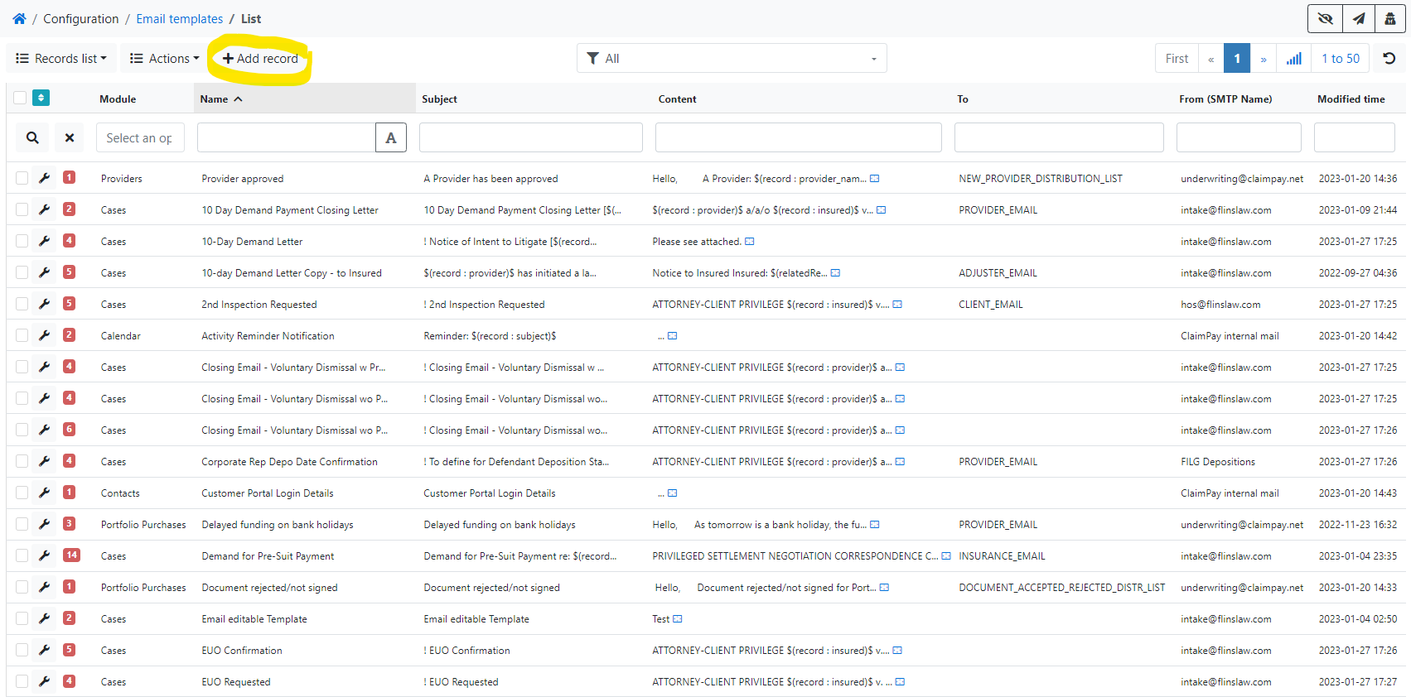

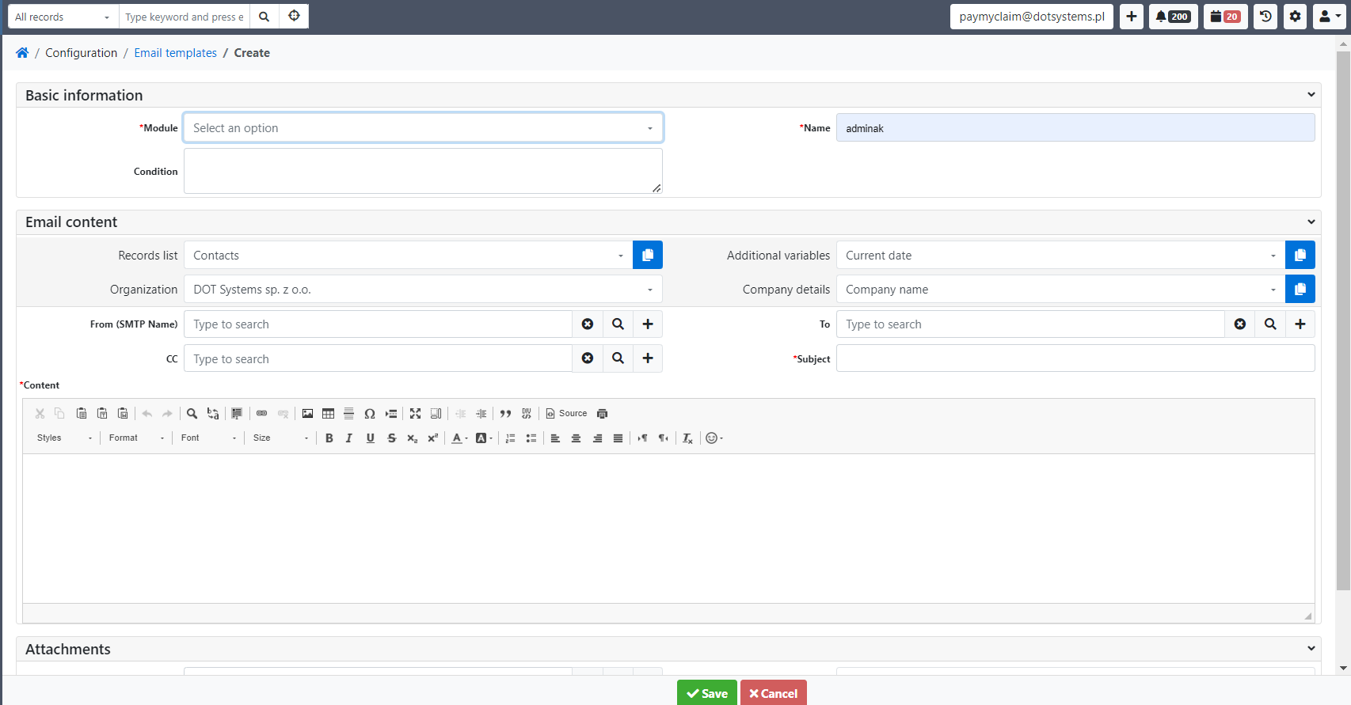

* in the filed *Module* select a module, for which you want to make an email template e.g. Case,
* in the field *Name* type a name (the name of the email template should be unique),
* in the *From (SMTP Name)* field, indicate the appropriate Case Handlers (in simple terms: a defined outgoing mailbox),
* in the *To* field, indicate the appropriate email address from defined placeholdes,
* fill in the *Subject* field (in order for the email sent to be associated with the record from which it was sent, place in the *Subject* in [] the placeholder with the record ID, e.g. for emails sent from Case module: [@@CASE\_ID@@]; you can also use dynamic fields described below),
* fill in the *Content* field; if you want to use dynamic fields go to *Fields from module* or *Fields from dependent modules* field and find the field you want use as a dynamic, , e.g. *Claim Number*, then click *Copy to clipboard – Field Value* button (blue one, next to the field):

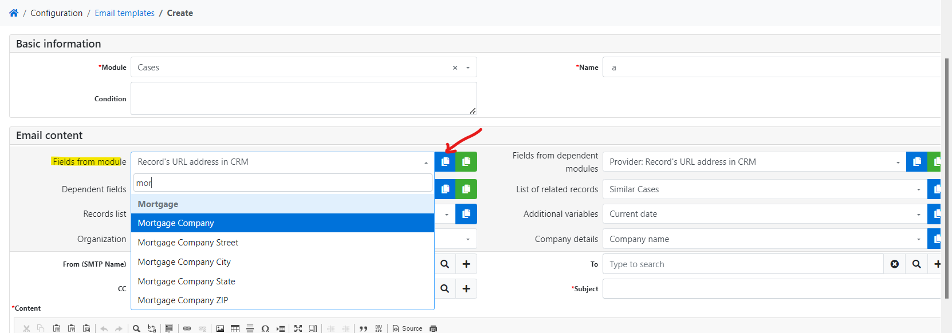

now go back to the *Content field* and copy the clipboard contents:

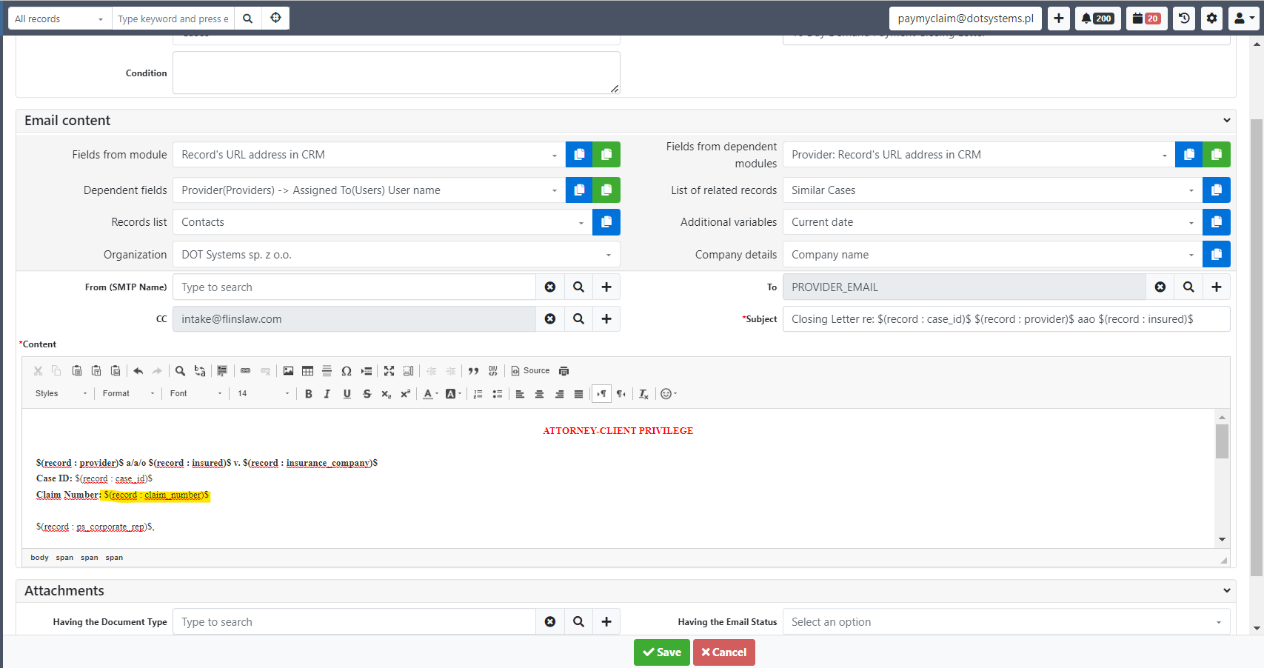

You can also use variables from the *Additional variables* list:

* *Current date*,
* *Current time*,
* *System time zone*,
* *User time zone*.
* save the record.

1. Support for dynamic Email Templates in the PMC Email Client

The feature allows to use all already prepared Email Templates to create a draft email and edit it before sending.

To open the *My* *mailbox* select *Virtual desk* from the menu, and then select *My* *mailbox*.

1. Start composing a new message in the PMC Email Client (through *Compose*, *Reply*, *Forward* etc.)

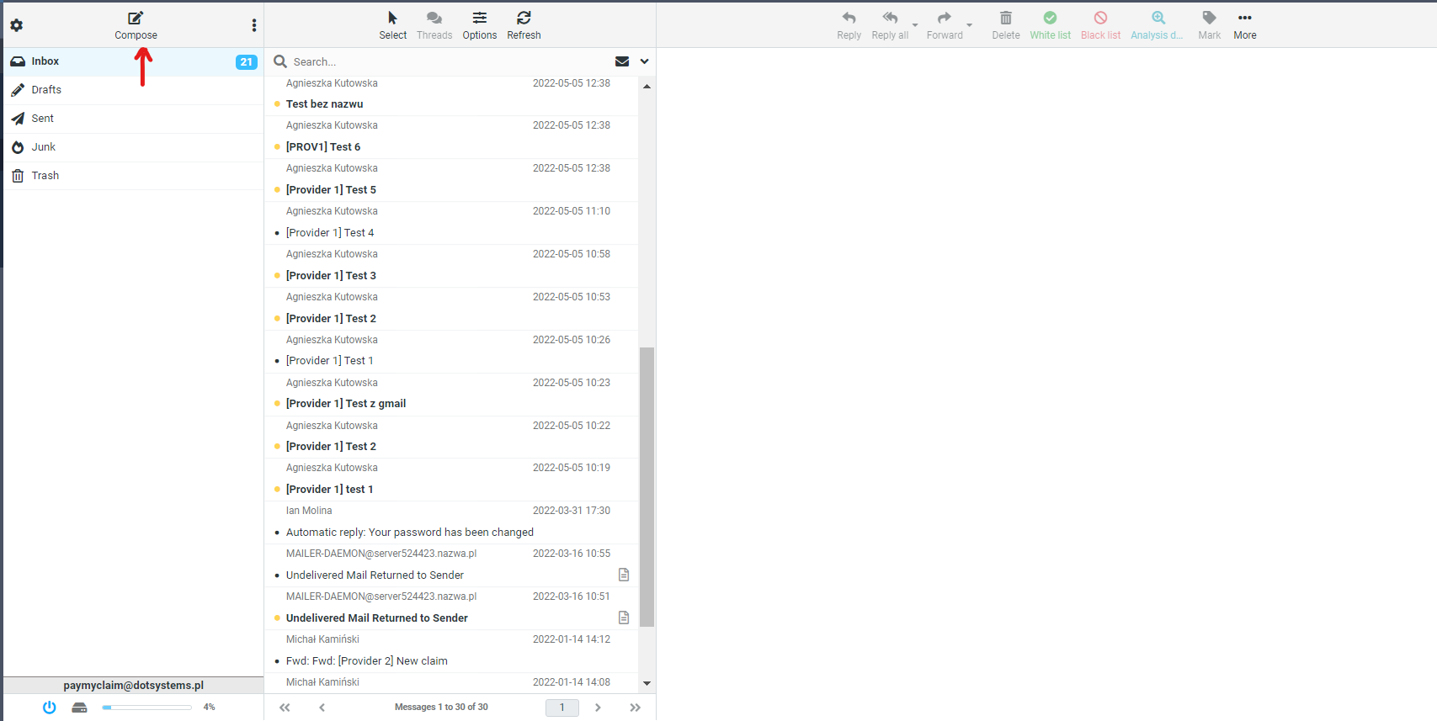

1. Press the *Template...* button and choose from your *Email Templates*. Filter templates by module, name, content etc. to find the relevant one.

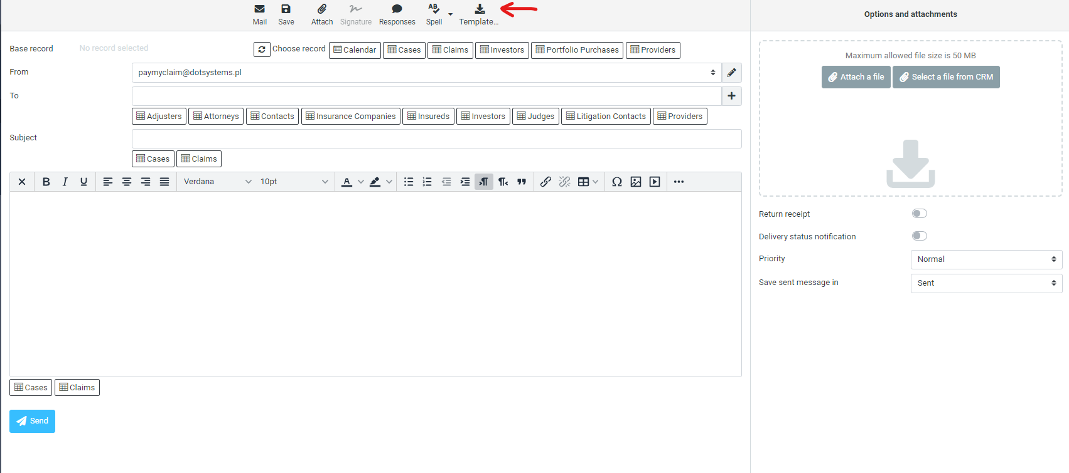

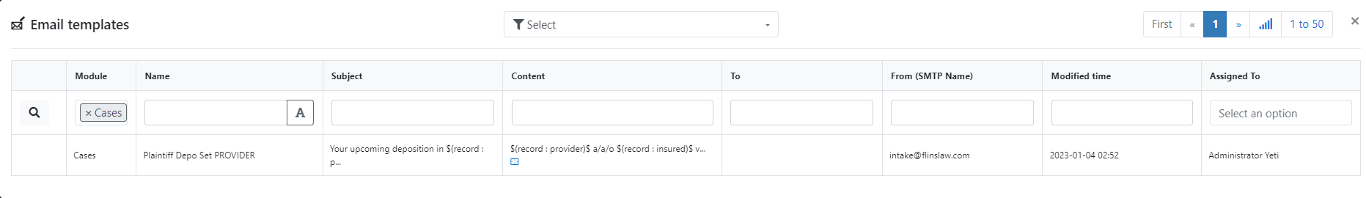

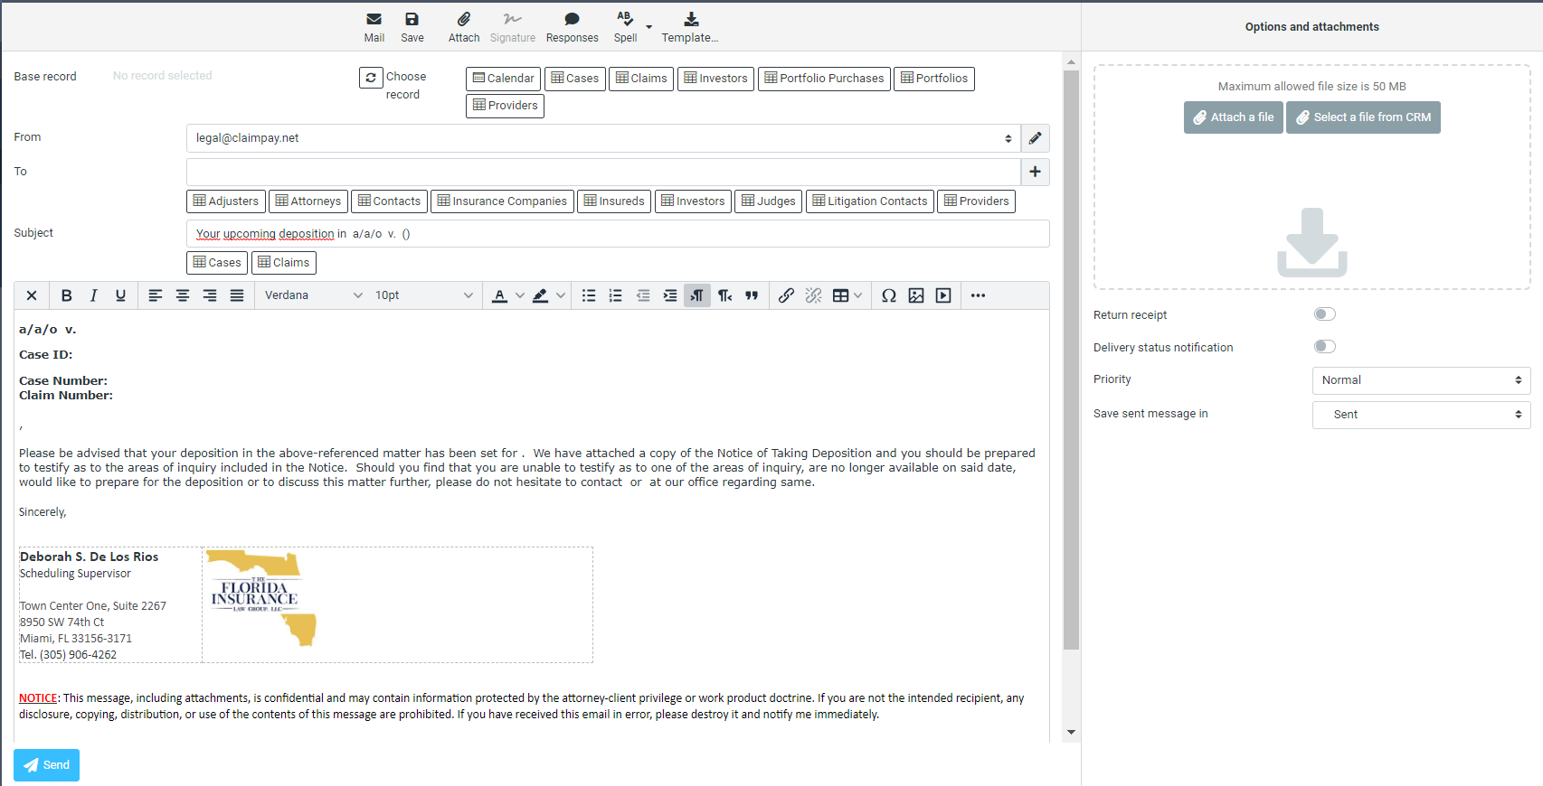

1. Press one of the module button, e.g. *Cases* and choose a record you need (for most litigation emails use the *Cases* button).

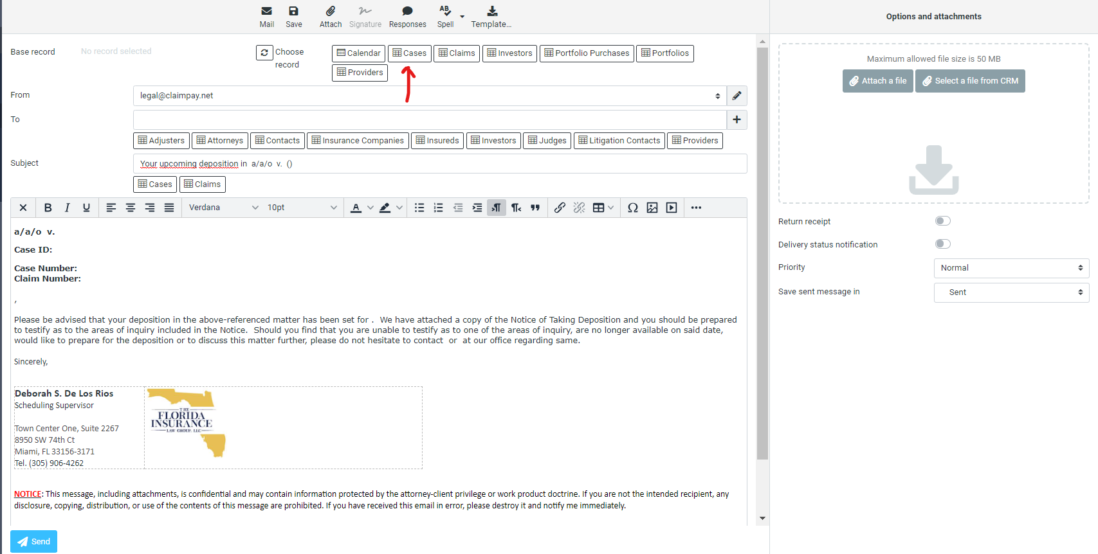

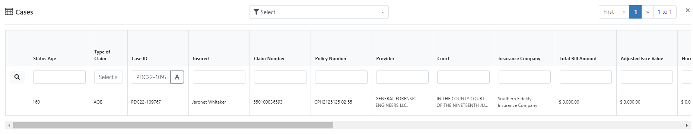

All dynamic placeholders in *From*, *To*, *Subject* and *Contents* email fields will be automatically replaces with values from the base record. Also the attachments will be automatically reassigned.

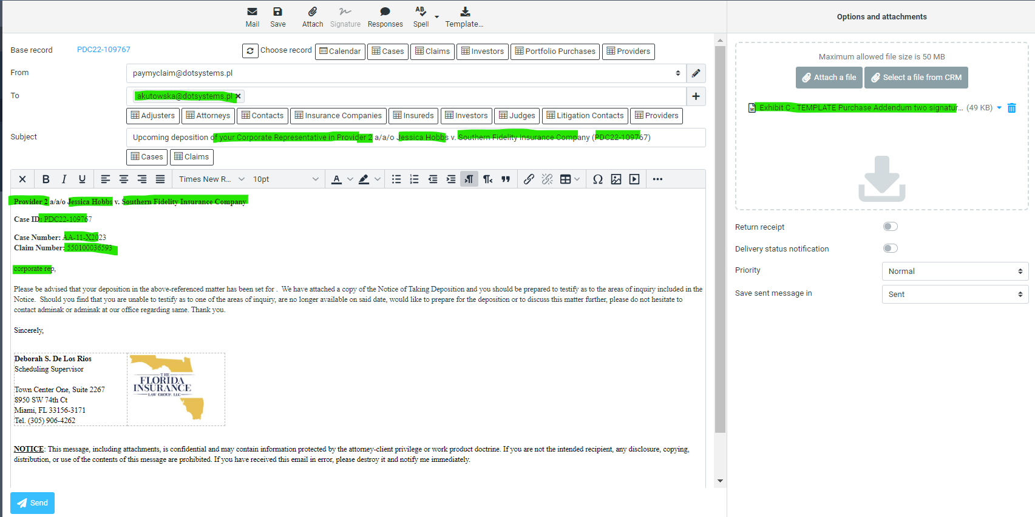

1. Now you can edit the contents of the email as needed, and finally press the *Send* button.
2. Document Types

The *Document Types*  form allows you to define a catalog of document types.

The document catalog with all defined *Document Types* is presented on the *Documents* tabs for modules:

* *Providers,*
* *Portfolios,*
* *Portfolio Purchases,*
* *Claims,*
* *Cases.*

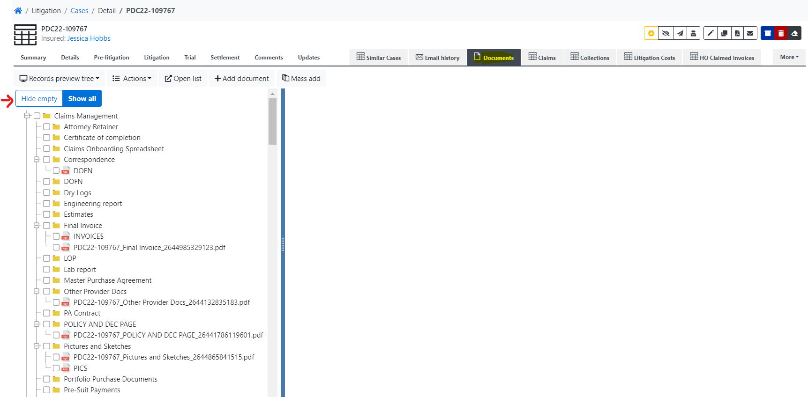

If you do not want to display *Document Types* in the directory for which there are no attached documents, press the *Hide empty* button.

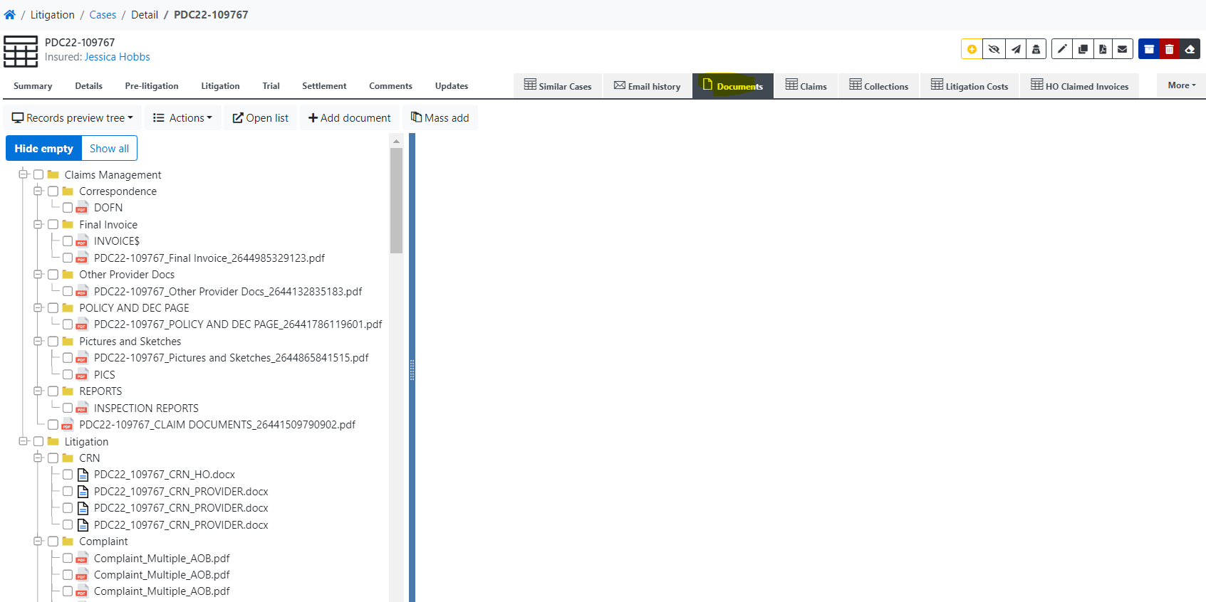

To open the *Document Types* form select *Configuration* from the menu, and then select *Document Types*.

To add a new *Document Type*:

* press the *+ Add record* button:

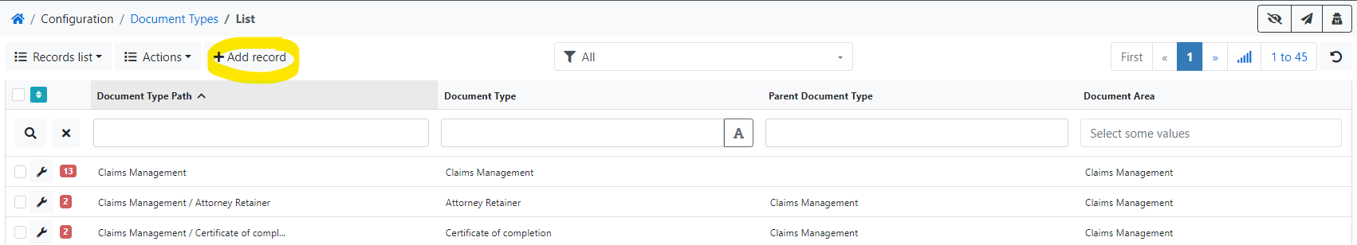

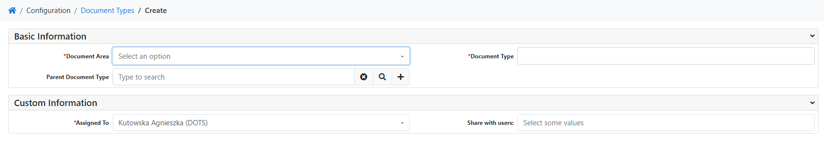

* in the filed *Document Area* select one of the following areas:
  + *Claims Management* (area dedicated to Claim documents),
  + *Litigation* (area dedicated to Case documents)*,*
  + *CMS,*
  + *Provider Documents* (area dedicated to Provider documents)*,,*
  + *Document Templates* (area dedicated to Document templates documents)
* in the field *Document Type* enter the name of the new document type (the name of the document type should be unique),
* if you want to add a new document type under the type previously defined in the *Parent Document Type*field select the path under which you want to place the new type, e.g. if you want to create a new document type under Litigation -> AOB:

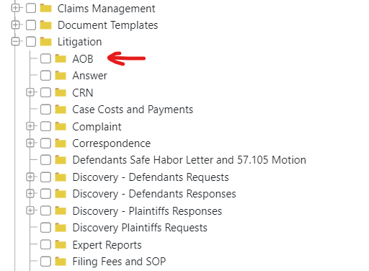

in the *Parent Document Type*field you should choose Litigation / AOB:

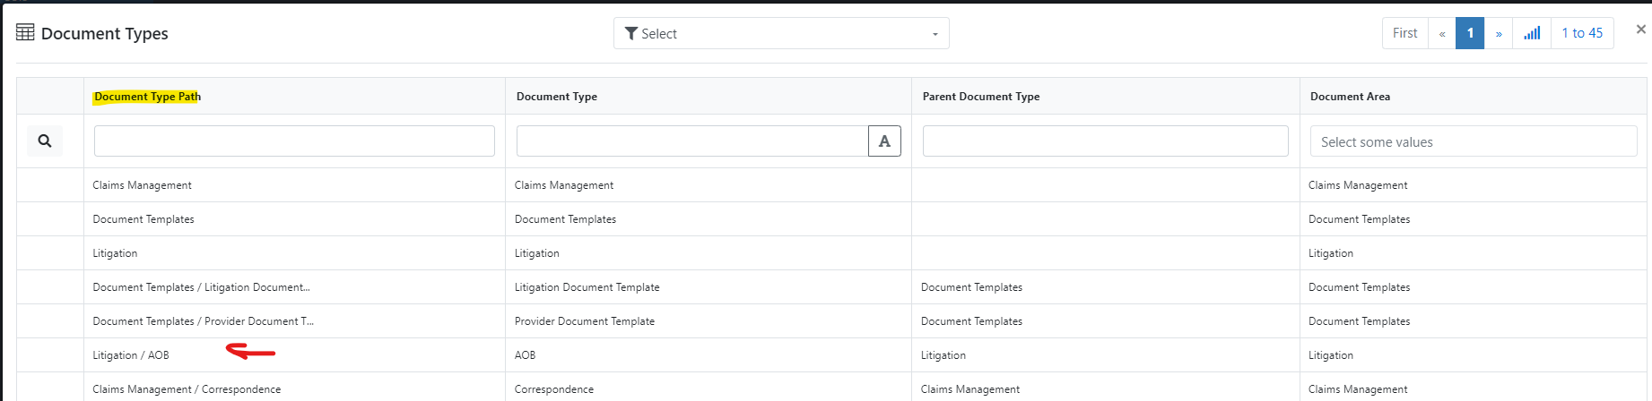

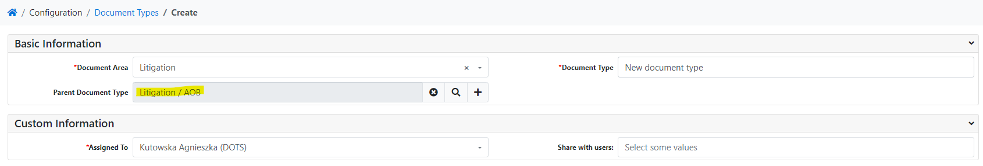

* save the record.

After this operation, the *Document Type* directory structure will look like this:

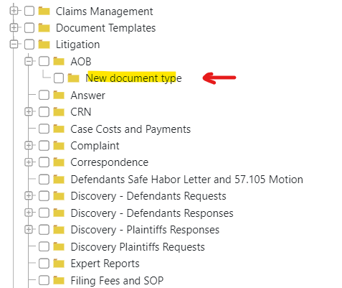

1. Document templates

The *Document Templates* form allows you to define document templates.

*Document templates* are defined for modules. They can be used to generate a document directly from a record in a selected module, through workflow or used in document packages.

To open the *Document template* form select *Configuration* from the menu, and then select *Document Templates*.

To add a new *Document Templates*:

* press the *+ Add record* button:

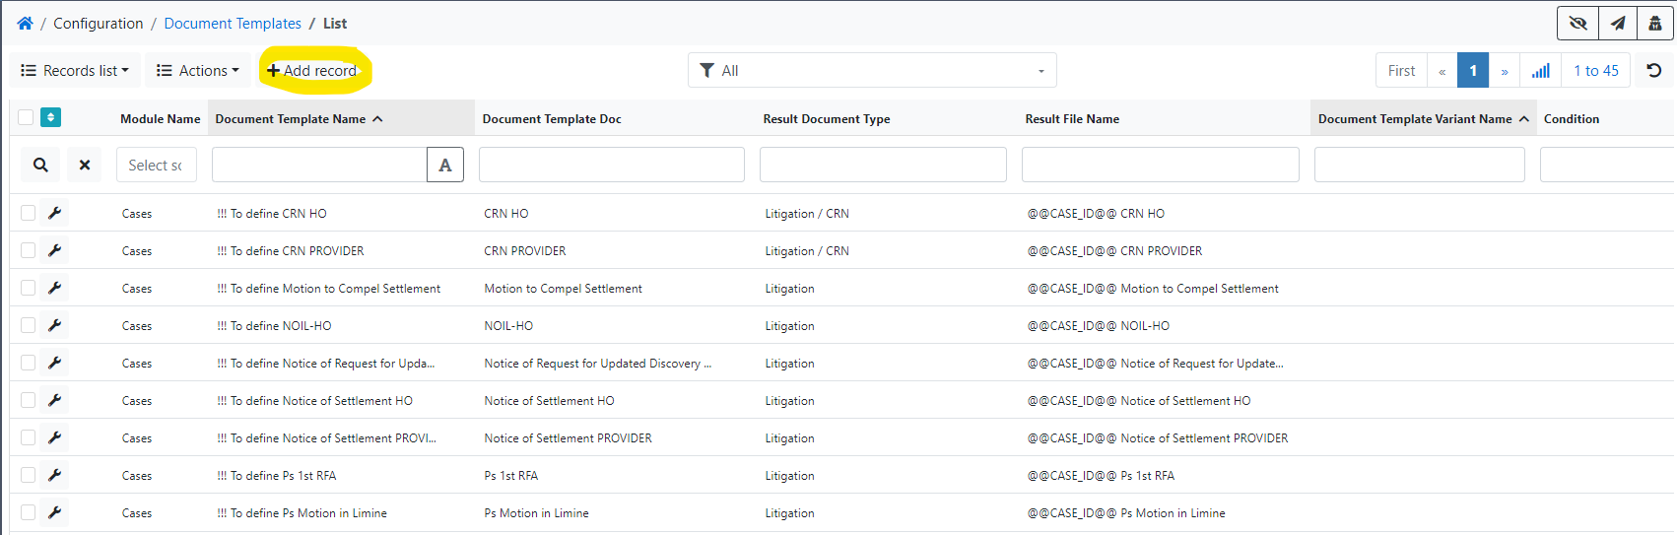

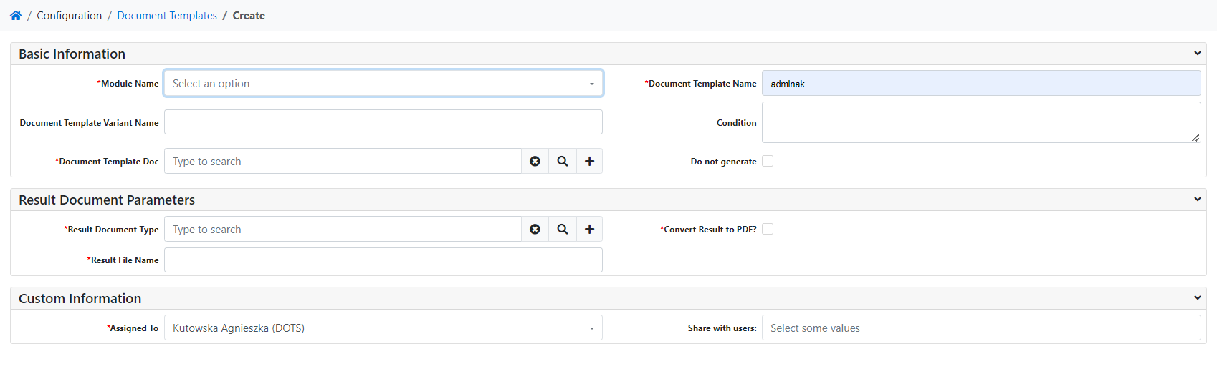

* in the filed *Module Name* select a module, for which you want to make a document template e.g. Case,
* in the field *Document Template Name* type a name (the name of the document template should be unique),
* in the *Document Template Doc* field, indicate the template previously added in the *Documents* form (menu *Virtual Desk* -> *Documents*),
* in the *Result Document Type* field, indicate the appropriate document type,
* in the *Result File Name* field, enter the name of the resulting file; you can use placeholders for the module for which you are making a document template, e.g. to add the CASE ID to the file name, use: @@CASE\_ID@@: @@CASE\_ID@@ Presuit Demand Letter. Generated for Case ID = PDC22-109767 document will have the name: PDC22\_109767\_Demand\_for\_Pre\_Suit\_Payment.pdf,
* save the record.

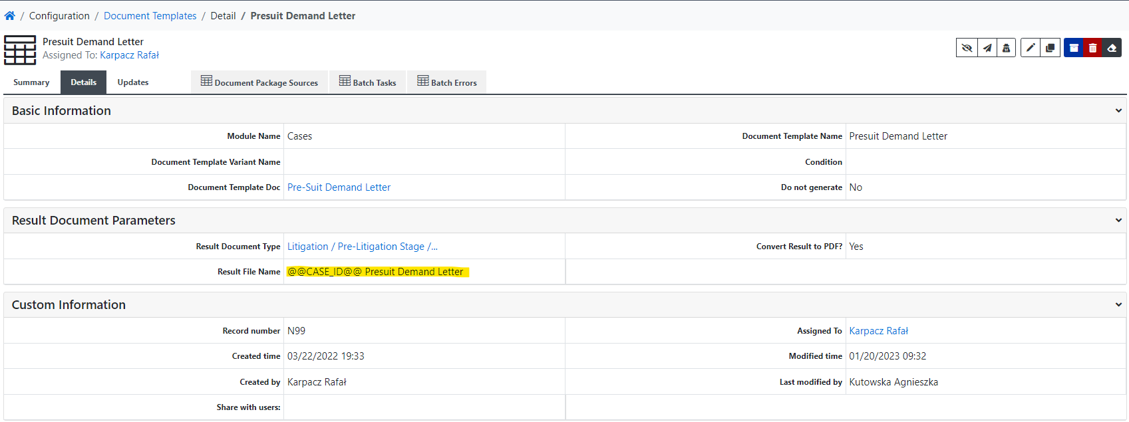

It is possible to define a condition (field *Condtion*) for which the template will be used.

For example, if you want to use the template only for a record in the *Cases* module where in the *County* field is typed ORANGE COUNTY and in the *Total Balance* field a value is greater than 8000, in the *Condition* field you should type:

{ "condition": "AND", "rules": [ { "fieldname": "county:Cases", "operator": "e", "value": "ORANGE COUNTY" }, { "fieldname": "total\_balance:Cases", "operator": "h", "value": "8000" } ] }

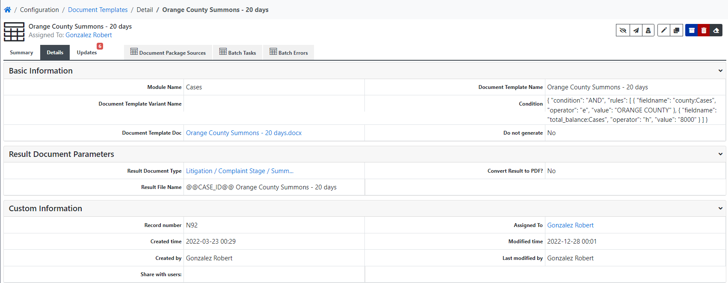

1. Document packages

The *Document packages* form allows you to define documents composed of several other documents.

After generating a document from a document package, it can be automatically sent by email from the email template to the defined address.

*Document packages* are defined for modules. They can be used to generate a document directly from a record in a selected module or through workflow.

To define a document package, you must have previously defined document templates.

To open the *Document packages* form select *Configuration* from the menu, and then select *Document Packages*.

To add a new *Document package*:

* press the *+ Add record* button:

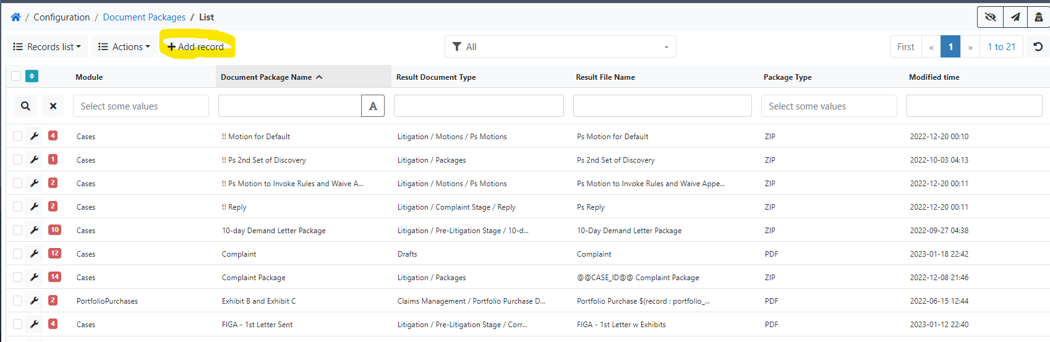

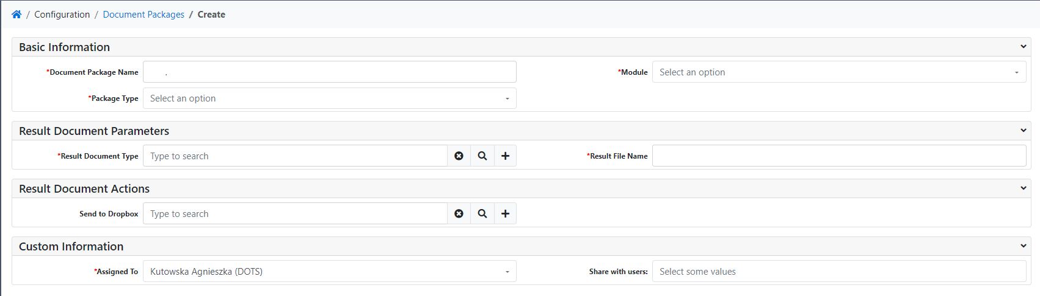

* in the field *Document Package Name* type a name (the name of the document package should be unique),
* in the filed *Module* select a module, for which you want to make a document package e.g. Case,
* if you want the generated document to be peaked – select the ZIP option in the *Package Type field*; otherwise, select *PDF*,
* in the *Result Document Type* field, indicate the appropriate document type,
* in the *Result File Name* field, enter the name of the resulting file; you can use placeholders for the module for which you are making a document template, e.g. to add the CASE ID to the file name, use: @@CASE\_ID@@: @@CASE\_ID@@ Demand for Pre-Suit Payment. Generated for Case ID = PDC22-109767 document package will have the name: PDC22\_109767\_Demand\_for\_Pre\_Suit\_Paymen.pdf or PDC22\_109767\_Demand\_for\_Pre\_Suit\_Paymen.zip
* if you want the generated document package to be immediately sent to Dropbox for signature, in the *Send to Dropbox* field, indicate the previously defined Dropbox Destination,
* save the record.

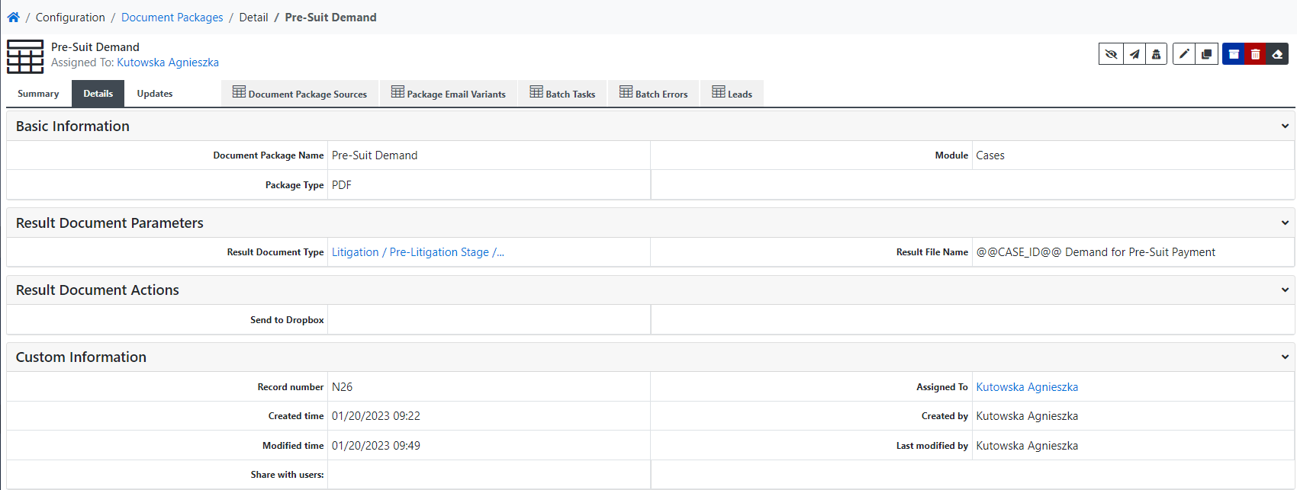

Now you should attach the document sources:

* go to *Document Package Sources* tab and press the *+ Add record* button:

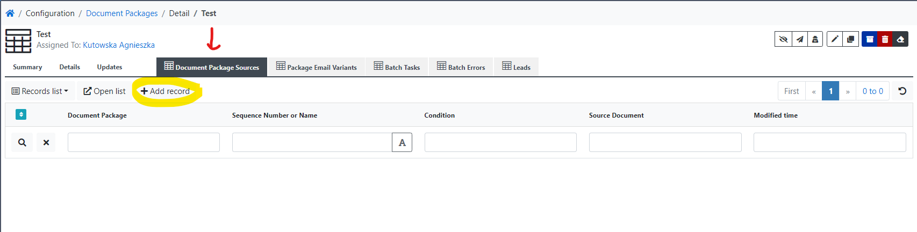

or:

* press the *+* button on *Document Package Sources* widget:

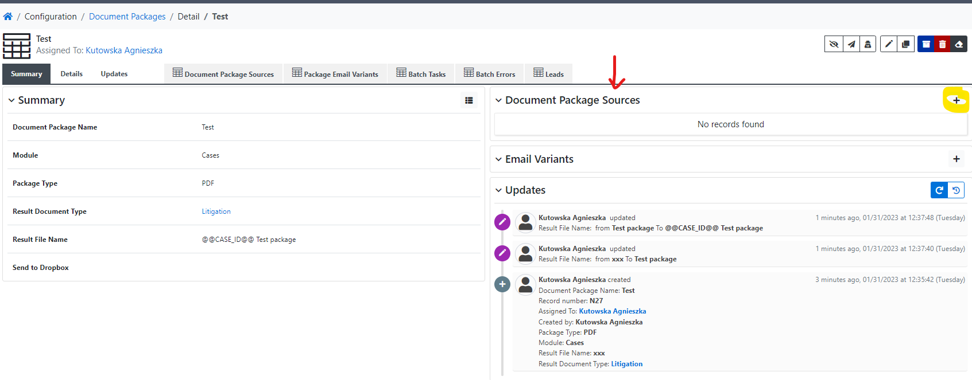

* in the field *Sequence Number or Name* type a name (the name should be unique),
* in the filed *Source Document* select:
  + *Documents*: if you want a specific, permanent document to be attached to the package (e.g. regulations document); in the field next to it, select the right document,
  + *Document Templates*: if you want a document template to be attached to the package; in the field next to it, select the right document template,
  + *Document package*: o if you want another package to be attached to the package; in the field next to it, select the right package,
  + *Document Types*: if you want attach all documents of a given type.

Repeat adding Document Package Sources until you have added all the documents you want in the package.

If defined Document package should be automatically sent by email you should define also *Email Variants*.

* go to *Package Email Variants* tab and press the *+ Add record* button:

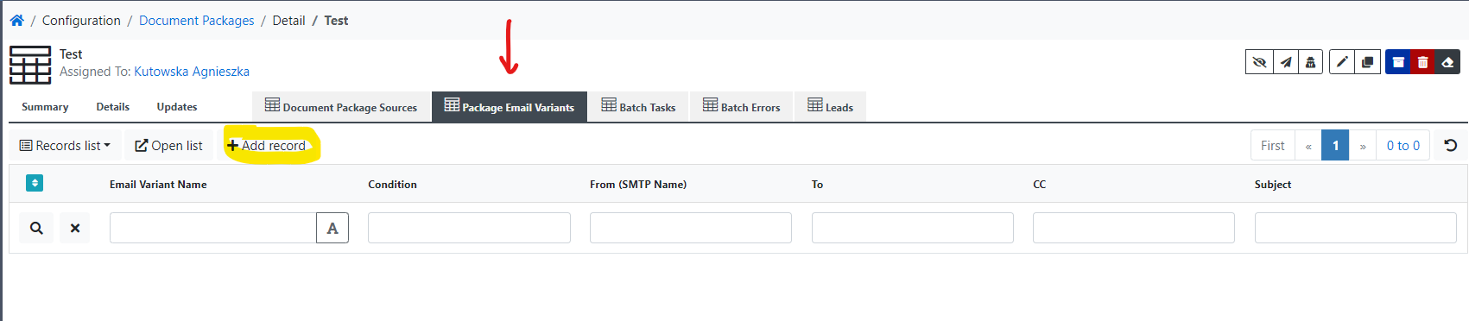

or:

* press the *+* button on *Email Variants* widget:

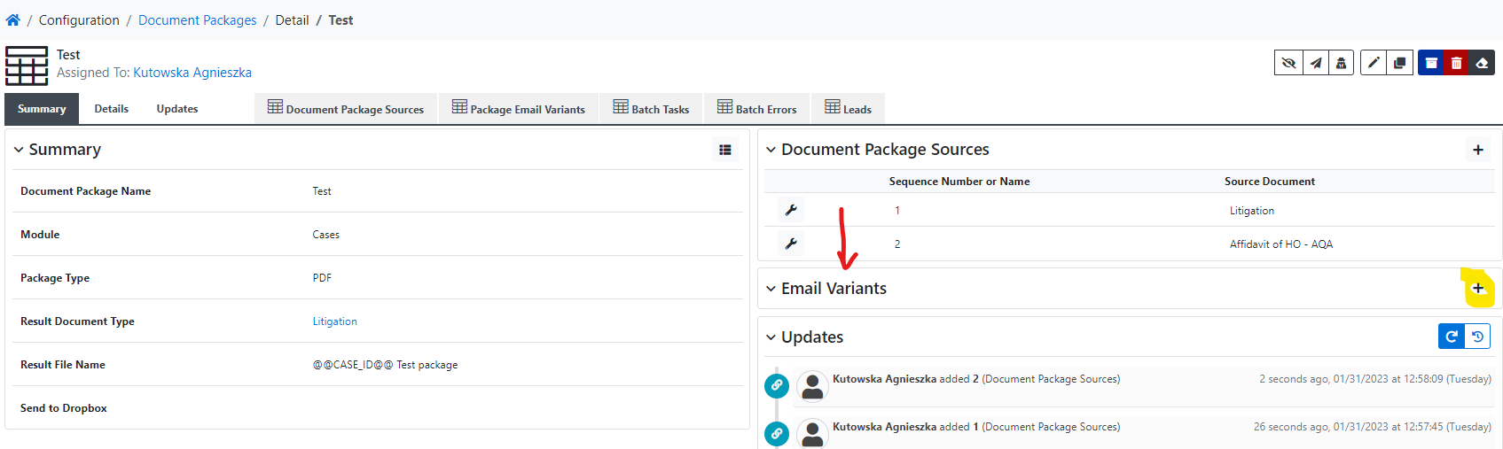

* in the filed *Module* select a module, for which you want to make an email variant e.g. Case,
* in the field *Email Variant Name* type a name,
* in the *From (SMTP Name)* field, indicate the appropriate Case Handlers (in simple terms: a defined outgoing mailbox)
* in the *To* field, indicate the appropriate email address (you can use placeholders),
* fill in the *Subject* field (in order for the email sent to be associated with the record from which it was sent, place in the *Subject* in [] the placeholder with the record ID, e.g. for emails sent from Case module: [@@CASE\_ID@@]),
* fill in the *Content* field,
* save the record.

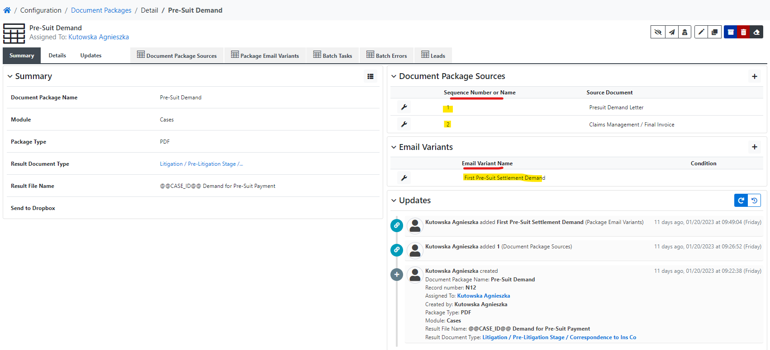

1. Condition syntax

condition = {"fieldname": "[field in the format: field name: module or field name: module: reference field]", "operator": "[one of the available operators, e.g. e]", "value": "[value to compare]" }

conditionGroup = { "condition: "AND|OR", "rules": [ condition | conditionGroup, ... ]}  
  
E.g.

"condition": "AND",

"rules": [

{

"condition": "OR",

"rules": [

{"fieldname":"field 1:module name","operator":"e","value":"value to compare 1" },

{"fieldname":"field 1:module name","operator":"e","value":"value to compare 2" }

]

},

{ "fieldname": "field 2:module name", "operator": "e", "value": "value to compare 3" }

]

}

Operators:

**e** -> equals,  
    **n** -> not equal to,  
    **s** -> starts with,  
    **ew** -> ends with,  
    **c** -> contains,  
    **ch** -> contains hierarchy,  
    **k** -> does not contain,  
    **kh** -> does not contain hierarchy,  
    **l** -> less than,  
    **g** -> greater than,  
    **m** -> less than\_or equal,  
    **h** -> greater or equal,  
    **b** -> before,  
    **a** -> after,  
    **bw** -> between,  
    **y** -> is empty,  
    **ny** -> is not empty,  
    **om** -> currently logged user,  
    **nom** -> user currently not logged,  
    **ogr** -> currently logged user group,  
    **wr** -> is watching record,  
    **nwr** -> is not watching record,  
    **hs** -> has changed,  
    **hst** -> has changed to,  
    **ro** -> is record open,  
    **rc** -> is record closed,  
    **nco** -> not created by owner.

**Examples for Cases module**

(field names are best copied from the Email templates form (see Email templates chapter))

IF case is in County A Then Include the template

{ "fieldname": "county:Cases", "operator": "e", "value": "County A" }

If case Case Type is HOS then include template

{ "fieldname": "type\_of\_claim:Cases", "operator": "e", "value": "AOB" }

If case Case Type is HOS then include template AND Claim Balance is over $8000 then include template

{ "condition": "AND", "rules": [

{ "fieldname": "type\_of\_claim:Cases", "operator": "e", "value": "AOB" },

{ "fieldname": "ls\_claim\_balance:Cases", "operator": "g", "value": "8000" }

] }

if (Case Type is HO **or** COMBO) **and** Total Balance greater than or equal to $50,000.00 then include template

{"condition": "AND",

"rules": [

{

"condition": "OR",

"rules": [

{ "fieldname": "type\_of\_claim:Cases", "operator": "e", "value": "HO" },

{ "fieldname": "type\_of\_claim:Cases", "operator": "e", "value": "Combo" }

]

},

{ "fieldname": "total\_balance:Cases", "operator": "h", "value": "50000" }

]

}

if Case type is NOT HOS then include template

{ "fieldname": "type\_of\_claim:Cases", "operator": "n", "value": "AOB" }

A reference to a field from a related module: if Address Book of County is www.dotsystems.pl

{ "fieldname": "address\_book:Counties:county", "operator": "e", "value": "www.dotsystems.pl" }

A reference to a field from a related module: if Address Book of County of Cours is www.dotsystems.pl

{ "fieldname": "address\_book:Counties:county:court", "operator": "e", "value": "www.dotsystems.pl" }

Dates must be in YYYY-MM-DD format, e.g. for Case:

{ "fieldname": "euo\_date:Cases", "operator": "b", "value": "2023-01-12" }

The syntax of the fieldname (an example the Case module (A)).

* field in the current module: field name: module name, e.g."county:Cases",
* field from related module: field you are looking for (3): related module (2): reference field (1), e.g. "address\_book:Counties:county"

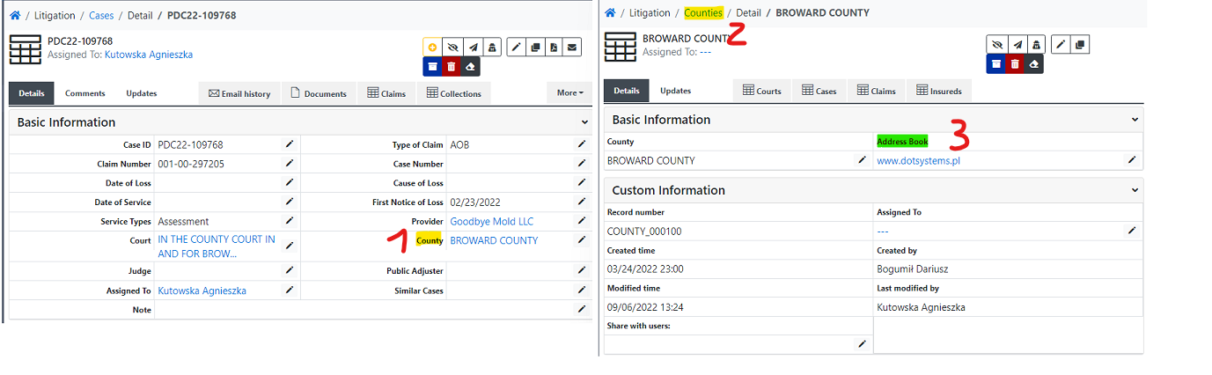

* field from related module: field you are looking for (4): last related module (3): reference field from modul B (2): reference field from modul A (1), e.g. "address\_book:Counties:county:court"

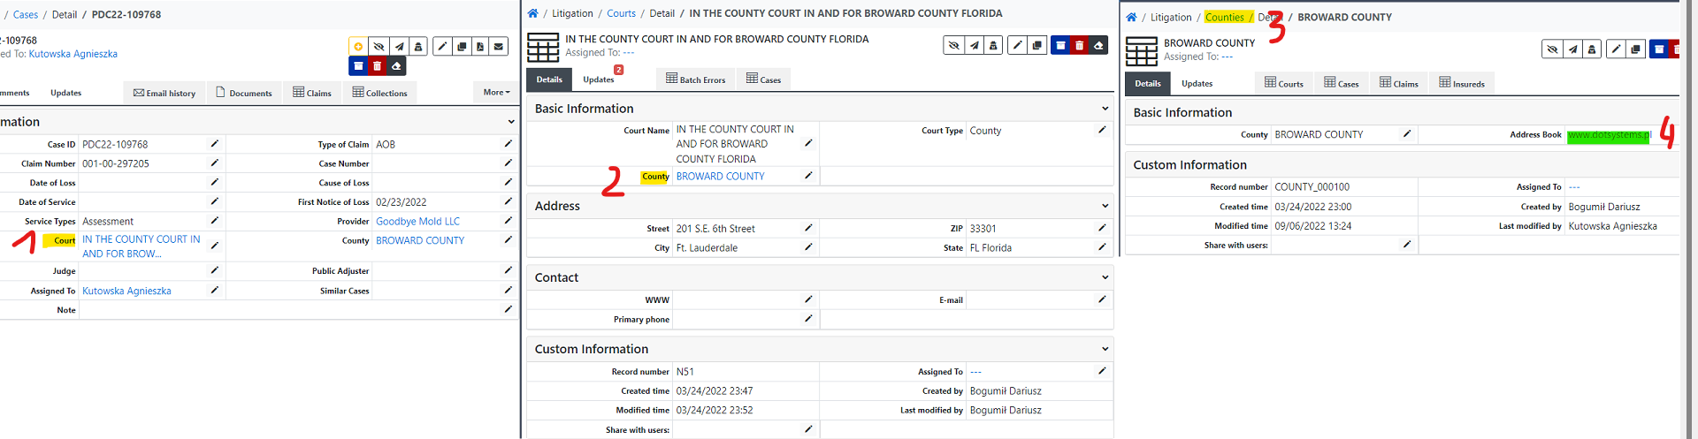

1. Inserting a signature into a document

If you want to attach a signature saved in the *Signature Image* field in the *Attorneys* module into a system-generated document:

1. Make sure you have the *Signature Image* field in the *Attorneys* form completed: open the *Attorneys* form from Menu: select *Litigation*, and then select *Attorneys*:

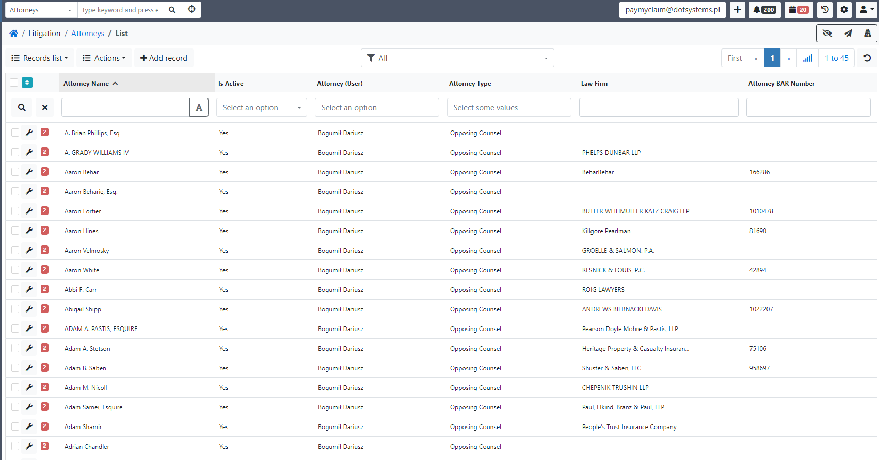

1. Use filters to find the right Attorney:

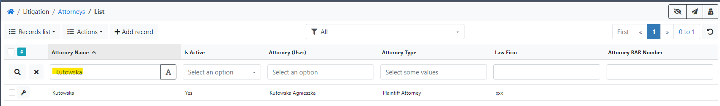

1. Open the record and check if the image with the signature is inserted in the *Signature Image* field. If not, edit the record and insert your digital signature; save the record.

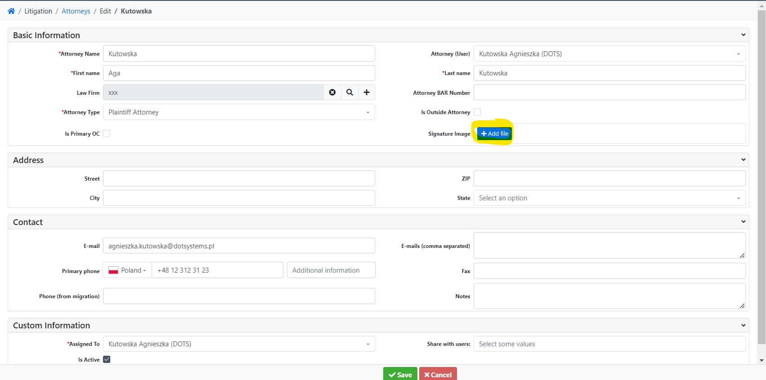

1. In the document template, insert any picture, and in the alt text type a reference to the field marked Raw at the end:

relatedRecord: $(relatedRecord**Raw** : attorney|signature\_image|Attorneys)$

Example:

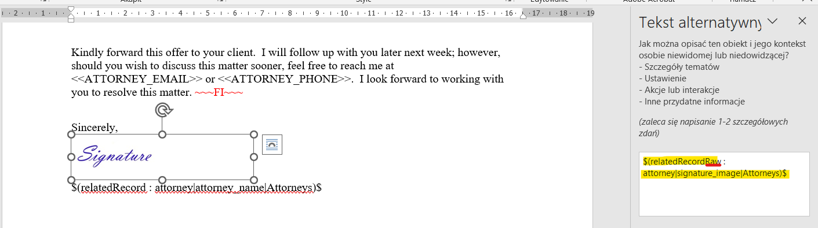

Document result generated for Attorney with a digital signature:

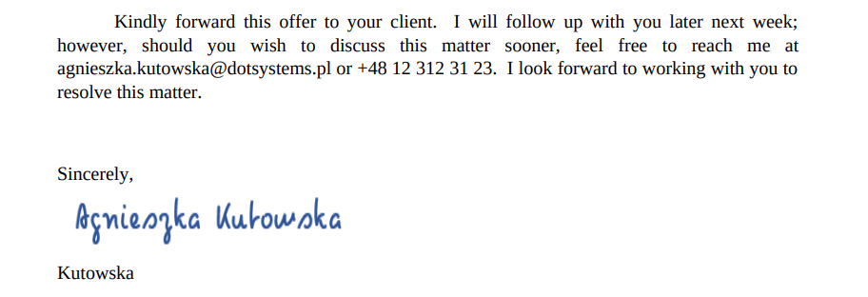

If you want an image with a digital signature to be conditioned by the value in the field, e.g. for document generated from Cases module, a signature of person A if field Contact Person in module Investors contains a specific sequence of characters and a signature of person B in other cases:

|  |  |
| --- | --- |
| **SELLER** | **BUYER** |
|  | ~~~IF \*Investor Contact Person not contains Carlos\*{"fieldname":"contact\_person:Investors:investor", "operator": "k", "value": " Agnieszka Kutowska " }~~~ relatedRecord: $(relatedRecordRaw : attorney|signature_image|Attorneys)$    ~~~FI~~~ ~~~IF \*Investor Contact Person contains Carlos\*{"fieldname":"contact\_person:Investors:investor", "operator": "c", "value": "Agnieszka Kutowska" }~~~  ~~~FI~~~ |
| \_\_\_\_\_\_\_\_\_\_\_\_\_\_\_\_\_\_\_\_\_\_\_\_\_\_\_\_\_\_\_\_\_\_\_\_\_\_\_  By: /fn/  Title: /ps/  Date: /ds/ | \_\_\_\_\_\_\_\_\_\_\_\_\_\_\_\_\_\_\_\_\_\_\_\_\_\_\_\_\_\_\_\_\_\_\_\_\_\_\_\_  By: ~~~IF \*Investor Contact Person not contains Carlos\*{"fieldname":"contact\_person:Investors:investor", "operator": "k", "value": " Agnieszka Kutowska " }~~~H. Paul Soberon-Llort~~~FI~~~ ~~~IF \*Investor Contact Person contains Carlos\*{"fieldname":"contact\_person:Investors:investor", "operator": "c", "value": " Agnieszka Kutowska " }~~~ Agnieszka Kutowska ~~~FI~~~  Title: Authorized Person  Date: <<PURCHASE\_ADDENDUM\_DATE>> |

Make sure the image is set (Wrap Text) to In Line with Text.

1. Placeholders

The *Placeholders* form allows you to define placeholder, that you can use in document templates.

To open the *Placeholders* select *Configuration* from the menu, and then select *Placeholders*.

*Placeholders* are defined for modules.

Before you create a new placeholder, open in the new tab the *Email template* form (select *Configuration* from the menu, and then select *Email Template)*. It will be helpful.

To create a new placeholder:

* click the *+ Add record* button:

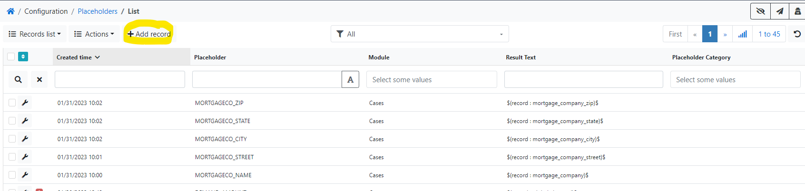

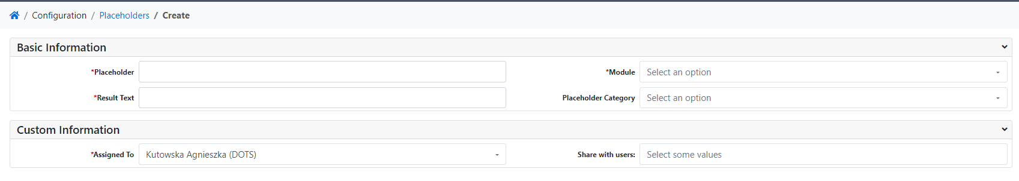

* in the filed *Module* select a module, for which you want to make a placeholder e.g. Case,
* in the field *Placeholder* type a name (the name of placeholder cannot contain spaces, use \_ to replace a space)

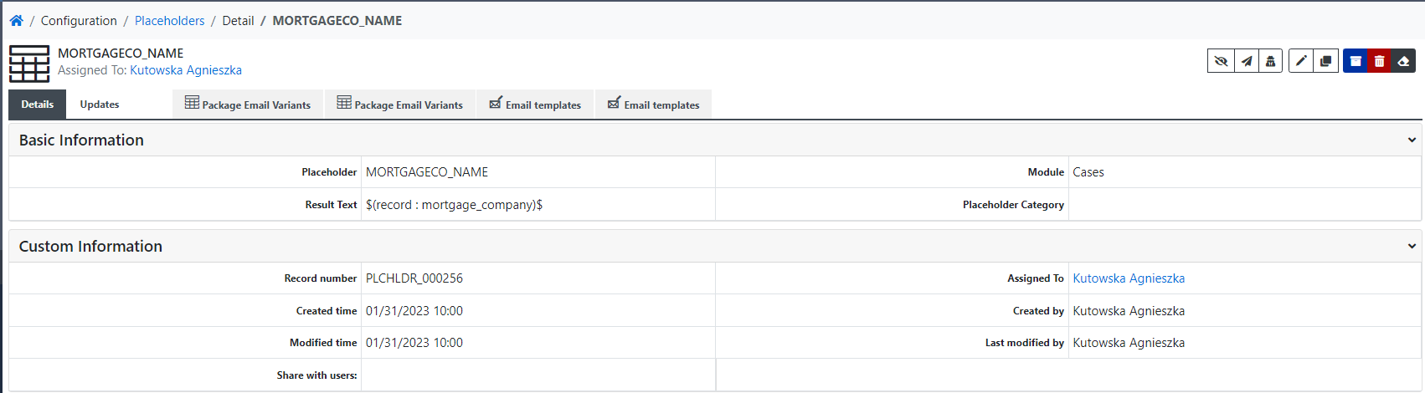

* go to the tab where you have the *Email template* form open; click the *+ Add record* button and select the same module (field Module) what you chose when creating placeholder,
* go to *Fields from module* or *Fields from dependent modules* field and find the field for which you want to create a placeholder, e.g. Mortgage Company, then click *Copy to clipboard – Field Value* button (blue one, next to the field):



* now go back to the *Placeholders* form and copy the clipboard contents into the *Result Text field*; save the record:

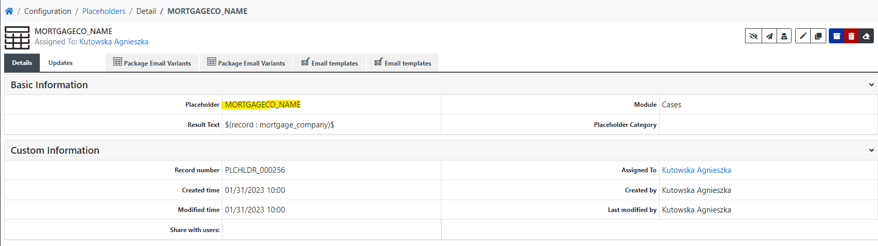

Now you can refer to the field in document templates by placing a defined placeholder between <<>>, e.g. <<MORTGAGECO\_NAME>>.

If you want to define a placeholder that refers to an email address field, you must select *Email Address* from the *Placeholder Category* field:

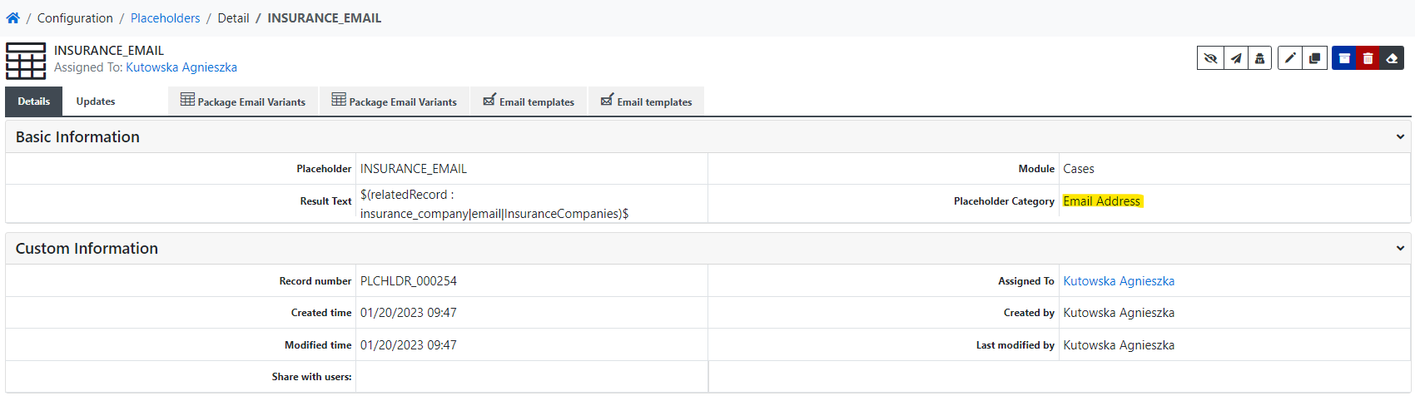

1. Docusign placeholders

If the document should be sent to Dropbox for signature and you want the signer to fill in the fields: By, Title, Date you must include the appropriate placeholders in the document:

* */fn/* for By
* */ps/* for Title
* */ds/* for Date.

The */ds/* placeholder will be automatically populated with the current date by Docusign.

You can change the font color to white for these placeholders so that they are not visible in the generated document.

1. Cases Workflows
   1. Module: Cases, MANUAL
      1. Assign a Case Manager to Shared with

Tasks:

* Copy "Case Manager" to "Share with users"
  + 1. Create Complaint Package

Conditions:

* All:
  + **Lock Automation** is 0

Tasks:

* Create package Complaint Package
* Set Complaint Status = Complaint Printed
  + 1. DOTS: Copy PDC Case ID to Case ID

Conditions:

* All:
  + **PDC Case ID** is not empty
* At least one:
  + **current-role** is DOTS
  + **current-role** is Board of Management

Tasks:

* copy PDC Case ID to Case ID
  + 1. Find County

Tasks:

* WF Insured.findCounty
  + 1. Find Similar Cases

Conditions:

* All:
  + **Lock Automation** is 0

Tasks:

* CF findSimilarCases
  + 1. Recalculate from Claims

Conditions:

* All:
  + **Lock Automation** is 0

Tasks:

* WF RECALCULATE\_FROM\_CLAIMS
* call recalculateFromCollections
  + 1. Set Court

Conditions:

* All:
  + **Total Balance** greater than 0
  + **Lock Automation** is 0
  + **County** is not empty

Tasks:

* Set Court
  1. Module: Cases, Section: Appeal
     1. Appeal Status change to Notice of Appeal Filed

Conditions:

* All:
  + Appeal Status has changed
  + Appeal Status is Notice of Appeal Filed
  + Lock Automation is 0

Tasks:

* set date Notice of Appeal
  + 1. "Change of Appeal Status"

Conditions:

* All:
  + Appeal Status has changed
  + Appeal Status is not empty

Tasks:

* Update Status, Status Age, Status Date, Stage
  1. Module: Cases, Section: Appeal
     1. On change of Attorney

Conditions:

* All:
  + AOB/DTP Attorney has changed
  + Lock Automation is 0
  + (Attorneys)- Attorney Name does not contain ---

Tasks:

* copy Attorney\_user from Attorneys module to Assign to
  1. Module: Cases, Section: Collections Summary
     1. Case Collections Summary data changed

Conditions:

* All:
  + Total Collections has changed
  + Total Collections greater than 0
  + Lock Automation is 0

Tasks:

* send a Notification to Assigned to: “Case Collections Summary data was changed: [link to the Case]”.
  + 1. ON\_CHANGE\_CALCULATE\_TOTAL\_BALANCE

Conditions:

* All:
  + Lock Automation is 0
* At least one:
  + Total Bill Amount has changed
  + Total Collections has changed
  + Adjusted Face Value has changed

Tasks:

* Total balance = Total Bill Amount - Total Collections, Adjusted Claim Balance = Adjusted Face Value - Total Collections
  1. Module: Cases, Section: Complaint
     1. 1 day after Ds Notice of Appearance Entered is set

Conditions:

* All:
  + **Ds Notice of Appearance Entered** is not empty
  + **Ds Notice of Appearance Entered** days ago 1

Tasks:

* send email template "Ps Depo Requests" to OPPOSING\_COUNSEL\_EMAIL
  + 1. 2 days after Complaint Status set to Filing Team

Conditions:

* All:
  + **Stage** is Complaint
  + **Status** is Case Filed
  + **Status Age** equal to 2
  + **Lock Automation** is 0

Tasks:

* add task for Case Manager in 2 days to after Complayant status is set to Case Filed "Check docket for executed summons for"
  + 1. 3 day after Ds Notice of Appearance Entered is set

Conditions:

* All:
  + **Ds Notice of Appearance Entered** is not empty
  + **Ds Notice of Appearance Entered** days ago 3

Tasks:

* create task for Scheduling Team - Depoitions to "Coordinate Deposition of D's Corp Rep and Field Adjuster in"
* create task for Case Manager to "Add Opposing Counsel's info to file in"
  + 1. 90 days after Service of Process change (AOB)

Conditions:

* All:
  + **Type of Claim** is AOB
  + **Service of Process** is not empty
  + **Service of Process** days ago 90
  + **Lock Automation** is 0

Tasks:

* create document template "Ps PFS"
* create task for Assigned Attorney to "Review and Edit Ps PFS to send to Defendant in AOB case re:"
  + 1. Answer changed

Conditions:

* All:
  + **Answer** has changed
  + **Answer** is not empty
  + **Lock Automation** is 0

Tasks:

* draft package Reply
* create task for Assigned Attorney to Review Answer and Affirmative Defenses for possible Motion to Strike in @@CASE ID@@ @@INJUREDPARTY\_NAME@@
* set Complaint status to Answer
  + 1. Answer date (Complaint stage) changed (AOB)

Conditions:

* All:
  + **Answer** has changed
  + **Answer** is not empty
  + **Type of Claim** is AOB
  + **Lock Automation** is 0

Tasks:

* create document template "CRN PROVIDER"
* create task for Assigned Attorney to "Review and Edit CRN in"
  + 1. Answer date (Complaint stage) changed (HO)

Conditions:

* All:
  + **Answer** has changed
  + **Answer** is not empty
  + **Type of Claim** is HO
  + **Lock Automation** is 0

Tasks:

* create document template "CRN HO"
* create task for Assigned Attorney to "Review and Edit CRN in"
  + 1. Answer Deadline changed

Conditions:

* All:
  + **Answer Deadline** has changed
  + **Answer Deadline** is not empty
  + **Lock Automation** is 0

Tasks:

* add event to Attorney and Case Manager calendar "Answer Due in"
  + 1. Answer field empty 7 days after after Answer Deadline

Conditions:

* All:
  + **Answer** is empty
  + **Answer Deadline** is not empty
  + **Answer Deadline** days ago 7

Tasks:

* draft package Motion for Default
* create task for Scheduling Team - Hearings to "Unilaterally set Ps Motion for Default for hearing in"
* change Complaint status to Answer Overdue
  + 1. Change of Complaint Status

Conditions:

* All:
  + **Complaint Status** has changed
  + **Complaint Status** is not empty

Tasks:

* Update Status, Status Age, Status Date, Stage
  + 1. Complaint Status change to Case Filed (Total Balance >=15000)

Conditions:

* All:
  + **Complaint Status** is Case Filed
  + **Complaint Status** has changed
  + **Lock Automation** is 0
  + **Total Balance** greater than or equal to 15000

Tasks:

* Set Case Filed date
* add entry to Costs Tab/Module for "Fililing Fee in the amount of $424.35"
  + 1. Complaint Status change to Case Filed (Total Balance<15000)

Conditions:

* All:
  + **Complaint Status** is Case Filed
  + **Complaint Status** has changed
  + **Lock Automation** is 0
  + **Total Balance** less than 15000

Tasks:

* Set Case Filed date
* add entry to Costs Tab/Module for "Fililing Fee in the amount of $320.85"
  + 1. Complaint Status change to Complaint Printed

Conditions:

* All:
  + **Complaint Status** has changed
  + **Complaint Status** is Complaint Printed
  + **Lock Automation** is 0

Tasks:

* create package "Complaint Package"
* create task for Case Manager to "Go to Dropbox and File Complaint Package for @@CASE ID@@ @@INJUREDPARTY\_NAME@@; once filed change status to Case Filed."
* set Complaint Package Prepared
  + 1. Complaint Status change to Correction Queue - in Eportal

Conditions:

* All:
  + **Complaint Status** has changed
  + **Complaint Status** is Correction Queue - in Eportal
  + **Lock Automation** is 0

Tasks:

* add task for Case mamager to "Review Correction Queue for"
  + 1. Complaint Status change to Dismissed - Failure to Appear PTC

Conditions:

* All:
  + **Complaint Status** has changed
  + **Complaint Status** is Dismissed - Failure to Appear PTC
  + **Lock Automation** is 0

Tasks:

* add task for Assigned Attorney to "Draft Motion to Set Asside Dismissal for"
  + 1. Complaint Status change to Dismissed - Not Served

Conditions:

* All:
  + **Complaint Status** has changed
  + **Complaint Status** is Dismissed - Not Served
  + **Lock Automation** is 0

Tasks:

* add task for Assigned Attorney to "Draft Motion to Set Asside Dismissal for"
  + 1. Complaint Status change to FWOP - need to set aside

Conditions:

* All:
  + **Complaint Status** has changed
  + **Complaint Status** is FWOP - need to set aside
  + **Lock Automation** is 0

Tasks:

* create task for Assigned Attorney to "Draft Motion to Set Aside FWOP for"
  + 1. Complaint Status change to LSOP Case - Pending Pmt

Conditions:

* All:
  + **Complaint Status** has changed
  + **Complaint Status** is LSOP Case - Pending Pmt
  + **Lock Automation** is 0

Tasks:

* add task for SUPERVISOR to "Pay LSOP for"
* add entry to Costs Tab/Module for "Service Fee in the amount of $15.55"
* set Complaint Status to LSOP Case - Service Pending
  + 1. Complaint Status change to LSOP Case - Service Pending

Conditions:

* All:
  + **Complaint Status** has changed
  + **Complaint Status** is LSOP Case - Service Pending
  + **Lock Automation** is 0

Tasks:

* create task for Case Manager "Check for and add Notice of Service of Process to @@CASE ID@@ @@INJUREDPARTY\_NAME@@; once added change status to LSOP Case - Served."
  + 1. Complaint Status change to LSOP Package Prepared

Conditions:

* All:
  + **Complaint Status** has changed
  + **Complaint Status** is LSOP Package Prepared
  + **Lock Automation** is 0

Tasks:

* add task for Case Manager "Serve LSOP PACKAGE through LSOP website
  + 1. Complaint Status change to Motion to Compel Answer

Conditions:

* All:
  + **Complaint Status** has changed
  + **Complaint Status** is Motion to Compel Answer
  + **Lock Automation** is 0

Tasks:

* create task for Scheduling Team - Hearing to "Coordinate hearing on Motion to Compel Answer"
  + 1. Complaint Status change to Motion to Set Aside Dismissal - Filed

Conditions:

* All:
  + **Complaint Status** has changed
  + **Complaint Status** is Motion to Set Aside Dismissal - Filed
  + **Lock Automation** is 0

Tasks:

* create task for Scheduling Team - Hearings to "Coordinate hearing on Motion to Set Aside Dismissal in"
  + 1. Complaint Status change to Motion to Set Aside Dismissal- Prepared

Conditions:

* All:
  + **Complaint Status** has changed
  + **Complaint Status** is Motion to Set Aside Dismissal- Prepared
  + **Lock Automation** is 0

Tasks:

* create task for Case Manager to "File Motion to Set Aside Dismissal in"
  + 1. Complaint Status change to Need to Reissue or Pay for Summons

Conditions:

* All:
  + **Complaint Status** has changed
  + **Complaint Status** is Need to Reissue or Pay for Summons
  + **Lock Automation** is 0

Tasks:

* Reissue or Pay for Summons for Case Manager
  + 1. Complaint Status change to Pending Filing

Conditions:

* All:
  + **Complaint Status** has changed
  + **Complaint Status** is Pending Filing
  + **Lock Automation** is 0

Tasks:

* add task for Case Manager "E-file initial package in Florida E-file Portal
  + 1. Complaint Status change to Possible Paid Prior to Filing

Conditions:

* All:
  + **Complaint Status** has changed
  + **Complaint Status** is Possible Paid Prior to Filing
  + **Lock Automation** is 0

Tasks:

* add task for SUPERVISOR "Check with Claimpay and/or client for possible payment prior to filing"
  + 1. Complaint Status change to Summons - Reissued

Conditions:

* All:
  + **Complaint Status** has changed
  + **Complaint Status** is Summons - Reissued
  + **Lock Automation** is 0

Tasks:

* add task for Case Manager "Serve Summons on Defendant via LSOP
  + 1. Complaint Status change to Summons - Reissued Miami Dade

Conditions:

* All:
  + **Complaint Status** has changed
  + **Complaint Status** is Summons - Reissued Miami Dade
  + **Lock Automation** is 0

Tasks:

* add task for Case Manager "Serve Summons on Defendant
  + 1. "Complaint Status change to Voluntary Dismissal w/ Prejudice"

Conditions:

* All:
  + **Complaint Status** has changed
  + **Complaint Status** is Voluntary Dismissal w/ Prejudice
  + **Lock Automation** is 0

Tasks:

* set Complaint Package Prepared, Final Status
* send e-mail template Closing Email - Voluntary Dismissal w Prejudice
  + 1. Complaint Status change to Voluntary Dismissal w/o Prejudice - No Fees

Conditions:

* All:
  + **Complaint Status** has changed
  + **Complaint Status** is Voluntary Dismissal w/o Prejudice - No Fees
  + **Lock Automation** is 0

Tasks:

* set Complaint Package Prepared, Final Status
* send e-mail template Closing Email - Voluntary Dismissal wo Prejudice No Fees
  + 1. Complaint Status change to Voluntary Dismissal w/o Prejudice - Re-file

Conditions:

* All:
  + **Complaint Status** has changed
  + **Complaint Status** is Voluntary Dismissal w/o Prejudice - Re-file
  + **Lock Automation** is 0

Tasks:

* set Complaint Package Prepared
* send e-mail template Closing Email - Voluntary Dismissal wo Prejudice Re-File
* create task for Case Manager to "Review case for deficiencies to cure before re-filing".
  + 1. "Ds MFET to File Answer changed"

Conditions:

* All:
  + **Ds MFET to File Answer** has changed
  + **Ds MFET to File Answer** is not empty
  + **Lock Automation** is 0

Tasks:

* set Complaint Status to Ds MFET (Answer)
* create task for Scheduling Team - Hearings to "Negotiate agreed order (no more than 30 days extension) with OC or Schedule Motion for Extension of Time for Hearing ASAP for"
  + 1. Ds Notice of Appearance changed

Conditions:

* All:
  + **Ds Notice of Appearance** has changed
  + **Ds Notice of Appearance** is not empty
  + **Lock Automation** is 0

Tasks:

* draft package Ps 2nd Set of Discovery
* Set Ds Notice of Appearance Entered
* set Complaint Status to FWOP - need to set aside
  + 1. Ds Notice of Appearance changed to NULL

Conditions:

* All:
  + **Ds Notice of Appearance** has changed
  + **Ds Notice of Appearance** is empty
  + **Lock Automation** is 0

Tasks:

* Clear Ds Notice of Appearance Entered
  + 1. Empty Answer date and and Ds MFET to File Answer = current day + 120

Conditions:

* All:
  + **Answer** is empty
  + **Ds MFET to File Answer** is not empty
  + **Ds MFET to File Answer** days ago 120

Tasks:

* create task for Assigned Attorney "Review for re: MFET"
  + 1. Motion to Dismiss changed

Conditions:

* All:
  + **Motion to Dismiss** has changed
  + **Motion to Dismiss** is not empty
  + **Lock Automation** is 0

Tasks:

* set Complaint status to Motion to Dismiss
* Create task for Scheduling Team - Hearings to "Confirm with @@ATTORNEY\_NAME@@ that MTD in @@CASE ID@@ @@INJUREDPARTY\_NAME@@ can be set for hearing; if so, reach out to OC to set hearing
  + 1. PTC (Small Claims) changed

Conditions:

* All:
* **PTC (Small Claims)** has changed
* **PTC (Small Claims)** is not empty
* **Lock Automation** is 0

Tasks:

* draft package Ps Motion to Invoke Rules and Waive Appearance
* add event to calendar "Pre-Trial Conference" for Assign To and Case Manager
* change status to "Pretrial Conference"
  + 1. Service of Process date changed

Conditions:

* All:
  + **Service of Process** has changed
  + **Service of Process** is not empty
  + **Lock Automation** is 0

Tasks:

* Set Plaintiff Discovery Status to 1st Disco Set - Served, 1st Disco Set - Served
  + 1. Service of Process has changed

Conditions:

* All:
  + **Service of Process** has changed
  + **Service of Process** is not empty
  + **Lock Automation** is 0

Tasks:

* change Complaint Status to LSOP Case Served
* add calendar event 20 days after Service of Process for Assign To and Case Manager
  + 1. Summons Issued changed

Conditions:

* All:
  + **Summons Issued** has changed
  + **Summons Issued** is not empty
  + **Lock Automation** is 0

Tasks:

* draft package LSOP Package
* task for Case Manager to "Go to Dropbox and Upload LSOP Package for @@CASE ID@@ @@INJUREDPARTY\_NAME@@ to LSOP Website; once filed change status to Case in LSOP Case - Pending Pmt."
* change Complaint status to "Summons - Executed"
  + 1. Set Lock Automation when Complaint status changed to FIGA - Litigation Stay

Conditions:

* All:
  + **Lock Automation** is 0
  + **Complaiant Status** changed to FIGA - Litigation Stay

Tasks:

* Set Lock Automation = 1
  1. Module: Cases, Section: Defendant Deposition
     1. 1 day before Depo of Plaintiff Date create task for Attorney (User)

Conditions:

* All:
* **Depo of Plaintiff Date** is not empty
* **Depo of Plaintiff Date** days later 1
* **Lock Automation** is 0

Tasks:

* 1 day before Depo of Plaintiff Date create task for Assigned Attorney "Prepare for Deposition of Plaintiff"
  + 1. 1 day before Insured Depo Date create task for Attorney (User)

Conditions:

* All:
  + **Insured Depo Date** is not empty
  + **Insured Depo Date** days later 1
  + **Lock Automation** is 0

Tasks:

* 1 day before Insured Depo Date create task for Assigned Attorney "Prepare for Deposition of Insured in"
  + 1. 1 day before Ps Engineer Depo Date create task for Attorney (User)

Conditions:

* All:
  + **Ps Engineer Depo Date** is not empty
  + **Ps Engineer Depo Date** days later 1
  + **Lock Automation** is 0

Tasks:

* 1 day before Ps Engineer Depo Date create task for Assigned Attorney "Prepare for Deposition of P's Engineer in"
  + 1. 1 day before Ps Insurance Expert Depo Date create task for Attorney (User)

Conditions:

* All:
  + **Ps Insurance Expert Depo Date** is not empty
  + **Ps Insurance Expert Depo Date** days later 1
  + **Lock Automation** is 0

Tasks:

* 1 day before Ps Insurance Expert Depo Date create task for Assigned Attorney "Prepare for Deposition of P's Ins Expert in"
  + 1. 1 day before Ps Pricing Expert Depo Date create task for Attorney (User)

Conditions:

* All:
  + **Ps Pricing Expert Depo Date** is not empty
  + **Ps Pricing Expert Depo Date** days later 1
  + **Lock Automation** is 0

Tasks:

* 1 day before Ps Pricing Expert Depo Date create task for Assigned Attorney "Prepare for Deposition of P's Pricing Expert in"
  + 1. Change of Defendant Deposition Status

Conditions:

* All:
  + **Defendant Deposition Status** has changed
  + **Defendant Deposition Status** is not empty

Tasks:

* Update Status, Status Age, Status Date, Stage
  + 1. Defendant Deposition change to Plaintiff Depo - Requested (AOB)

Conditions:

* All:
  + **Defendant Deposition Status** has changed
  + **Defendant Deposition Status** is Plaintiff Depo - Requested
  + **Lock Automation** is 0
  + **Type of Claim** is AOB

Tasks:

* send E-Mail Email Template "Request for Dates of Availability (Plaintiff) PROVIDER" to PROVIDER\_EMAIL
* create task for Scheduling Team - Depositions to "Coordinate Depo of Plaintiff in"
* create task for Assigned Attorney "Review Notice of Taking Deposition Plaintiff for Possible MPO in"
  + 1. Defendant Deposition change to Plaintiff Depo - Requested (HO)

Conditions:

* All:
  + **Defendant Deposition Status** has changed
  + **Defendant Deposition Status** is Plaintiff Depo - Requested
  + **Lock Automation** is 0
  + **Type of Claim** is HO

Tasks:

* send E-Mail Email Template "Request for Dates of Availability (Plaintiff) HO" to CLIENT\_EMAIL
* create task for Scheduling Team - Depositions to "Coordinate Depo of Plaintiff in"
* create task for Assigned Attorney "Review Notice of Taking Deposition Plaintiff for Possible MPO in"
  + 1. Defendant Deposition Status change to Engineer Expert Depo - Requested

Conditions:

* All:
  + **Defendant Deposition Status** has changed
  + **Defendant Deposition Status** is Engineer Expert Depo - Requested
  + **Lock Automation** is 0

Tasks:

* create task for Scheduling Team - Depositions to "Coordinate Depo of P's Engineer in"
* create task for Assigned Attorney "Review Notice of Taking Deposition (Engineer) for Possible MPO in"
  + 1. Defendant Deposition Status change to Ins Expert Depo - Requested

Conditions:

* All:
  + **Defendant Deposition Status** has changed
  + **Defendant Deposition Status** is Ins Expert Depo - Requested
  + **Lock Automation** is 0

Tasks:

* create task for Scheduling Team - Depositions to "Coordinate Depo of P's Ins Expert in"
* create task for Assigned Attorney "Review Notice of Taking Deposition (Ins Expert) for Possible MPO in"
  + 1. Defendant Deposition Status change to Insured Depo - Requested

Conditions:

* All:
  + **Defendant Deposition Status** has changed
  + **Defendant Deposition Status** is Insured Depo - Requested
  + **Lock Automation** is 0

Tasks:

* create task for Scheduling Team - Depositions to "Coordinate Depo of Insured in"
* create task for Assigned Attorney "Review Notice of Taking Deposition (Insured) for Possible MPO in"
  + 1. Defendant Deposition Status change to Pricing Expert Depo - Requested

Conditions:

* All:
  + **Defendant Deposition Status** has changed
  + **Defendant Deposition Status** is Pricing Expert Depo - Requested
  + **Lock Automation** is 0

Tasks:

* create task for Scheduling Team - Depositions to "Coordinate Depo of P's Pricing Expert in"
* create task for Assigned Attorney "Review Notice of Taking Deposition (Pricing Expert) for Possible MPO in"
  + 1. Depo of Plaintiff Date changed (AOB)

Conditions:

* All:
  + **Depo of Plaintiff Date** has changed
  + **Depo of Plaintiff Date** is not empty
  + **Lock Automation** is 0
  + **Type of Claim** is AOB

Tasks:

* add calendar event Assigned and Case Manager "Deposition of Plaintiff in"
* send email template "Plaintiff Depo Set PROVIDER" to PROVIDER\_EMAIL
* Set Defendant Deposition Status to Plaintiff Depo - Set
  + 1. Depo of Plaintiff Date changed (HO)

Conditions:

* All:
  + **Depo of Plaintiff Date** has changed
  + **Depo of Plaintiff Date** is not empty
  + **Lock Automation** is 0
  + **Type of Claim** is HO

Tasks:

* add calendar event Assigned and Case Manager "Deposition of Plaintiff in"
* send email template "Plaintiff Depo Set HO" to CLIENT\_EMAIL
* Set Defendant Deposition Status to Plaintiff Depo - Set
  + 1. Insured Depo Date changed

Conditions:

* All:
  + **Insured Depo Date** has changed
  + **Insured Depo Date** is not empty
  + **Lock Automation** is 0

Tasks:

* add calendar event to Assigned and Case Manager "Deposition of Insured in"
* create task for Scheduling Team - Depositions to "Send calendar invite and confirmation email to Insured in"
* Set Defendant Deposition Status to Insured Depo - Set
  + 1. Ps Engineer Depo Date changed

Conditions:

* All:
  + **Ps Engineer Depo Date** has changed
  + **Ps Engineer Depo Date** is not empty
  + **Lock Automation** is 0

Tasks:

* add calendar event to Assigned and Case Manager "Deposition of P's Engineer in"
* create task for Scheduling Team - Depositions to "Send calendar invite and confirmation email to P's Engineer in"
* Set Defendant Deposition Status to Engineer Expert Depo - Set
  + 1. Ps Insurance Expert Depo Date changed

Conditions:

* All:
  + **Ps Insurance Expert Depo Date** has changed
  + **Ps Insurance Expert Depo Date** is not empty
  + **Lock Automation** is 0

Tasks:

* add calendar event to Assigned and Case Manager "Deposition of P's Ins Expert in"
* create task for Scheduling Team - Depositions to "Send calendar invite and confirmation email to P's Ins Expert in"
* Set Defendant Deposition Status to Ins Expert Depo - Set
  + 1. Ps MPO (Engineer) changed

Conditions:

* All:
  + **Ps MPO (Engineer)** has changed
  + **Ps MPO (Engineer)** is not empty
  + **Lock Automation** is 0

Tasks:

* create a task for Scheduling Team - Hearings to "Coordinate hearing on Ps Motion for Protective Order (P Engineer) in"
* change Defendant Deposition status to "Engineer Depo - MPO Filed"
  + 1. Ps MPO (Ins Expert) changed

Conditions:

* All:
  + **Ps MPO (Ins Expert)** is not empty
  + **Ps MPO (Ins Expert)** has changed
  + **Lock Automation** is 0

Tasks:

* create a task for Scheduling Team - Hearings to "Coordinate hearing on Ps Motion for Protective Order (P Ins Expert) in"
* set Defendant Deposition Status to Ins Expert Depo - MPO Filed
  + 1. Ps MPO (Insured) changed

Conditions:

* All:
  + **Ps MPO (Insured)** has changed
  + **Ps MPO (Insured)** is not empty
  + **Lock Automation** is 0

Tasks:

* create a task for Scheduling Team - Hearings to "Coordinate hearing on Ps Motion for Protective Order (Insured) in"
* Set Defendant Deposition Status to Insured Depo - MPO Filed
  + 1. Ps MPO (Plaintiff) changed

Conditions:

* All:
  + **Ps MPO (Plaintiff)** has changed
  + **Ps MPO (Plaintiff)** is not empty
  + **Lock Automation** is 0

Tasks:

* create a task for Scheduling Team - Hearings to "Coordinate hearing on Ps Motion for Protective Order (Plaintiff) in"
* Set Defendant Deposition Status to Plaintiff Depo - MPO Filed
  + 1. Ps MPO (Pricing Expert) changed

Conditions:

* All:
  + **Ps MPO (Pricing Expert)** is not empty
  + **Ps MPO (Pricing Expert)** has changed
  + **Lock Automation** is 0

Tasks:

* create a task for Scheduling Team - Hearings to "Coordinate hearing on Ps Motion for Protective Order (Ps Pricing Expert) in"
* change Defendant Deposition Satatus to "Pricing Expert Depo - MPO Filed"
  + 1. Ps Pricing Expert Depo Date changed

Conditions:

* All:
  + **Ps Pricing Expert Depo Date** has changed
  + **Ps Pricing Expert Depo Date** is not empty
  + **Lock Automation** is 0

Tasks:

* add calendar event to Assigned and Case Manager "Deposition of P's Pricing Expert in"
* create task for Scheduling Team - Depositions to "Send calendar invite and confirmation email to P's Pricing Expert in"
* Set Defendant Deposition Status to Pricing Expert Depo - Set
  1. Module: Cases, Section: Defendant Discovery
     1. Change of Defendant Discovery Status

Conditions:

* All:
  + **Defendant Discovery Status** has changed
  + **Defendant Discovery Status** is not empty

Tasks:

* Update Status, Status Age, Status Date, Stage
  + 1. Defendnat Discovery change to 1st Disco Set - Ds MTC Better Responses

Conditions:

* All:
  + **Defendant Discovery Status** has changed
  + **Defendant Discovery Status** is 1st Disco Set - Ds MTC Better Responses
  + **Lock Automation** is 0

Tasks:

* create task for Assigned Attorney to "Review and draft Response to Ds MTC Better Responses in or provide better responses"
  + 1. Defendnat Discovery change to 1st Disco Set - Ds MTC Responses

Conditions:

* All:
  + **Defendant Discovery Status** has changed
  + **Defendant Discovery Status** is 1st Disco Set - Ds MTC Responses
  + **Lock Automation** is 0

Tasks:

* create task for Assigned Attorney to "Review and draft response to Ds MTC Responses in or provide discovery responses"
  + 1. Defendnat Discovery change to 1st Disco Set - Response Pending Review

Conditions:

* All:
  + **Defendant Discovery Status** has changed
  + **Defendant Discovery Status** is 1st Disco Set - Response Pending Review
  + **Lock Automation** is 0

Tasks:

* create task for Assigned Attorney to "Review Discovery Responses Draft to 1st Set in"
  + 1. Defendnat Discovery change to 1st Disco Set - Response Served

Conditions:

* All:
  + **Defendant Discovery Status** has changed
  + **Defendant Discovery Status** is 1st Disco Set - Response Served
  + **Lock Automation** is 0

Tasks:

* add date to "Ds 1st Disco Set - Response Served"
  + 1. Defendnat Discovery change to 2nd Disco Set - Ds MTC Better Responses

Conditions:

* All:
  + **Defendant Discovery Status** has changed
  + **Defendant Discovery Status** is 2nd Disco Set - Ds MTC Better Responses
  + **Lock Automation** is 0

Tasks:

* create task for Assigned Attorney to "Review and draft Response to Ds MTC Better Responses in or provide better responses"
  + 1. Defendnat Discovery change to 2nd Disco Set - Ds MTC Responses

Conditions:

* All:
  + **Defendant Discovery Status** has changed
  + **Defendant Discovery Status** is 2nd Disco Set - Ds MTC Responses
  + **Lock Automation** is 0

Tasks:

* create task for Assigned Attorney to "Review and draft response to Ds MTC Responses in or provide discovery responses"
  + 1. Defendnat Discovery change to 2nd Disco Set - Response Pending Review

Conditions:

* All:
  + **Defendant Discovery Status** has changed
  + **Defendant Discovery Status** is 2nd Disco Set - Response Pending Review
  + **Lock Automation** is 0

Tasks:

* create task for Assigned Attorney to "Review Discovery Responses Draft to 2nd Set in"
  + 1. Defendnat Discovery change to 2nd Disco Set - Response Served

Conditions:

* All:
  + **Defendant Discovery Status** has changed
  + **Defendant Discovery Status** is 2nd Disco Set - Response Served
  + **Lock Automation** is 0

Tasks:

* Set Ds 2nd Disco Set - Response Served date
  + 1. Defendnat Discovery change to Expert Disco Set - Ds MTC Better Responses

Conditions:

* All:
  + **Defendant Discovery Status** has changed
  + **Defendant Discovery Status** is Expert Disco Set - Ds MTC Better Responses
  + **Lock Automation** is 0

Tasks:

* create task for Assigned Attorney to "Review and draft Response to Ds MTC Better Responses in or provide better responses"
  + 1. Defendnat Discovery change to Expert Disco Set - Ds MTC Responses

Conditions:

* All:
  + **Defendant Discovery Status** has changed
  + **Defendant Discovery Status** is Expert Disco Set - Ds MTC Responses
  + **Lock Automation** is 0

Tasks:

* create task for Assigned Attorney to "Review and draft response to Ds MTC Responses in or provide discovery responses"
  + 1. Defendnat Discovery change to Expert Disco Set - Response Pending Review

Conditions:

* All:
  + **Defendant Discovery Status** has changed
  + **Defendant Discovery Status** is Expert Disco Set - Response Pending Review
  + **Lock Automation** is 0

Tasks:

* create task for Assigned Attorney to "Review Discovery Responses Draft to Expert Set in"
  + 1. Defendnat Discovery change to Expert Disco Set - Response Served

Conditions:

* All:
  + **Defendant Discovery Status** has changed
  + **Defendant Discovery Status** is Expert Disco Set - Response Served
  + **Lock Automation** is 0

Tasks:

* Set Ds Expert Disco Set - Response Served
  + 1. Ds 1st Disco Set - Received Date changed

Conditions:

* All:
  + **Ds 1st Disco Set - Received** is not empty
  + **Ds 1st Disco Set - Received** has changed
  + **Lock Automation** is 0

Tasks:

* add calendar event to Attoreny (User) 29 after Ds 1st Disco Set - Received date: "Responses due in"
* create task for Case Manager to "Draft Responses to Ds 1st Disco Set in"
* Set Defendant Discovery Status to 1st Disco Set - Received
  + 1. Ds 2nd Disco Set - Received date changed

Conditions:

* All:
  + **Ds 2nd Disco Set - Received** is not empty
  + **Ds 2nd Disco Set - Received** has changed
  + **Lock Automation** is 0

Tasks:

* add calendar event to Attoreny (User) 29 after Ds 2nd Disco Set - Received: ""Responses due in"
* create task for Case Manager to "Draft Responses to Ds 2nd Disco Set in"
* Set Defendant Discovery Status to 2nd Disco Set - Received
  + 1. Ds Expert Disco Set - Received date changed

Conditions:

* All:
  + **Ds Expert Disco Set - Received** is not empty
  + **Ds Expert Disco Set - Received** has changed
  + **Lock Automation** is 0

Tasks:

* add calendar event to Attoreny (User) 29 after Ds Expert Disco Set - Received date: "Responses due in"
* create task for Case Manager to "Draft Responses to Ds Expert Disco Set in"
* Set Defendant Discovery Status to Expert Disco Set - Received
  + 1. No date in Ds 1st Disco Set - Response Served within 25 days of Ds 1st Disco Set - Received

Conditions:

* All:
  + **Status** is 1st Disco Set - Received
  + **Ds 1st Disco Set - Response Served** is empty
  + **Ds 1st Disco Set - Received** days ago 25
  + **Lock Automation** is 0

Tasks:

* create "Ps Motion for Extension of Time - Discovery"
* deposit Ps Motion for Extension of Time - Discovery to Peru Queue for filing
* change Defendnat Discovery Status to 1st Disco Set - Ps MFET Filed, set Ps Motion For Extension Of Time
  + 1. No date in Ds 2nd Disco Set - Response Served within 25 days of Ds 2nd Disco Set - Received

Conditions:

* All:
  + **Status** is 2nd Disco Set - Received
  + **Ds 2nd Disco Set - Response Served** is empty
  + **Ds 2nd Disco Set - Received** days ago 25
  + **Lock Automation** is 0

Tasks:

* create "Ps Motion for Extension of Time - Discovery"
* deposit Ps Motion for Extension of Time - Discovery to Peru Queue for filing
* change Defendnat Discovery Status to 2nd Disco Set - Ps MFET Filed, set Ps Motion For Extension Of Time
  + 1. No date in Ds Expert Disco Set - Response Served within 25 days of Ds Expert Disco Set - Received

Conditions:

* All:
  + **Status** is Expert Disco Set - Received
  + **Ds Expert Disco Set - Response Served** is empty
  + **Ds Expert Disco Set - Received** days ago 25
  + **Lock Automation** is 0

Tasks:

* create "Ps Motion for Extension of Time - Discovery"
* deposit Ps Motion for Extension of Time - Discovery to Peru Queue for filing
* change Defendnat Discovery Status to Expert Disco Set - Ps MFET Filed, set Ps Motion For Extension Of Time
  1. Module: Cases, Section: Defendant MSJ
     1. Change of Defendant MSJ Status

Conditions:

* All:
  + **Defendant MSJ Status** has changed
  + **Defendant MSJ Status** is not empty

Tasks:

* Update Status, Status Age, Status Date, Stage
  + 1. Defendant MSJ Status change to Ds MSJ Denied

Conditions:

* All:
  + **Defendant MSJ Status** has changed
  + **Defendant MSJ Status** is Ds MSJ Denied
  + **Lock Automation** is 0

Tasks:

* set date Order on Ds MSJ
  + 1. Defendant MSJ Status change to Ds MSJ Received

Conditions:

* All:
  + **Defendant MSJ Status** has changed
  + **Defendant MSJ Status** is Ds MSJ Received
  + **Lock Automation** is 0

Tasks:

* set date Ds MSJ Received
* create task for ASSIGNED ATTORNEY to "Review Ds MSJ and Draft Response in"
  + 1. Defendant MSJ Status change to Ps Response to MSJ Drafted

Conditions:

* All:
* **Defendant MSJ Status** has changed
* **Defendant MSJ Status** is Ps Response to MSJ Drafted
* **Lock Automation** is 0

Tasks:

* create task for LEGAL ASSISTANT to "File Ps Response to Ds MSJ in"
  + 1. Defendant MSJ Status change to Ps Response to MSJ Filed

Conditions:

* All:
  + **Defendant MSJ Status** has changed
  + **Defendant MSJ Status** is Ps Response to MSJ Filed
  + **Lock Automation** is 0

Tasks:

* set date Ps Response to MSJ Filed
  + 1. Defendant MSJ Status change toDs MSJ Granted

Conditions:

* All:
  + **Defendant MSJ Status** has changed
  + **Defendant MSJ Status** is Ds MSJ Granted
  + **Lock Automation** is 0

Tasks:

* set date Order on Ds MSJ
* create task for ASSIGNED ATTORNEY to "Review Order Granting Ds MSJ and determine whether there are grounds for appeal in"
  + 1. "Ds MSJ Hearing Date changed"

Conditions:

* All:
  + **Ds MSJ Hearing Date** has changed
  + **Ds MSJ Hearing Date** is not empty
  + **Lock Automation** is 0

Tasks:

* set Defendant MSJ Status to Ds MSJ Set for Hearing, set Ps Response to MSJ Due to 21 days before date in Ds MSJ Hearing Date
  1. Module: Cases, Section: Insurance Details
     1. on change Insurance Company

Conditions:

* All:
  + **Insurance Company** has changed

Tasks:

* Set Insurance Company Email = Insurance Company. Email
  1. Module: Cases, Section: Basic information
     1. on change of Provider

Conditions:

* All:
  + **Provider** has changed

Tasks:

* set Corporate Representative, Engineer, Insurance Expert, Pricing Expert, Public Adjuster, Indoor Environmental Professional, Inspector
  + 1. On change of County set Court

Conditions:

* All:
  + Total Balance greater than 0
  + County is not empty
  + Lock Automation is 0
* At least one:
  + County has changed

Tasks:

* Set Court
  1. Module: Cases, Section: Custom information
     1. Assign to change

Conditions:

* All:
  + **Assigned To** has changed

Tasks:

* Copy Assign to to Attoreny (user)
  1. Module: Cases, Section: Mediation Arbitration
     1. Arbitration - Deadline date changed

Conditions:

* All:
  + **Arbitration - Deadline** has changed
  + **Arbitration - Deadline** is not empty
  + **Lock Automation** is 0

Tasks:

* send email template "Letter to OC re Arbitration" to OPPOSING\_COUNSEL\_EMAIL and
* create task for Scheduling Team - Mediation Arbitration to "Coordinate Arbitration with OC's office in"
  + 1. Arbitration Date changed (AOB)

Conditions:

* All:
  + **Arbitration Date** has changed
  + **Arbitration Date** is not empty
  + **Lock Automation** is 0
  + **Type of Claim** is AOB

Tasks:

* send email template "Letter to Client re Arbitration PROVIDER" to PROVIDER\_EMAIL
  + 1. Arbitration Date changed (HO)

Conditions:

* All:
  + **Arbitration Date** has changed
  + **Arbitration Date** is not empty
  + **Lock Automation** is 0
  + **Type of Claim** is HO

Tasks:

* send email template "Letter to Client re Arbitration HO" to CLIENT\_EMAIL
  + 1. Change of Mediation Arbitration Status

Conditions:

* All:
  + **Mediation Arbitration Status** has changed
  + **Mediation Arbitration Status** is not empty

Tasks:

* Update Status, Status Age, Status Date, Stage
  + 1. Mediation - Deadline changed

Conditions:

* All:
  + **Mediation - Deadline MA** has changed
  + **Mediation - Deadline MA** is not empty
  + **Lock Automation** is 0

Tasks:

* send email template "Letter to OC re Mediation" to OPPOSING\_COUNSEL\_EMAIL
* create task for Scheduling Team - Mediation Arbitration to "Coordinate Mediation with OC's office in"
  + 1. Mediation Arbitration change to Arbitration - Award Entered (ABO)

Conditions:

* All:
  + **Mediation Arbitration Status** has changed
  + **Mediation Arbitration Status** is Arbitration - Award Entered
  + **Lock Automation** is 0
  + **Type of Claim** is AOB

Tasks:

* Create task for Assigned Attorney to "Review Arbitartion Award to determine whether Mtn for Trial De Novo will be necessary in"
* send email template "Letter to Client - Arbitration Award PROVIDER" to PROVIDER\_EMAIL
* set Arbitration Award
  + 1. Mediation Arbitration change to Arbitration - Award Entered (HO)

Conditions:

* All:
  + **Mediation Arbitration Status** has changed
  + **Mediation Arbitration Status** is Arbitration - Award Entered
  + **Lock Automation** is 0
  + **Type of Claim** is HO

Tasks:

* Create task for Assigned Attorney to "Review Arbitartion Award to determine whether Mtn for Trial De Novo will be necessary in"
* send email template "Letter to Client - Arbitration Award HO" to CLIENT\_EMAIL
* set Arbitration Award
  + 1. Mediation Arbitration change to Arbitration - Mtn for Trial De Novo

Conditions:

* All:
  + **Mediation Arbitration Status** has changed
  + **Mediation Arbitration Status** is Arbitration - Mtn for Trial De Novo
  + **Lock Automation** is 0

Tasks:

* create task for Scheduling Team - Hearings to "Coordinate hearing on Mtn for Trial De Novo"
  + 1. Mediation Arbitration change to Mediation - Settled

Conditions:

* All:
  + **Mediation Arbitration Status** has changed
  + **Mediation Arbitration Status** is Mediation - Settled
  + **Lock Automation** is 0

Tasks:

* Set Settlement Status to Settled - Awaiting Release
  + 1. Mediation Date changed (AOB)

Conditions:

* All:
  + **Mediation Date** has changed
  + **Mediation Date** is not empty
  + **Lock Automation** is 0
  + **Type of Claim** is AOB

Tasks:

* send email template "Letter to Client re Mediation PROVIDER" to Provider\_EMAIL
  + 1. Mediation Date changed (HO)

Conditions:

* All:
  + **Mediation Date** has changed
  + **Mediation Date** is not empty
  + **Lock Automation** is 0
  + **Type of Claim** is HO

Tasks:

* send email template "Letter to Client re Mediation HO" to CLIENT\_EMAIL
  1. Module: Cases, Section: Other
     1. "Add to Popup Message changed"

Conditions:

* All:
  + **Add to Popup Message** has changed
  + **Add to Popup Message** is not empty

Tasks:

update Popup Message

* 1. Module: Cases, Section: PFS CRN 57.105
     1. Change of PFS CRN 57.105 Status

Conditions:

* All:
  + **PFS CRN 57.105 Status** has changed
  + **PFS CRN 57.105 Status** is not empty

Tasks:

* Update Status, Status Age, Status Date, Stage
  + 1. PFS CRN 57.105 change to CRN Filed

Conditions:

* All:
  + **PFS CRN 57.105 Status** has changed
  + **PFS CRN 57.105 Status** is CRN Filed
  + **Lock Automation** is 0

Tasks:

* Set CRN Filed
  + 1. PFS CRN 57.105 change to CRN Ready

Conditions:

* All:
  + **PFS CRN 57.105 Status** has changed
  + **PFS CRN 57.105 Status** is CRN Ready
  + **Lock Automation** is 0

Tasks:

* create task for Case Manager "Upload completed CRN on CFO Website in"
  + 1. PFS CRN 57.105 change to PROVIDER PFS Ready

Conditions:

* All:
  + **PFS CRN 57.105 Status** has changed
  + **PFS CRN 57.105 Status** is PROVIDER PFS Ready
  + **Lock Automation** is 0

Tasks:

* create task for Case Manager "File Notice of PFS and E-Mail PFS Package to OC in"
  + 1. PFS CRN 57.105 change to PROVIDER PFS Served

Conditions:

* All:
  + **PFS CRN 57.105 Status** has changed
  + **PFS CRN 57.105 Status** is PROVIDER PFS Served
  + **Lock Automation** is 0

Tasks:

* Set PFS Served
  + 1. PFS Received date changed (AOB)

Conditions:

* All:
  + **PFS Received** has changed
  + **PFS Received** is not empty
  + **Lock Automation** is 0
  + **Type of Claim** is AOB

Tasks:

* create task for Assigned Attorney to "Review PFS received in"
* send email teplate "PFS Letter PROVIDER" to PROVIDER\_EMAIL
* send email template "Request for Explanation PFS PROVIDER" to OPPOSING\_COUNSEL\_EMAIL
* 25 days after date in "PFS Received" create calendar event for Assigned and Case Manager: "Deadline to respond to PFS in"
* Set PFS CRN 57.105 Status to PFS Received
  + 1. PFS Received date changed (HO)

Conditions:

* All:
  + **PFS Received** has changed
  + **PFS Received** is not empty
  + **Lock Automation** is 0
  + **Type of Claim** is HO

Tasks:

* create task for Assigned Attorney to "Review PFS received in"
* send email teplate "PFS Letter HO" to CLIENT\_EMAIL
* send email template "Request for Explanation PFS HO" to OPPOSING\_COUNSEL\_EMAIL AND
* 25 days after date in "PFS Received" create calendar event for Assigned and Case Manager: "Deadline to respond to PFS in"
* Set PFS CRN 57.105 Status to PFS Received
  + 1. Safe Harbor Letter Received date changed (AOB)

Conditions:

* All:
  + **Safe Harbor Letter Received** has changed
  + **Safe Harbor Letter Received** is not empty
  + **Lock Automation** is 0
  + **Type of Claim** is AOB

Tasks:

* create task for Assigned Attorney to "Review Safe Haror Letter received in"
* send email template "Safe Harbor Letter PROVIDER" to PROVIDER\_EMAIL
* send email template "Request for Explanation 57.105 PROVIDER" to OPPOSING\_COUNSEL\_EMAIL
* 19 days after date in "Safe Harbor Letter Received" create calendar event for Assigned and Case Manager: "Safe Harbor Deadline in"
* Set PFS CRN 57.105 Status to 57.105 Received
  + 1. Safe Harbor Letter Received date changed (HO)

Conditions:

* All:
  + **Safe Harbor Letter Received** has changed
  + **Safe Harbor Letter Received** is not empty
  + **Lock Automation** is 0
  + **Type of Claim** is HO

Tasks:

* create task for Assigned Attorney to "Review Safe Haror Letter received in"
* send email teplate "Safe Harbor Letter HO" to CLIENT\_EMAIL
* send email template "Request for Explanation 57.105 HO" to OPPOSING\_COUNSEL\_EMAIL
* 19 days after date in "Safe Harbor Letter Received" create calendar event for Assigned and Case Manager "Safe Harbor Deadline in"
* Set PFS CRN 57.105 Status to 57.105 Received
  1. Module: Cases, Section: Plaintiff Deposition
     1. 1 day before Contractor Depo Date create task for Attorney

Conditions:

* All:
  + **Contractor Depo Date** is not empty
  + **Contractor Depo Date** days later 1
  + **Lock Automation** is 0

Tasks:

* 1 day before Contractor Depo Date create task for Assigned Attorney to "Prepare for Deposition of D's Contractor Depo in"
  + 1. 1 day before Corp Rep Depo Date create task for Attorney

Conditions:

* All:
  + **Corp Rep Depo Date** is not empty
  + **Corp Rep Depo Date** days later 1
  + **Lock Automation** is 0

Tasks:

* create task for Assigned Attorney to "Prepare for Deposition of D's Corp Rep Depo in"
  + 1. 1 day before Engineer Depo Date create task for Attorney

Conditions:

* All:
  + **Engineer Depo Date** is not empty
  + **Engineer Depo Date** days later 1
  + **Lock Automation** is 0

Tasks:

* 1 day before Engineer Depo Date create task for Assigned Attorney to "Prepare for Deposition of D's Engineer in"
  + 1. 1 day before FA Depo Date create task for Attorney

Conditions:

* All:
  + **FA Depo Date** is not empty
  + **FA Depo Date** days later 1
  + **Lock Automation** is 0

Tasks:

* create task for Assigned Attorney to "Prepare for Deposition of D's Field Adjuster"
  + 1. 1 day before Insured Depo Date create task for Attorney

Conditions:

* All:
  + **Insured Depo Date (PP)** is not empty
  + **Insured Depo Date (PP)** days later 1
  + **Lock Automation** is 0

Tasks:

* 1 day before Insured Depo Date create task for Assigned Attorney to "Prepare for Deposition of Insured in"
  + 1. 1 day Pricing Expert Depo Date create task for Attorney

Conditions:

* All:
  + **Pricing Expert Depo Date** is not empty
  + **Pricing Expert Depo Date** days later 1
  + **Lock Automation** is 0

Tasks:

* 1 day before Pricing Expert Depo Date date create task for Assigned Attorney to "Prepare for Deposition of D's Pricing Expert in"
  + 1. Change of Plaintiff Deposition Status

Conditions:

* All:
  + **Plaintiff Deposition Status** has changed
  + **Plaintiff Deposition Status** is not empty

Tasks:

* Update Status, Status Age, Status Date, Stage
  + 1. Contractor Depo Date changed

Conditions:

* All:
  + **Contractor Depo Date** has changed
  + **Contractor Depo Date** is not empty
  + **Lock Automation** is 0

Tasks:

* calendar event for Assigned and Case Manager "Deposition of D's Contractor in"
* set Plaintiff Deposition Status to Contractor Depo - Set
  + 1. Corp Rep Depo Date changed

Conditions:

* All:
  + **Corp Rep Depo Date** has changed
  + **Corp Rep Depo Date** is not empty
  + **Lock Automation** is 0

Tasks:

* add calendar event for Assigned and Case Manager "Deposition of D's Corp Rep in"
* set Plaintiff Deposition Status to CR Depo - Set
  + 1. Ds MPO (Contractor) changed

Conditions:

* All:
  + **Ds MPO (Contractor)** has changed
  + **Ds MPO (Contractor)** is not empty
  + **Lock Automation** is 0

Tasks:

* create task for Scheduling Team - Hearings to "Coordiante hearing for Ds Depo Motion for Protective Order in"
* set Plaintiff Deposition Status to Contractor Depo - Motion for Protective Order
  + 1. Ds MPO (Corp Rep) changed

Conditions:

* All:
  + **Ds MPO (Corp Rep)** has changed
  + **Ds MPO (Corp Rep)** is not empty
  + **Lock Automation** is 0

Tasks:

* create a task for Scheduling Team - Hearings to "Coordinate hearing on Ds Depo Motion for Protective Order (CR) in "
* set Plaintiff Deposition Status to CR Depo - Motion for Protective Order
  + 1. Ds MPO (Engineer) changed

Conditions:

* All:
  + **Ds MPO (Engineer)** has changed
  + **Ds MPO (Engineer)** is not empty
  + **Lock Automation** is 0

Tasks:

* create a task for Scheduling Team - Hearings to "Coordinate hearing on Ds Depo Motion for Protective Order (Engineer) in"
  + 1. Ds MPO (FA) changed

Conditions:

* All:
  + **Ds MPO (FA)** has changed
  + **Ds MPO (FA)** is not empty
  + **Lock Automation** is 0

Tasks:

* create a task for Scheduling Team - Hearing to "Coordinate hearing on Ds Depo Motion for Protective Order (FA) in"
* set Plaintiff Deposition Status to FA Depo - Motion for Protective Order
  + 1. Ds MPO (Insured) changed

Conditions:

* All:
  + **Ds MPO (Insured)** has changed
  + **Ds MPO (Insured)** is not empty
  + **Lock Automation** is 0

Tasks:

* create a task for Scheduling Team - Hearings to "Coordinate hearing on Ds Depo Motion for Protective Order (Insured) in"
* set Plaintiff Deposition Status to Insured Depo - Motion for Protective Order
  + 1. Ds MPO (Pricing Expert) changed

Conditions:

* All:
  + **Ds MPO (Pricing Expert)** has changed
  + **Ds MPO (Pricing Expert)** is not empty
  + **Lock Automation** is 0

Tasks:

* create a task for Scheduling Team - Hearing to "Coordinate hearing on Ds Depo Motion for Protective Order (Pricing Expert) in"
* set Plaintiff Deposition Status to Pricing Expert Depo - Motion for Protective Order
  + 1. Engineer Depo Date changed

Conditions:

* All:
  + **Engineer Depo Date** has changed
  + **Engineer Depo Date** is not empty
  + **Lock Automation** is 0

Tasks:

* add calendar event to Assign and Case Manager "Deposition of D's Engineerin"
* set Plaintiff Deposition Status to Engineer Depo - Set
  + 1. FA Depo Date changed

Conditions:

* All:
  + **FA Depo Date** has changed
  + **FA Depo Date** is not empty
  + **Lock Automation** is 0

Tasks:

* add calendar event to Assigned and Case Manager "Deposition of D's Field Adjuster in"
* set Plaintiff Deposition Status to FA Depo - Set
  + 1. Insured Depo Date changed

Conditions:

* All:
  + **Insured Depo Date (PP)** has changed
  + **Insured Depo Date (PP)** is not empty
  + **Lock Automation** is 0

Tasks:

* set Plaintiff Deposition Status to Insured Depo - Set
* add calendar event to Assigned and Case Manager "Deposition of Insured in"
  + 1. Plaintiff Deposition Status = CR Depo - Requested and no date has been entered within 7

Conditions:

* All:
  + Status is CR Depo - Requested
  + Status Age equal to 7
  + Lock Automation is 0
  + Stage is Plaintiff Deposition

Tasks:

* send e-mail template "Ps 2nd Request for dates for CRs Depo" to OPPOSING\_COUNSEL\_EMAIL
  + 1. Plaintiff Deposition Status = Insured Depo - Requested and no date has been entered within 7

Conditions:

* All:
  + Status is Insured Depo - Requested
  + Status Age equal to 7
  + Lock Automation is 0
  + Stage is Plaintiff Deposition

Tasks:

* send e-mail "Ps 2nd Request for dates for Insured Depo" to Opposing Counsel
  + 1. Plaintiff Deposition Status = Contractor Depo - Requested and no date has been entered within 14

Conditions:

* All:
  + Status is Contractor Depo - Requested
  + Status Age equal to 14
  + Lock Automation is 0
  + Stage is Plaintiff Deposition

Tasks:

* send e-mail template "Ps 3rd Request for dates for Contractor Depo" to OPPOSING\_COUNSEL\_EMAIL
  + 1. Plaintiff Deposition Status = Contractor Depo - Requested and no date has been entered within 21

Conditions:

* All:
  + Status is Contractor Depo - Requested
  + Status Age equal to 21
  + Lock Automation is 0
  + Stage is Plaintiff Deposition

Tasks:

* create task for Scheduling Team - Depositions to "Unilaterally Set Depo of D's Contractor in"
  + 1. Plaintiff Deposition Status = Contractor Depo - Requested and no date has been entered within 7

Conditions:

* All:
  + Status is Contractor Depo - Requested
  + Status Age equal to 7
  + Lock Automation is 0
  + Stage is Plaintiff Deposition

Tasks:

* send e-mail template "Ps 2nd Request for dates for Contractor Depo" to OPPOSING\_COUNSEL\_EMAIL
  + 1. Plaintiff Deposition Status = CR Depo - Requested and no date has been entered within 14

Conditions:

* All:
  + Status is CR Depo - Requested
  + Status Age equal to 14
  + Lock Automation is 0
  + Stage is Plaintiff Deposition

Tasks:

* send e-mail template "Ps 3rd Request for dates for CR Depo" to OPPOSING\_COUNSEL\_EMAIL
  + 1. Plaintiff Deposition Status = CR Depo - Requested and no date has been entered within 21

Conditions:

* All:
  + Status is CR Depo - Requested
  + Status Age equal to 21
  + Lock Automation is 0
  + Stage is Plaintiff Deposition

Tasks:

* create task for Scheduling Team - Depositions to "Unilaterally Set Depo of D's CR in"
  + 1. Plaintiff Deposition Status = Engineer Depo - Requested and no date has been entered within 14

Conditions:

* All:
  + Status is Engineer Depo - Requested
  + Status Age equal to 14
  + Lock Automation is 0
  + Stage is Plaintiff Deposition

Tasks:

* send e-mail "Ps 3rd Request for dates for Engineer Depo" to OPPOSING\_COUNSEL\_EMAIL
  + 1. Plaintiff Deposition Status = Engineer Depo - Requested and no date has been entered within 21

Conditions:

* All:
  + Status is Engineer Depo - Requested
  + Status Age equal to 21
  + Lock Automation is 0
  + Stage is Plaintiff Deposition

Tasks:

* create task for Scheduling Team - Depo to "Unilaterally Set Depo of D's Engineer in"
  + 1. Plaintiff Deposition Status = Engineer Depo - Requested and no date has been entered within 7Status

Conditions:

* All:
  + Status is Engineer Depo - Requested
  + Status Age equal to 7
  + Lock Automation is 0
  + Stage is Plaintiff Deposition

Tasks:

* send e-mail template "Ps 2nd Request for dates for Engineer Depo" to OPPOSING\_COUNSEL\_EMAIL
  + 1. Plaintiff Deposition Status = FA Depo - Requested and no date has been entered within 14

Conditions:

* All:
  + Status is FA Depo - Requested
  + Status Age equal to 14
  + Lock Automation is 0
  + Stage is Plaintiff Deposition

Tasks:

* send e-mail "Ps 3rd Request for dates for FA Depo" to OPPOSING\_COUNSEL\_EMAIL
  + 1. Plaintiff Deposition Status = FA Depo - Requested and no date has been entered within 21

Conditions:

* All:
  + Status is FA Depo - Requested
  + Status Age equal to 21
  + Lock Automation is 0
  + Stage is Plaintiff Deposition

Tasks:

* create task for Scheduling Team - Depositions to "Unilaterally Set Depo of D's FA in"
  + 1. Plaintiff Deposition Status = FA Depo - Requested and no date has been entered within 7

Conditions:

* All:
  + Status is FA Depo - Requested
  + Status Age equal to 7
  + Lock Automation is 0
  + Stage is Plaintiff Deposition

Tasks:

* send e-mail template "Ps 2nd Request for dates for FA Depo" to OPPOSING\_COUNSEL\_EMAIL
  + 1. Plaintiff Deposition Status = Insured Depo - Requested and no date has been entered within 14

Conditions:

* All:
  + Status is Insured Depo - Requested
  + Status Age equal to 14
  + Lock Automation is 0
  + Stage is Plaintiff Deposition

Tasks:

* send e-mail "Ps 3rd Request for dates for Insured Depo" to Opposing Counsel
  + 1. Plaintiff Deposition Status = Insured Depo - Requested and no date has been entered within 21

Conditions:

* All:
  + Status is Insured Depo - Requested
  + Status Age equal to 21
  + Lock Automation is 0
  + Stage is Plaintiff Deposition

Tasks:

* create task for Scheduling Team - Hearings to "Unilaterally Set Depo of Insured in"
  + 1. Plaintiff Deposition Status = Pricing Expert Depo - Requested and no date has been entered within 14

Conditions:

* All:
  + Status is Pricing Expert Depo - Requested
  + Status Age equal to 14
  + Lock Automation is 0
  + Stage is Plaintiff Deposition

Tasks:

* send e-mail template "Ps 3rd Request for dates for Pricing Expert Depo" to Opposing Counse
  + 1. Plaintiff Deposition Status = Pricing Expert Depo - Requested and no date has been entered within 21

Conditions:

* All:
  + Status is Pricing Expert Depo - Requested
  + Status Age equal to 21
  + Lock Automation is 0
  + Stage is Plaintiff Deposition

Tasks:

* create task for Scheduling Team - Depositions to "Unilaterally Set Depo of D's Pricing Expert"
  + 1. Plaintiff Deposition Status = Pricing Expert Depo - Requested and no date has been entered within 7Status

Conditions:

* All:
  + Status is Pricing Expert Depo - Requested
  + Status Age equal to 7
  + Lock Automation is 0
  + Stage is Plaintiff Deposition

Tasks:

* send e-mail template "Ps 2nd Request for dates for Pricing Expert Depo" to Opposing Counsel
  + 1. Plaintiff Deposition Status change to Contractor Depo - MTC Filed

Conditions:

* All:
  + **Plaintiff Deposition Status** has changed
  + **Plaintiff Deposition Status** is Contractor Depo - MTC Filed
  + **Lock Automation** is 0

Tasks:

* create a task for Scheduling Team - Hearings to "Coordiante hearing on P's Motion for Compel Depo (Contractor) for"
  + 1. Plaintiff Deposition Status change to CR Depo - MTC Filed

Conditions:

* All:
  + **Plaintiff Deposition Status** has changed
  + **Plaintiff Deposition Status** is CR Depo - MTC Filed
  + **Lock Automation** is 0

Tasks:

* create a task for Scheduling Team - Hearings to "Coordinate hearing on P's  Motion for Compel Depo (Corp Rep) in"
  + 1. Plaintiff Deposition Status change to Engineer Depo - MTC Filed

Conditions:

* All:
  + **Plaintiff Deposition Status** has changed
  + **Plaintiff Deposition Status** is Engineer Depo - MTC Filed
  + **Lock Automation** is 0

Tasks:

* create a task for Scheduling Team - Hearings to "Coordinate hearing on P's  Motion for Compel Depo (Engineer) in"
  + 1. Plaintiff Deposition Status change to FA Depo - MTC Filed

Conditions:

* All:
  + **Plaintiff Deposition Status** has changed
  + **Plaintiff Deposition Status** is FA Depo - MTC Filed
  + **Lock Automation** is 0

Tasks:

* create a task for Scheduling Team - Hearings to "Coordinate hearing on P's  Motion for Compel Depo (FA) in"
  + 1. Plaintiff Deposition Status change to Pricing Expert Depo - MTC Filed

Conditions:

* All:
  + **Plaintiff Deposition Status** has changed
  + **Plaintiff Deposition Status** is Pricing Expert Depo - MTC Filed
  + **Lock Automation** is 0

Tasks:

* create a task for Scheduling Team - Hearings to "Coordinate hearing on P's  Motion for Compel Depo (Pricing Expert) in"
  + 1. Pricing Expert Depo Date changed

Conditions:

* All:
  + **Pricing Expert Depo Date** has changed
  + **Pricing Expert Depo Date** is not empty
  + **Lock Automation** is 0

Tasks:

* set Plaintiff Deposition Status to Pricing Expert Depo - Set
* add calendar event to Assigned and Case Manager "Deposition of D's Pricing Expert in"
  1. Module: Cases, Section: Plaintiff Discovery
     1. IF 7 days after Ps 3rd Disco Set - Agreed Due Date no date has been entered

Conditions:

* All:
  + **Status** is 3rd Disco Set - Ds MFET Agreed Extension
  + **Ps 3rd Disco Set - Response Received** is empty
  + **Ps 3rd Disco Set - Agreed Due Date** days ago 7
  + **Lock Automation** is 0

Tasks:

* create task for Assigned Attorney to "Review for overdue discovery responses to 3rd Disco Set and draft Motion to Compel with Sanctions if Necessary"
  + 1. "1 day before Ps 1st Disco Set - Ds MFET Hearing date create task for Attorney to "

Conditions:

* All:
  + **Ps 1st Disco Set - Ds MFET Hearing** is not empty
  + **Ps 1st Disco Set - Ds MFET Hearing** days later 1
  + **Lock Automation** is 0

Tasks:

* create task for Assigned Attorney 1 day before to "Prepare for D's MFET - 1st Set in"
  + 1. 1 day before Ps 2nd Disco Set - Ds MFET Hearing date create task for Attorney

Conditions:

* All:
  + **Ps 2nd Disco Set - Ds MFET Hearing** is not empty
  + **Ps 2nd Disco Set - Ds MFET Hearing** days later 1
  + **Lock Automation** is 0

Tasks:

* 1 day before Ps 2nd Disco Set - Ds MFET Hearing create task for Assigned Attorney to "Prepare for D's MFET - 2nd Set in"
  + 1. "1 day before Ps 3rd Disco Set - Ds MFET Hearing create task for Attorney"

Conditions:

* All:
  + **Ps 3rd Disco Set - Ds MFET Hearing** is not empty
  + **Ps 3rd Disco Set - Ds MFET Hearing** days later 1
  + **Lock Automation** is 0

Tasks:

* 1 day before Ps 3rd Disco Set - Ds MFET Hearing create task for Assigned Attorney to "Prepare for D's MFET - 3rd Set in"
  + 1. 1 day before Ps Expert Disco Set - Ds MFET Hearing date create task for Attorney

Conditions:

* All:
  + **Ps Expert Disco Set - Ds MFET Hearing** is not empty
  + **Ps Expert Disco Set - Ds MFET Hearing** days later 1
  + **Lock Automation** is 0

Tasks:

* 1 day before Ps Expert Disco Set - Ds MFET Hearing create task for Assigned Attorney to "Prepare for D's MFET - Expert Set in"
  + 1. 2nd Disco Set - Response Received changed

Conditions:

* All:
  + **Ps 2nd Disco Set - Response Received** has changed
  + **Ps 2nd Disco Set - Response Received** is not empty
  + **Lock Automation** is 0

Tasks:

* set Plaintiff Discovery Status to "2nd Disco Set - Response Received"
* create task for Assigned Attorney to "Review Discovery Responses to 2nd Set of Discovery"
  + 1. "45 days after Ps 1st Disco Set - Served"

Conditions:

* All:
  + Status is 1st Disco Set - Served
  + Lock Automation is 0
  + Ps 1st Disco Set - Response Received is empty
  + Ps 1st Disco Set - Agreed Due Date is empty
  + Ps 1st Disco Set - Ds MFET is empty
  + Status Age equal to 45
  + Stage is Plaintiff Discovery

Tasks:

* send email template "Overdue Discovery Responses - 1st Set" to OPPOSING\_COUNSEL\_EMAIL
  + 1. 7 days after Ps 1st Disco Set - Agreed Due Date

Conditions:

* All:
  + **Status** is 1st Disco Set - Ds MFET Agreed Extension
  + **Ps 1st Disco Set - Response Received** is empty
  + **Ps 1st Disco Set - Agreed Due Date** days ago 7 ()
  + **Lock Automation** is 0

Tasks:

* create task for Assigned Attorney to "Review for overdue discovery responses to 1st Disco Set and draft Motion to Compel with Sanctions if Necessary"
  + 1. 7 days after Ps 2nd Disco Set - Agreed Due Date no date has been entered

Conditions:

* All:
  + **Status** is 2nd Disco Set - Ds MFET Agreed Extension
  + **Ps 2nd Disco Set - Agreed Due Date** days ago 7
  + **Ps 2nd Disco Set - Response Received** is empty
  + **Lock Automation** is 0

Tasks:

* create task for Assigned Attorney to "Review for overdue discovery responses to 2nd Disco Set and draft Motion to Compel with Sanctions if Necessary"
  + 1. 7 days after Ps Expert Disco Set - Agreed Due Date no date has been entered

Conditions:

* All:
  + **Status** is Expert Disco Set - Ds MFET Agreed Extension
  + **Ps Expert Disco Set - Response Received** is empty
  + **Ps Expert Disco Set - Agreed Due Date** days ago 7
  + **Lock Automation** is 0

Tasks:

* create task for Assigned Attorney to "Review for overdue discovery responses to Expert Disco Set and draft Motion to Compel with Sanctions if Necessary"
  + 1. Change of Plaintiff Discovery Status

Conditions:

* All:
  + **Plaintiff Discovery Status** has changed
  + **Plaintiff Discovery Status** is not empty

Tasks:

* Update Status, Status Age, Status Date, Stage
  + 1. Expert Disco Set - Response Received changed

Conditions:

* All:
  + **Ps Expert Disco Set - Response Received** has changed
  + **Ps Expert Disco Set - Response Received** is not empty
  + **Lock Automation** is 0

Tasks:

* Set Plaintiff Discovery Status to Expert Disco Set - Response Received
* create task for Assigned Attorney to "Review Discovery Responses to Expert Set of Discovery"
  + 1. No date in Request for Disco Update - Received within 30 days of Request for Disco Update - Served

Conditions:

* All:
  + **Status** is Request for Disco Update - Served
  + **Request for Disco Update - Received** is empty
  + **Request for Disco Update - Served** days ago 30 ()
  + **Lock Automation** is 0

Tasks:

* send email template "Overdue Discovery Responses - Update" to OPPOSING\_COUNSEL\_EMAIL
* create "Ps Motion to Compel Update"
* deposit Ps Motion to Compel Update to Peru Queue
  + 1. Plaintiff Discovery Status = 1st Disco Set - Served and no date has been entered within 60

Conditions:

* All:
  + **Status** is 1st Disco Set - Served
  + **Status Age** equal to 60
  + **Ps 1st Disco Set - Response Received** is empty
  + **Ps 1st Disco Set - Agreed Due Date** is empty
  + **Ps 1st Disco Set - Ds MFET** is empty
  + **Lock Automation** is 0
  + **Stage** is Plaintiff Discovery

Tasks:

* generate Ps Motion to Compel Response to 1st Set of Discovery
* deposit Ps Motion to Compel Response to 1st Set of Discovery to Peru Queue
* create task for Scheduling Team - Hearings "Coordinate hearing on Ps MTC - 1st Set in @@CASE ID@@ @@INJUREDPARTY\_NAME@@"
  + 1. Plaintiff Discovery Status = 2nd Disco Set - Served and no date has been entered within 45

Conditions:

* All:
  + **Status** is 2nd Disco Set - Served
  + **Status Age** equal to 45
  + **Ps 2nd Disco Set - Response Received** is empty
  + **Ps 2nd Disco Set - Agreed Due Date** is empty
  + **Ps 2nd Disco Set - Ds MFET** is empty
  + **Lock Automation** is 0
  + **Stage** is Plaintiff Discovery

Tasks:

* send email template "Overdue Discovery Responses - 2nd Set" to OPPOSING\_COUNSEL\_EMAIL;
  + 1. Plaintiff Discovery Status = 2nd Disco Set - Served and no date has been entered within 60

Conditions:

* All:
  + **Status** is 2nd Disco Set - Served
  + **Status Age** equal to 60
  + **Ps 2nd Disco Set - Response Received** is empty
  + **Ps 2nd Disco Set - Agreed Due Date** is empty
  + **Ps 2nd Disco Set - Ds MFET** is empty
  + **Lock Automation** is 0
  + **Stage** is Plaintiff Discovery

Tasks:

* create Ps Motion to Compel Response to 2nd Set of Discovery
* deposit Ps Motion to Compel Response to 2nd Set of Discovery to Peru Queue
* create task for Scheduling Team - Hearings "Coordinate hearing on Ps MTC - 2nd Set in"
  + 1. Plaintiff Discovery Status = 3rd Disco Set - Served and no date has been entered within 45

Conditions:

* All:
  + **Status** is 3rd Disco Set - Served
  + **Status Age** equal to 45
  + **Ps 3rd Disco Set - Response Received** is empty
  + **Ps 3rd Disco Set - Agreed Due Date** is empty
  + **Ps 3rd Disco Set - Ds MFET** is empty
  + **Lock Automation** is 0
  + **Stage** is Plaintiff Discovery

Tasks:

* send email template "Overdue Discovery Responses - 3rd Set" to OPPOSING\_COUNSEL\_EMAIL
  + 1. Plaintiff Discovery Status = 3rd Disco Set - Served and no date has been entered within 60

Conditions:

* All:
  + **Status** is 3rd Disco Set - Served
  + **Status Age** equal to 60
  + **Ps 3rd Disco Set - Response Received** is empty
  + **Ps 3rd Disco Set - Agreed Due Date** is empty
  + **Ps 3rd Disco Set - Ds MFET** is empty
  + **Lock Automation** is 0
  + **Stage** is Plaintiff Discovery

Tasks:

* create Ps Motion to Compel Response to 3rd Set of Discovery
* deposit Ps Motion to Compel Response to 3rd Set of Discovery to Peru Queue
* create task for Scheduling Team - Hearings "Coordinate hearing on Ps MTC - 3rd Set in"
  + 1. Plaintiff Discovery Status = Expert Disco Set - Served and no date has been entered within 45

Conditions:

* All:
  + **Status** is Expert Disco Set - Served
  + **Status Age** equal to 45
  + **Ps Expert Disco Set - Response Received** is empty
  + **Ps Expert Disco Set - Agreed Due Date** is empty
  + **Ps Expert Disco Set - Ds MFET** is empty
  + **Lock Automation** is 0
  + **Stage** is Plaintiff Discovery

Tasks:

* send email template "Overdue Discovery Responses - Expert" to OPPOSING\_COUNSEL\_EMAIL
  + 1. Plaintiff Discovery Status = Expert Disco Set - Served and no date has been entered within 60

Conditions:

* All:
  + **Status** is Expert Disco Set - Served
  + **Status Age** equal to 60
  + **Ps Expert Disco Set - Response Received** is empty
  + **Ps Expert Disco Set - Agreed Due Date** is empty
  + **Ps Expert Disco Set - Ds MFET** is empty
  + **Lock Automation** is 0
  + **Stage** is Plaintiff Discovery

Tasks:

* generate Ps Motion to Compel Response to Expert Set of Discovery
* deposit Ps Motion to Compel Response to Expert Set of Discovery to Peru Queue
* create task for Scheduling Team - Hearings "Coordinate hearing on Ps MTC - Expert Set in"
  + 1. Plaintiff Discovery Status change to 1st Disco Set - MTC Better Responses

Conditions:

* All:
  + **Plaintiff Discovery Status** has changed
  + **Plaintiff Discovery Status** is 1st Disco Set - MTC Better Responses
  + **Lock Automation** is 0

Tasks:

* create task for Scheduling Team - Hearing to "Coordinate hearing on 's Motion to Compel Better Responses to s 1st Disco Set in"
  + 1. Plaintiff Discovery Status change to 1st Disco Set - MTC Responses

Conditions:

* All:
  + **Plaintiff Discovery Status** has changed
  + **Plaintiff Discovery Status** is 1st Disco Set - MTC Responses
  + **Lock Automation** is 0

Tasks:

* create task for Scheduling Team - Hearings "Coordinate hearing on Plaintiff's Motion to Compel Responses to Plaintiff's 1st Disco Set in"
  + 1. Plaintiff Discovery Status change to 2nd Disco Set - MTC Better Responses

Conditions:

* All:
  + **Plaintiff Discovery Status** has changed
  + **Plaintiff Discovery Status** is 2nd Disco Set - MTC Better Responses
  + **Lock Automation** is 0

Tasks:

* create task for Scheduling Team - Hearing to "Coordinate hearing on 's Motion to Compel Better Responses to Ps 2nd Disco Set in"
  + 1. Plaintiff Discovery Status change to 2nd Disco Set - MTC Responses

Conditions:

* All:
  + **Plaintiff Discovery Status** has changed
  + **Plaintiff Discovery Status** is 2nd Disco Set - MTC Responses
  + **Lock Automation** is 0

Tasks:

* create task for Scheduling Team - Hearings "Coordinate hearing on Plaintiff's Motion to Compel Responses to Plaintiff's 2nd Disco Set in"
  + 1. Plaintiff Discovery Status change to 3rd Disco Set - MTC Better Responses

Conditions:

* + All:
  + **Plaintiff Discovery Status** has changed
  + **Plaintiff Discovery Status** is 3rd Disco Set - MTC Better Responses
  + **Lock Automation** is 0

Tasks:

* create task for Scheduling Team - Hearing to "Coordinate hearing on 's Motion to Compel Better Responses to Ps 3rd Disco Set in"
  + 1. Plaintiff Discovery Status change to 3rd Disco Set - MTC Responses

Conditions:

* All:
  + **Plaintiff Discovery Status** has changed
  + **Plaintiff Discovery Status** is 3rd Disco Set - MTC Responses
  + **Lock Automation** is 0

Tasks:

* create task for Scheduling Team - Hearings "Coordinate hearing on Plaintiff's Motion to Compel Responses to Plaintiff's 3rd Disco Set in"
  + 1. Plaintiff Discovery Status change to Expert Disco Set - MTC Better Responses

Conditions:

* All:
  + **Plaintiff Discovery Status** has changed
  + **Plaintiff Discovery Status** is Expert Disco Set - MTC Better Responses
  + **Lock Automation** is 0

Tasks:

* create task for Scheduling Team - Hearing to "Coordinate hearing on 's Motion to Compel Better Responses to Ps Expert Disco Set in"
  + 1. Plaintiff Discovery Status change to Expert Disco Set - MTC Responses

Conditions:

* All:
  + **Plaintiff Discovery Status** has changed
  + **Plaintiff Discovery Status** is Expert Disco Set - MTC Responses
  + **Lock Automation** is 0

Tasks:

* create task for Scheduling Team - Hearings "Coordinate hearing on Plaintiff's Motion to Compel Responses to Plaintiff's Expert Disco Set in"
  + 1. Ps 1st Disco Set - Agreed Due Date changed

Conditions:

* All:
  + **Ps 1st Disco Set - Agreed Due Date** has changed
  + **Ps 1st Disco Set - Agreed Due Date** is not empty
  + **Lock Automation** is 0

Tasks:

* Plaintiff Discovery Status to to 1st Disco Set - Ds MFET Agreed Extenstion
  + 1. Ps 1st Disco Set - Ds MFET changed

Conditions:

* All:
  + **Ps 1st Disco Set - Ds MFET** has changed
  + **Ps 1st Disco Set - Ds MFET** is not empty
  + **Lock Automation** is 0

Tasks:

* send email template "Response to MFET Disco - 1st Set" to OPPOSING\_COUNSEL\_EMAIL
* create task for Scheduling Team - Hearings to "Reach out to OC in for Agreed Order (no more than 30 days); if not sent for hearing ASAP"
* Set Plaintiff Discovery Status to 1st Disco Set - Ds MFET
  + 1. Ps 1st Disco Set - Ds MFET Hearing date changed

Conditions:

* All:
  + **Ps 1st Disco Set - Ds MFET Hearing** has changed
  + **Ps 1st Disco Set - Ds MFET Hearing** is not empty
  + **Lock Automation** is 0

Tasks:

* set Plaintiff Discovery Status to 1st Disco Set - Ds MFET Hearing Set
* create calendar event to Assigned and Case Manager "Ds MFET Hearing re: 1st Disco Set in"
  + 1. Ps 1st Disco Set - Response Received changed

Conditions:

* All:
* **Ps 1st Disco Set - Response Received** has changed
* **Ps 1st Disco Set - Response Received** is not empty
* **Lock Automation** is 0

Tasks:

* Set Plaintiff Discovery Status to 1st Disco Set - Response Received
* create task for Attorney(User) to "Review Discovery Responses to 1st Set of Discovery"
  + 1. Ps 2nd Disco Set - Agreed Due Date changed

Conditions:

* All:
  + **Ps 2nd Disco Set - Agreed Due Date** has changed
  + **Ps 2nd Disco Set - Agreed Due Date** is not empty
  + **Lock Automation** is 0

Tasks:

* Set Plaintiff Discovery Status to to 2nd Disco Set - Ds MFET Agreed Extenstion
  + 1. Ps 2nd Disco Set - Ds MFET date changed

Conditions:

* All:
  + **Ps 2nd Disco Set - Ds MFET** has changed
  + **Ps 2nd Disco Set - Ds MFET** is not empty
  + **Lock Automation** is 0

Tasks:

* send email template "Response to MFET Disco - 2nd Set" to OPPOSING\_COUNSEL\_EMAIL
* create task for Scheduling Team - Hearings to "Reach out to OC in for Agreed Order (no more than 30 days); if not sent for hearing ASAP"
  + 1. Ps 2nd Disco Set - Ds MFET Hearing date changed

Conditions:

* All:
  + **Ps 2nd Disco Set - Ds MFET Hearing** has changed
  + **Ps 2nd Disco Set - Ds MFET Hearing** is not empty
  + **Lock Automation** is 0

Tasks:

* set Plaintiff Discovery Status to 2nd Disco Set - Ds MFET Hearing Set
* create calendar event to Assigned and Case Manager "Ds MFET Hearing re: 2nd Disco Set in"
  + 1. Ps 2nd Disco Set - Served changed

Conditions:

* All:
  + **Ps 2nd Disco Set - Served** has changed
  + **Ps 2nd Disco Set - Served** is not empty
  + **Lock Automation** is 0

Tasks:

* set Plaintiff Discovery Status to 2nd Disco Set - Response Received
  + 1. Ps 3rd Disco Set - Agreed Due Date changed

Conditions:

* All:
  + **Ps 3rd Disco Set - Agreed Due Date** has changed
  + **Ps 3rd Disco Set - Agreed Due Date** is not empty
  + **Lock Automation** is 0

Tasks:

* Set Plaintiff Discovery Status to 3rd Disco Set - Ds MFET Agreed Extenstion
  + 1. Ps 3rd Disco Set - Ds MFET date changed

Conditions:

* All:
  + **Ps 3rd Disco Set - Ds MFET** has changed
  + **Ps 3rd Disco Set - Ds MFET** is not empty
  + **Lock Automation** is 0

Tasks:

* send email template "Response to MFET Disco - 3rd Set" to OPPOSING\_COUNSEL\_EMAIL
* create task for Scheduling Team - Hearings to "Reach out to OC in for Agreed Order (no more than 30 days); if not sent for hearing ASAP"
  + 1. Ps 3rd Disco Set - Ds MFET Hearing date changed

Conditions:

* All:
  + **Ps 3rd Disco Set - Ds MFET Hearing** has changed
  + **Ps 3rd Disco Set - Ds MFET Hearing** is not empty
  + **Lock Automation** is 0

Tasks:

* set Plaintiff Discovery Status to 3rd Disco Set - Ds MFET Hearing Set
* create calendar event for Assigned and Case Manager "Ds MFET Hearing re: 3rd Disco Set in"
  + 1. Ps 3rd Disco Set - Response Received changed

Conditions:

* All:
  + **Ps 3rd Disco Set - Response Received** has changed
  + **Ps 3rd Disco Set - Response Received** is not empty
  + **Lock Automation** is 0

Tasks:

* Set Plaintiff Discovery Status to 3rd Disco Set - Response Received
* create task for Assigned Attorney to "Review Discovery Responses to 3rd Set of Discovery"
  + 1. Ps 3rd Disco Set - Served changed

Conditions:

* All:
  + **Ps 3rd Disco Set - Served** has changed
  + **Ps 3rd Disco Set - Served** is not empty
  + **Lock Automation** is 0

Tasks:

* set Plaintiff Discovery Status to "3rd Disco Set - Served"
  + 1. Ps Expert Disco Set - Agreed Due Date changed

Conditions:

* All:
  + **Ps Expert Disco Set - Agreed Due Date** has changed
  + **Ps Expert Disco Set - Agreed Due Date** is not empty
  + **Lock Automation** is 0

Tasks:

* Set Plaintiff Discovery Status to Expert Disco Set - Ds MFET Agreed Extenstion
  + 1. Ps Expert Disco Set - Ds MFET date change

Conditions:

* All:
  + **Ps Expert Disco Set - Ds MFET** has changed
  + **Ps Expert Disco Set - Ds MFET** is not empty
  + **Lock Automation** is 0

Tasks:

* send email template "Response to MFET Disco - Expert Set" to OPPOSING\_COUNSEL\_EMAIL
* create task for Scheduling Team - Hearings to "Reach out to OC in for Agreed Order (no more than 30 days); if not sent for hearing ASAP"
  + 1. Ps Expert Disco Set - Ds MFET Hearing date changed

Conditions:

* All:
  + **Ps Expert Disco Set - Ds MFET Hearing** has changed
  + **Ps Expert Disco Set - Ds MFET Hearing** is not empty
  + **Lock Automation** is 0

Tasks:

* set Plaintiff Discovery Status to Expert Disco Set - Ds MFET Hearing Set
* create calendar event "Ds MFET Hearing re: Expert Disco Set in"
  + 1. Ps Expert Disco Set - Served changed

Conditions:

* All:
  + **Ps Expert Disco Set - Served** has changed
  + **Ps Expert Disco Set - Served** is not empty
  + **Lock Automation** is 0

Tasks:

* set Plaintiff Discovery Status to "Expert Disco Set - Served"
  + 1. Request for Disco Update - Received changed

Conditions:

* All:
  + **Request for Disco Update - Received** has changed
  + **Request for Disco Update - Received** is not empty
  + **Lock Automation** is 0

Tasks:

* Set Plaintiff Discovery Status to Request for Disco Update - Received
  1. Module: Cases, Section: Plaintiff MSJ
     1. Change of Plaintiff MSJ Status

Conditions:

* All:
  + **Plaintiff MSJ Status** has changed
  + **Plaintiff MSJ Status** is not empty

Tasks:

* Update Status, Status Age, Status Date, Stage
  + 1. Plaintiff MSJ Status change to Ds Response to MSJ Received

Conditions:

* All:
  + **Plaintiff MSJ Status** has changed
  + **Plaintiff MSJ Status** is Ds Response to MSJ Received
  + **Lock Automation** is 0

Tasks:

* set date Ds Response to MSJ Received
* create task for Assigned Attorney to "Review Ds Response to Ps MSJ in"
  + 1. Plaintiff MSJ Status change to Ps MSJ Denied

Conditions:

* All:
  + **Plaintiff MSJ Status** has changed
  + **Plaintiff MSJ Status** is Ps MSJ Denied
  + **Lock Automation** is 0

Tasks:

* set date Order on Ps MSJ
* create task for ASSIGNED ATTORNEY to "Review Order Denying Ps MSJ in"
  + 1. Plaintiff MSJ Status change to Ps MSJ Drafted

Conditions:

* All:
  + **Plaintiff MSJ Status** has changed
  + **Plaintiff MSJ Status** is Ps MSJ Drafted
  + **Lock Automation** is 0

Tasks:

* set date Ps MSJ Drafted
  + 1. Plaintiff MSJ Status change to Ps MSJ Filed

Conditions:

* All:
  + **Plaintiff MSJ Status** has changed
  + **Plaintiff MSJ Status** is Ps MSJ Filed
  + **Lock Automation** is 0

Tasks:

* set date Ps MSJ Filed
* create task for Scheduling Team - Hearings to "Coordinate Special Set Hearing on Ps MSJ within the next 45-60 days in"
  + 1. Plaintiff MSJ Status change to Ps MSJ Granted

Conditions:

* All:
  + **Plaintiff MSJ Status** has changed
  + **Plaintiff MSJ Status** is Ps MSJ Granted
  + **Lock Automation** is 0

Tasks:

* set date Order on Ps MSJ
* create task for ASSIGNED ATTORNEY to "Draft Motion for Entitlement to Attorney's Fees and Costs in"
  + 1. Ps MSJ Hearing Date changed

Conditions:

* All:
  + **Ps MSJ Hearing Date** has changed
  + **Ps MSJ Hearing Date** is not empty
  + **Lock Automation** is 0

Tasks:

* set Plaintiff MSJ Status to Ps MSJ Set for Hearing, Ds Response to MSJ Due to 20 days before date in Ps MSJ Hearing Date
  1. Module: Cases, Section: Pre-Litigation
     1. 2nd Inspection Date changed

Conditions:

* All:
  + **2nd Inspection Date** has changed
  + **2nd Inspection Date** is not empty
  + **Lock Automation** is 0

Tasks:

* Set Pre-Litigation Status to 2nd Inspection Scheduled
* send email template "Inspection Confirmation" to CLIENT\_EMAIL
  + 1. Change of Pre-Litigation Status status

Conditions:

* All:
  + **Pre-Litigation Status** has changed
  + **Pre-Litigation Status** is not empty

Tasks:

* Update Status, Status Age, Status Date, Stage
  + 1. EUO Scheduled date changed AOB

Conditions:

* All:
  + **EUO Date** has changed
  + **EUO Date** is not empty
  + **Lock Automation** is 0
  + **Type of Claim** is AOB

Tasks:

* Set Pre-Litigation Status to EUO Scheduled
* send email template "EUO Confirmation" to PROVIDER\_EMAIL
  + 1. EUO Scheduled date changed HO

Conditions:

* All:
  + **EUO Date** has changed
  + **EUO Date** is not empty
  + **Lock Automation** is 0
  + **Type of Claim** is HO

Tasks:

* Set Pre-Litigation Status to EUO Scheduled
* send email template "EUO Confirmation" to CLIENT\_EMAIL
  + 1. If Status = 10-Day Demand - Settled Awaiting Payment for 45 days for RECEIVABLES to Review if Payment Received

Conditions:

* All:
  + **Status** is 10-Day Demand - Settled Awaiting Payment
  + **Status Age** equal to 45
  + **Lock Automation** is 0
  + **Stage** is Pre-Litigation

Tasks:

* create task for RECEIVABLES to "Review if Payment Received in for, if payment Received change status"
  + 1. If Status = Mediation - Settled Awaiting Payment for 45 days create task for RECEIVABLES to Review if Payment Received

Payment Received Conditions:

* All:
  + **Status** is Mediation - Settled Awaiting Payment
  + **Status Age** equal to 45
  + **Lock Automation** is 0
  + **Stage** is Pre-Litigation

Tasks:

* create task for RECEIVABLES to "Review if Payment Received in , if payment Received change status"
  + 1. If status = Presuit - Settlement with fees for 45 days create task for RECEIVABLES to Review if Payment Received

Conditions:

* All:
  + **Status** is Presuit - Settlement with fees
  + **Lock Automation** is 0
  + **Status Age** equal to 45
  + **Stage** is Pre-Litigation

Tasks:

* create task for RECEIVABLES to "Review if Payment Received in and Closure of Case"
  + 1. If status = SPOL - Request Received for 45 days create task for HOS PRE-SUIT to Review file for completed SPOL

Conditions:

* All:
  + **Status** is SPOL - Request Received
  + **Lock Automation** is 0
  + **Status Age** equal to 45
  + **Stage** is Pre-Litigation

Tasks:

* create task for HOS PRE-SUIT to "Review file for completed SPOL"
  + 1. Inspection Date changed

Conditions:

* All:
  + **Inspection Date** has changed
  + **Inspection Date** is not empty
  + **Lock Automation** is 0

Tasks:

* Set Pre-Litigation Status to Inspection Scheduled
* send email template "Inspection Confirmation" to CLIENT\_EMAIL
  + 1. Pre-Litigation change to 10-Day Demand - Error

Conditions:

* All:
  + **Pre-Litigation Status** has changed
  + **Pre-Litigation Status** is 10-Day Demand - Error
  + **Lock Automation** is 0

Tasks:

* create new task to PDC PRE-SUIT to "Review Error in"
  + 1. Pre-Litigation change to 10-Day Demand - Missing info

Conditions:

* All:
  + **Pre-Litigation Status** has changed
  + **Pre-Litigation Status** is 10-Day Demand - Missing info
  + **Lock Automation** is 0

Tasks:

* create new task to PDC PRE-SUIT to "Obtain Missing Info in"
  + 1. Pre-Litigation change to 10-Day Demand - Non-Conforming AOB

Conditions:

* All:
  + **Pre-Litigation Status** has changed
  + **Pre-Litigation Status** is 10-Day Demand - Non-Conforming AOB
  + **Lock Automation** is 0

Tasks:

* create new task to PDC PRE-SUIT to "Review AOB in for Conformity"
  + 1. Pre-Litigation change to 10-Day Demand - Partial Payment

Conditions:

* All:
  + **Pre-Litigation Status** has changed
  + **Pre-Litigation Status** is 10-Day Demand - Partial Payment
  + **Lock Automation** is 0

Tasks:

* create task for PDC PRE-SUIT to "Review to determine pending amount and reason for partial pay"
  + 1. Pre-Litigation change to 10-Day Demand - Possible Payment Rcvd - Review

Conditions:

* All:
  + **Pre-Litigation Status** has changed
  + **Pre-Litigation Status** is 10-Day Demand - Possible Payment Rcvd - Review
  + **Lock Automation** is 0

Tasks:

* create new task to PDC PRE-SUIT to "Review for possible Payment in and determine next step"
  + 1. Pre-Litigation change to 10-Day Demand - Requested Mediation

Conditions:

* All:
  + **Pre-Litigation Status** has changed
  + **Pre-Litigation Status** is 10-Day Demand - Requested Mediation
  + **Lock Automation** is 0

Tasks:

* create new task to ST - ADR to "Schedule Mediation in for @@CASE ID@@ @@INJUREDPARTY\_NAME@@"
  + 1. Pre-Litigation change to 10-Day Demand - Sent

Conditions:

* All:
  + **Pre-Litigation Status** has changed
  + **Pre-Litigation Status** is 10-Day Demand - Sent
  + **Lock Automation** is 0

Tasks:

* draft package "10-day Demand Letter Package"
* set 10-Day Demand Sent
* ~~send email template "10-day Demand Letter Copy - to Insured~~ 
  + 1. Pre-Litigation change to 10-Day Demand Response - Denied (failure to cooperate)

Conditions:

* All:
  + **Pre-Litigation Status** has changed
  + **Pre-Litigation Status** is 10-Day Demand Response - Denied (failure to cooperate)
  + **Lock Automation** is 0

Tasks:

* set 10-day Demand Response Received
* send email "Letter to Client - Failure to cooperate" to Client
  + 1. Pre-Litigation change to 10-Day Demand Response - Offer pay in full

Conditions:

* All:
  + **Pre-Litigation Status** has changed
  + **Pre-Litigation Status** is 10-Day Demand Response - Offer pay in full
  + **Lock Automation** is 0

Tasks:

* set date 10-Day Demand Received
  + 1. Pre-Litigation change to 10-Day Demand Response - Partial offer

Conditions:

* All:
  + **Pre-Litigation Status** has changed
  + **Pre-Litigation Status** is 10-Day Demand Response - Partial offer
  + **Lock Automation** is 0

Tasks:

* set date 10-Day Demand Received
  + 1. Pre-Litigation change to 2nd Inspection Requested

Conditions:

* All:
  + **Pre-Litigation Status** has changed
  + **Pre-Litigation Status** is 2nd Inspection Requested
  + **Lock Automation** is 0

Tasks:

* create task for HOS Pre-Suit Team to "Reach out to PA or Schedule 2nd Inspection for"
* set 2nd Inspection Requested
* send email template "2nd Inspection Requested" to CLIENT\_EMAIL and PA\_EMAIL
  + 1. Pre-Litigation change to Appraisal - Demanded HOMEOWNER

Conditions:

* All:
  + **Pre-Litigation Status** has changed
  + **Pre-Litigation Status** is Appraisal - Demanded HOMEOWNER
  + **Lock Automation** is 0

Tasks:

* send email template "Pre-litigation Appraisal Letter" to CLIENT\_EMAIL
  + 1. Pre-Litigation change to Appraisal - Demanded PROVIDER

Conditions:

* All:
  + **Pre-Litigation Status** has changed
  + **Pre-Litigation Status** is Appraisal - Demanded PROVIDER
  + **Lock Automation** is 0

Tasks:

* send email template "Pre-litigation Appraisal Letter" to PROVIDER\_EMAIL
  + 1. Pre-Litigation change to EUO Request Received - HO

Conditions:

* All:
  + **Pre-Litigation Status** has changed
  + **Pre-Litigation Status** is EUO Request Received - HO
  + **Lock Automation** is 0

Tasks:

* create task for Scheduling Team - Depositions to "Schedule EUO for"
* set EUO Requested
* send email template "EUO Requested" to CLIENT\_EMAIL
  + 1. Pre-Litigation change to EUO Request Received - PROVIDER

Conditions:

* All:
  + **Pre-Litigation Status** has changed
  + **Pre-Litigation Status** is EUO Request Received - PROVIDER
  + **Lock Automation** is 0

Tasks:

* create task for Scheduling Team - Depositions to "Schedule EUO for"
* set EUO Requested
* send email template "EUO Requested" to PROVIDER\_EMAIL
  + 1. Pre-Litigation change to Inspection Requested

Conditions:

* All:
  + **Pre-Litigation Status** has changed
  + **Pre-Litigation Status** is Inspection Requested
  + **Lock Automation** is 0

Tasks:

* create task for HOS Pre-Suit Team to "Reach out to PA or Schedule Inspection for"
* set Inspection Requested
* send email template "Inspection Requested" to CLIENT\_EMAIL and PA\_EMAIL
  + 1. Pre-Litigation change to Mediation - Demanded

Conditions:

* All:
  + **Pre-Litigation Status** has changed
  + **Pre-Litigation Status** is Mediation - Demanded
  + **Lock Automation** is 0

Tasks:

* create new task to ST - ADR to "Schedule Mediation for"
  + 1. Pre-Litigation change to New Case Entered - Missing info

Conditions:

* All:
  + **Pre-Litigation Status** has changed
  + **Pre-Litigation Status** is New Case Entered - Missing info
  + **Lock Automation** is 0

Tasks:

* create new task to HOS PRE-SUIT to "Obtain Missing Info"
  + 1. Pre-Litigation change to NOI - Appraisal Requested

Conditions:

* All:
  + **Pre-Litigation Status** has changed
  + **Pre-Litigation Status** is NOI - Appraisal Requested
  + **Lock Automation** is 0

Tasks:

* send task to assigned assistant to "Contact client"
  + 1. Pre-Litigation change to NOI - Information Requested

Conditions:

* All:
  + **Pre-Litigation Status** has changed
  + **Pre-Litigation Status** is NOI - Information Requested
  + **Lock Automation** is 0

Tasks:

* create new task to HOS PRE-SUIT to "Review NOI Response in for"
  + 1. Pre-Litigation change to NOI - Inspection Requested

Conditions:

* All:
  + **Pre-Litigation Status** has changed
  + **Pre-Litigation Status** is NOI - Inspection Requested
  + **Lock Automation** is 0

Tasks:

* create new task to HOS PRE-SUIT to "Schedule Inspection for"
  + 1. Pre-Litigation change to NOI - Offer Made

Conditions:

* All:
  + **Pre-Litigation Status** has changed
  + **Pre-Litigation Status** is NOI - Offer Made
  + **Lock Automation** is 0

Tasks:

* create new task to HOS PRE-SUIT to "Review NOI Response in "
  + 1. Pre-Litigation change to NOI – Mediation Requested

Conditions:

* All:
  + **Pre-Litigation Status** has changed
  + **Pre-Litigation Status** is NOI – Mediation Requested
  + **Lock Automation** is 0

Tasks:

* create new task to ST - ADR to "Schedule Mediation in for"
  + 1. Pre-Litigation change to Presuit - Partial Offer

Conditions:

* All:
  + **Pre-Litigation Status** has changed
  + **Pre-Litigation Status** is Presuit - Partial Offer
  + **Lock Automation** is 0

Tasks:

* add task for PDC PRE-SUIT to "Review @@CASE ID@@ @@INJUREDPARTY\_NAME@@ to determine pending amount and reason for partial pay and create 10-day Demand Letter - Adjuster Package" for remaining balance."
  + 1. Pre-Litigation change to Record Statement Requested

Conditions:

* All:
  + **Pre-Litigation Status** has changed
  + **Pre-Litigation Status** is Record Statement Requested
  + **Lock Automation** is 0

Tasks:

* create task for Scheduling Team - Depositions to "Schedule Recorded Statement for"
* set Recorded Statement Requested
* send email template "Recorded Statement Requested" to CLIENT\_EMAIL
  + 1. Pre-Litigation change to Request for Documents Received

Conditions:

* All:
  + **Pre-Litigation Status** has changed
  + **Pre-Litigation Status** is Request for Documents Received
  + **Lock Automation** is 0

Tasks:

* create task for HOS Pre-Suit Team to "Reach out to Homeowner to discuss request for additional damages for"
* set Request for Documents Received
* send email template "Request for Documents" to CLIENT\_EMAIL and PA\_EMAIL
  + 1. Pre-Litigation change to Request for Documents Responded

Conditions:

* All:
  + **Pre-Litigation Status** has changed
  + **Pre-Litigation Status** is Request for Documents Responded
  + **Lock Automation** is 0

Tasks:

* Set Request for Documents Response
  + 1. Pre-Litigation change to SPOL - Completed Received

Conditions:

* All:
  + **Pre-Litigation Status** has changed
  + **Pre-Litigation Status** is SPOL - Completed Received
  + **Lock Automation** is 0

Tasks:

* create task for HOS PRE-SUIT to "Review SPOL for"
  + 1. Pre-Litigation change to SPOL - Request Received

Conditions:

* All:
  + **Pre-Litigation Status** has changed
  + **Pre-Litigation Status** is SPOL - Request Received
  + **Lock Automation** is 0

Tasks:

* send email template "SPOL Requested" to CLIENT\_EMAIL
* set SPOL Request Received
* add due date to Calendar in 50 days
  + 1. Pre-Litigation change to SPOL - Sent to Ins Co

Conditions:

* All:
  + **Pre-Litigation Status** has changed
  + **Pre-Litigation Status** is SPOL - Sent to Ins Co
  + **Lock Automation** is 0

Tasks:

* set Completed SPOL Sent
  + 1. Pre-Litigation change to Voluntary Payment in Full - 10% HOMEOWNER

Conditions:

* All:
  + **Pre-Litigation Status** has changed
  + **Pre-Litigation Status** is Voluntary Payment in Full - 10% HOMEOWNER
  + **Lock Automation** is 0

Tasks:

* create task for SUPERVISOR to "Review file for to Close"
* set Voluntary Payment Date
* send email template "Pre-Litigation Settlement Statement HO" to Client\_EMAIL
  + 1. Pre-Litigation change to Voluntary Payment in Full -10-day - 10%

Conditions:

* All:
  + **Pre-Litigation Status** has changed
  + **Pre-Litigation Status** is Voluntary Payment in Full - 10% PROVIDER
  + **Lock Automation** is 0

Tasks:

* set date Voluntary Payment Date
* send email template "Pre-Litigation Settlement Statement" to PROVIDER\_EMAIL
* create task for SUPERVISOR to "Review file for to Close"
  + 1. Pre-Litigation change to Voluntary Payment Offer - No fees

Conditions:

* All:
  + **Pre-Litigation Status** has changed
  + **Pre-Litigation Status** is Voluntary Payment Offer - No fees
  + **Lock Automation** is 0

Tasks:

* set date 10-Day Demand Received
* send e-mail template "Pre-Litigation Payment Closing Letter"
* create task for SUPERVISOR to "Review for file to Close"
  + 1. Pre-Litigation Status change to 10-Day Demand - No Fees

Conditions:

* All:
  + **Pre-Litigation Status** has changed
  + **Pre-Litigation Status** is 10-Day Demand - No Fees
  + **Lock Automation** is 0

Tasks:

* set Pre-Litigation State to Voluntary Payment Offer -No Fees
  + 1. Pre-Litigation Status change to 10-Day Demand - Paid Through Client

Conditions:

* + All:
  + **Pre-Litigation Status** has changed
  + **Pre-Litigation Status** is 10-Day Demand - Paid Through Client
  + **Lock Automation** is 0

Tasks:

* set Final Status to Closed, set Voluntary Payment Date
* send e-mail template "10 Day Demand Payment Closing Letter"
  + 1. Pre-Litigation Status change to 10-Day Demand - Payment Rcvd by Client

Conditions:

* All:
  + **Pre-Litigation Status** has changed
  + **Pre-Litigation Status** is 10-Day Demand - Payment Rcvd by Client
  + **Lock Automation** is 0

Tasks:

* set Pre-Litigation State to Voluntary Payment Offer - No Fees
  + 1. Pre-Litigation Status change to 10-Day Demand - with Fees

Conditions:

* All:
  + **Pre-Litigation Status** has changed
  + **Pre-Litigation Status** is 10-Day Demand - with Fees
  + **Lock Automation** is 0

Tasks:

* set Pre-Litigation State to Voluntary Payment in Full - 10% PROVIDER
  + 1. Pre-Litigation Status change to Contact Pending

Conditions:

* All:
  + **Pre-Litigation Status** has changed
  + **Pre-Litigation Status** is Contact Pending
  + **Lock Automation** is 0

Tasks:

* add task for HOS Pre-Suit to "Contact $(record : insured)$ in Order to discuss retainer"
  + 1. Pre-Litigation Status change to Presuit - 2nd Demand Sent

Conditions:

* All:
  + **Pre-Litigation Status** has changed
  + **Pre-Litigation Status** is Presuit - 2nd Demand Sent
  + **Lock Automation** is 0

Tasks:

* send e-mail template "Second Demand for Pre-Suit Payment" to $(record : adjuster)$
* add task for PDC Pre-Suit to "Follow up with Adjuster regarding 2nd Pre-Suit Demand"
  + 1. Pre-Litigation Status change to Presuit - 3rd Demand Sent

Conditions:

* All:
  + **Pre-Litigation Status** has changed
  + **Pre-Litigation Status** is Presuit - 3rd Demand Sent
  + **Lock Automation** is 0

Tasks:

* send e-mail template "Third Demand for Pre-Suit Payment" to $(record : adjuster)$
* add task for PDC Pre-Suit to "Follow up with Adjuster regarding 3rd Pre-Suit Demand"
  + 1. Pre-Litigation Status change to Presuit - 4th Demand Sent

Conditions:

* All:
  + **Pre-Litigation Status** has changed
  + **Pre-Litigation Status** is Presuit - 4th Demand Sent
  + **Lock Automation** is 0

Tasks:

* send e-mail template "Fourth Demand for Pre-Suit Payment" to $(record : adjuster)$
  + 1. Pre-Litigation Status change to Presuit - Offer to Pay in Full

Conditions:

* All:
  + **Pre-Litigation Status** has changed
  + **Pre-Litigation Status** is Presuit - Offer to Pay in Full
  + **Lock Automation** is 0

Tasks:

* stop all workflow automation
* send email template "Presuit-Offer to Pay in Full"
  + 1. Pre-Litigation Status change to Presuit - Paid and Closed

Conditions:

* All:
  + **Pre-Litigation Status** has changed
  + **Pre-Litigation Status** is Presuit - Paid and Closed
  + **Lock Automation** is 0

Tasks:

* set Pre-Litigation Status to Voluntary Payment in Full - 10% PROVIDER
  + 1. Pre-Litigation Status change to Presuit - Paid No Fees

Conditions:

* All:
  + **Pre-Litigation Status** has changed
  + **Pre-Litigation Status** is Presuit - Paid No Fees
  + **Lock Automation** is 0

Tasks:

* set Pre-Litigation Status to Voluntary Payment Offer - No fees
  + 1. Pre-Litigation Status change to Ready for Litigation

Conditions:

* + All:
  + **Pre-Litigation Status** has changed
  + **Pre-Litigation Status** is Ready for Litigation
  + **Lock Automation** is 0

Tasks:

* add task for SUPERVISOR to "Review file for @@CASE ID@@ @@INJUREDPARTY\_NAME@@ to determine if ready to activate status to Complaint Printed"
* Set Assigned to from users from User Group = Attorneys
* Set AOB/DTP Attorney according to user from Assigned to field (based on User group Attorneys)
  + 1. Pre-Litigation Status change to Retainer Agreement - Received (LIT)

Conditions:

* All:
  + **Pre-Litigation Status** has changed
  + **Pre-Litigation Status** is Retainer Agreement - Received (LIT)
  + **Lock Automation** is 0

Tasks:

* send E-Mail Template "Welcome Letter" to CLIENT\_EMAIL
* create task for HOS PRE-SUIT to "Create NOIL Online"
  + 1. Pre-Litigation Status change to Retainer Agreement - Received (PRE-SUIT)

Conditions:

* All:
  + **Pre-Litigation Status** has changed
  + **Pre-Litigation Status** is Retainer Agreement - Received (PRE-SUIT)
  + **Lock Automation** is 0

Tasks:

* create LOR PACKAGE
* send E-Mail Template "Welcome Letter" to CLIENT\_EMAIL
  + 1. Pre-Litigation Status: 90 days have passed since FNOL

Conditions:

* All:
  + **First Notice of Loss** days ago 90 ()
  + **Lock Automation** is 0
  + **Stage** is Pre-Litigation
  + **Status** is Retainer Agreement - Received (PRE-SUIT)

Tasks:

* create task for HOS PRE-SUIT to "Create NOIL Online for"
  + 1. Pre-Litigation Status: New Case Entered - Not Ripe does not change within 10 days

Conditions:

* All:
  + **Status Age** equal to 10
  + **Status** is New Case Entered - Not Ripe
  + **Stage** is Pre-Litigation
  + **Lock Automation** is 0

Tasks:

* change status to "Presuit - Demand Sent"
  + 1. Pre-Litigation Status: Presuit - 2nd Demand Sent does not change within 10 days

Conditions:

* All:
  + **Status Age** equal to 10
  + **Status** is Presuit - 2nd Demand Sent
  + **Stage** is Pre-Litigation
  + **Lock Automation** is 0

Tasks:

* change status to "Presuit - 3rd Demand Sent"
  + 1. Pre-Litigation Status: Presuit - 3rd Demand Sent does not change within 10 days

Conditions:

* All:
  + **Status Age** equal to 10
  + **Status** is Presuit - 3rd Demand Sent
  + **Stage** is Pre-Litigation
  + **Lock Automation** is 0

Tasks:

* change status to "Presuit - 4th Demand Sen"
  + 1. Pre-Litigation Status: Presuit - 4th Demand Sent does not change 90 days since First Notice of Loss

Conditions:

* All:
  + **Status** is Presuit - 4th Demand Sent
  + **Stage** is Pre-Litigation
  + **Lock Automation** is 0
  + **First Notice of Loss** days ago 90

Tasks:

* change status to "10-Day Demand - Sent"
  + 1. Pre-Litigation Status: Presuit - Demand Sent does not change within 10 days

Conditions:

* All:
  + **Status Age** equal to 10
  + **Stage** is Pre-Litigation
  + **Lock Automation** is 0
  + **Status** is Presuit - Demand Sent
  + **Case ID** starts with PDC

Tasks:

* change status to "Presuit - 2nd Demand Sent"
  + 1. Pre-Litigation Status: Presuit - Settlement Negotiations does not change 90 days since First Notice of Loss

Conditions:

* All:
  + **Status** is Presuit - Settlement Negotiations
  + **Stage** is Pre-Litigation
  + **Lock Automation** is 0
  + **First Notice of Loss** days ago 90

Tasks:

* change status to "10-Day Demand - Sent"
  + 1. Pre-Litigation Status: Retainer Agreement - Pending not change within 3 days

Conditions:

* All:
  + **Status Age** equal to 3
  + **Status** is Retainer Agreement - Pending
  + **Stage** is Pre-Litigation
  + **Lock Automation** is 0

Tasks:

* add task for HOS Pre-Suit to "Contact $(record : insured)$ to follow up re Pending Retainer"
  + 1. Pre-Litigation: NOI - Filed does not change within 16 days

Conditions:

* All:
  + **Status** is NOI - Filed
  + **Status Age** equal to 16
  + **Lock Automation** is 0
  + **Stage** is Pre-Litigation

Tasks:

* set Pre-Litigation Status to Review for Litigation
  + 1. Recorded Statement Date changed

Conditions:

* All:
  + **Recorded Statement Date** has changed
  + **Recorded Statement Date** is not empty
  + **Lock Automation** is 0

Tasks:

* Set Pre-Litigation Status to Record Statement Scheduled
* send email template "Recorded Statement Confirmation" to CLIENT\_EMAIL
  + 1. Status of Pre-Litigation change to New Case Entered - HO

Conditions:

* All:
  + **Pre-Litigation Status** has changed
  + **Pre-Litigation Status** is New Case Entered - HO
  + **Lock Automation** is 0

Tasks:

* set Referral Date
  + 1. Status of Pre-Litigation change to Presuit-Demand Sent

Conditions:

* All:
  + **Pre-Litigation Status** has changed
  + **Pre-Litigation Status** is Presuit - Demand Sent
  + **Lock Automation** is 0
  + **Case ID** starts with PDC

Tasks:

* Create Package "Pre-Suit Demand"
* add task for PDC Pre-Suit to "Follow up with Adjuster regarding Pre-Suit Demand"
* Update Pre-Suit Demand Sent
  + 1. Status Pre-Litigation 10-Day Demand - Sent does not change within 16 days

Conditions:

* All:
  + **Status** is 10-Day Demand - Sent
  + **Status Age** equal to 16
  + **Lock Automation** is 0
  + **Stage** is Pre-Litigation

Tasks:

* change Pre-Litigation Status Ready for Litigation
  + 1. Status UNDECIDED does not change within 14 days

Conditions:

* All:
  + **Status Age** equal to 14
  + **Lock Automation** is 0
  + **Status** is UNDECIDED
  + **Type of Claim** is HO
  + **Stage** is Pre-Litigation

Tasks:

* create task for HOS PRE-SUIT to "Follow up with prospective client regarding Retainer"
  + 1. Status UNDECIDED does not change within 90 days

Conditions:

* All:
  + **Status Age** equal to 90
  + **Lock Automation** is 0
  + **Status** is UNDECIDED
  + **Type of Claim** is HO
  + **Stage** is Pre-Litigation

Tasks:

* create task for HOS PRE-SUIT to "Notify Referral Source that we are closing file"
  1. Module: Cases, Section: Settlement Negotiations
     1. ON\_CHANGE Settl. Negot. Demand

Conditions:

* All:
  + **Demand** has changed
  + **Demand** is not empty

Tasks:

* Add new note to Demand Notes
  + 1. ON\_CHANGE Settl. Negot. Offer

Conditions:

* All:
  + **Offer** has changed
  + **Offer** is not empty

Tasks:

* Add new note to Offer Notes
  1. Module: Cases, Section: Settlement
     1. Change of Settlement Status

Conditions:

* All:
  + **Settlement Status** has changed
  + **Settlement Status** is not empty

Tasks:

* Update Status, Status Age, Status Date, Stage
  + 1. Copy AOB/DTP Attorney to Demand Attorney

Conditions:

* All:
  + **Lock Automation** is 0
  + **Stage** has changed to Settlement

Tasks:

* Set AOB/DTP Attorney to Demand Attorney
  + 1. Set Fees and Costs

Conditions:

* All:
  + **Lock Automation** is 0
* At least one:
  + **Attorney Fee** has changed
  + **Settlement Costs** has changed

Tasks:

* Set Fees and Costs = Attorney Fee + Settlement Cost
  + 1. Settlement Status change to Motion to Compel Settlement

Conditions:

* All:
  + **Settlement Status** has changed
  + **Settlement Status** is Motion to Compel Settlement
  + **Lock Automation** is 0

Tasks:

* Create "Motion to Compel Settlement"
* send "Motion to Compel Settlement" to Peru Queue for filing
* Create task for Scheduling Team - Hearings to "Coordinate hearing on Plaintiff's Motion to Compel Settlement in"
* set Motion to Compel Settlement
  + 1. Settlement Status change to SETTLED & PAID

Conditions:

* All:
  + **Settlement Status** has changed
  + **Settlement Status** is SETTLED & PAID
  + **Lock Automation** is 0

Tasks:

* set date Settlement Payment Received
* Create "Voluntary Dismissal with Prejudice"
* create Task for Peru Team to "Voluntary Dismissal with Prejudice - send filing"
* create task for Supervisor to "Review file to determine if file can be Closed in"
  + 1. Settlement Status change to SETTLED & PAID - Benefits Only - Pending Fees

Conditions:

* All:
  + **Settlement Status** has changed
  + **Settlement Status** is SETTLED & PAID - Benefits Only - Pending Fees
  + **Lock Automation** is 0

Tasks:

* create task for Assigned Attorney "F/U with OC regarding Fees Check"
  + 1. Settlement Status change to SETTLED & PAID - Fees Only - Pending Benefits

Conditions:

* All:
  + **Settlement Status** has changed
  + **Settlement Status** is SETTLED & PAID - Fees Only - Pending Benefits
  + **Lock Automation** is 0

Tasks:

* create task for Assigned Attorney "F/U with OC regarding Benefits Check"
  + 1. Settlement Status change to SETTLED & PAID - Global

Conditions:

* All:
  + **Settlement Status** has changed
  + **Settlement Status** is SETTLED & PAID - Global
  + **Lock Automation** is 0

Tasks:

* create task for Supervisor to "Review file to determine if file can be Closed in"
  + 1. Settlement Status change to SETTLED & PAID - Presuit w Fees

Conditions:

* All:
  + **Settlement Status** has changed
  + **Settlement Status** is SETTLED & PAID - Presuit w Fees
  + **Lock Automation** is 0

Tasks:

* create task for Supervisor to "Review file to determine if file can be Closed in"
  + 1. Settlement Status change to SETTLED - Awaiting Release (AOB)

Conditions:

* All:
  + **Settlement Status** has changed
  + **Settlement Status** is SETTLED - Awaiting Release
  + **Lock Automation** is 0
  + **Type of Claim** is AOB

Tasks:

* Create "Notice of Settlement PROVIDER"
* send documents to Peru Queue for filing
* ~~Send e-mail template "Settlement Email - OC" to OPPOSING\_COUNSEL\_EMAIL~~
* ~~Send e-mail template "Settlement Email - PROVIDER" to PROVIDER\_EMAIL~~
* set Settlement Date
  + 1. Settlement Status change to SETTLED - Awaiting Release (HO)

Conditions:

* All:
  + **Settlement Status** has changed
  + **Settlement Status** is SETTLED - Awaiting Release
  + **Lock Automation** is 0
  + **Type of Claim** is HO

Tasks:

* Create "Notice of Settlement HO"
* send documents to Peru Queue for filing
* ~~Send e-mail template "Settlement Email - OC" to OPPOSING\_COUNSEL\_EMAIL~~
* ~~Send e-mail template "Settlement Email - Client" to CLIENT\_EMAIL~~
* set Settlement Date
  + 1. Settlement Status change to SETTLED - Executed Release Sent

Conditions:

* All:
  + **Settlement Status** has changed
  + **Settlement Status** is SETTLED - Executed Release Sent
  + **Lock Automation** is 0

Tasks:

* set date Executed Release Sent to OC
  + 1. Settlement Status change to SETTLED - Global Awaiting Release

Conditions:

* All:
  + **Settlement Status** has changed
  + **Settlement Status** is SETTLED - Global Awaiting Release
  + **Lock Automation** is 0

Tasks:

* set date Settlement Date
  + 1. Settlement Status change to SETTLED - Global Executed Release Sent

Conditions:

* All:
  + **Settlement Status** has changed
  + **Settlement Status** is SETTLED - Global Executed Release Sent
  + **Lock Automation** is 0

Tasks:

* set date Executed Release Sent to OC
  + 1. Settlement Status change to SETTLED - Global Release Sent to Client

Conditions:

* All:
  + **Settlement Status** has changed
  + **Settlement Status** is SETTLED - Global Release Sent to Client
  + **Lock Automation** is 0

Tasks:

* set date Release Sent to Client
  + 1. Settlement Status change to SETTLED - Proposed Release Rcvd

Conditions:

* All:
  + **Settlement Status** has changed
  + **Settlement Status** is SETTLED - Proposed Release Rcvd
  + **Lock Automation** is 0

Tasks:

* Create task for Assigned Attorney to "Review Proposed Release and send to Client in"
  + 1. Settlement Status change to SETTLED - Release Sent to Client

Conditions:

* All:
  + **Settlement Status** has changed
  + **Settlement Status** is SETTLED - Release Sent to Client
  + **Lock Automation** is 0

Tasks:

* set date Release Sent to Client
  + 1. Settlement Status change to Settlement Negotiation - Demand Sent

Conditions:

* All:
  + **Settlement Status** has changed
  + **Settlement Status** is Settlement Negotiation - Demand Sent
  + **Lock Automation** is 0

Tasks:

* set date Initial Demand Sent
  + 1. Settlement Status change to Settlement Negotiation - Offer Received

Conditions:

* All:
  + **Settlement Status** has changed
  + **Settlement Status** is Settlement Negotiation - Offer Received
  + **Lock Automation** is 0

Tasks:

* set date Counter Offer Received
* create Task for Assigned Attorney to "Send counter-offer to client and respond to OC in"
  + 1. Settlement Status change to Settlement Payment Reminder Letter

Conditions:

* All:
  + **Settlement Status** has changed
  + **Settlement Status** is Settlement Payment Reminder Letter
  + **Lock Automation** is 0

Tasks:

* send e-mail template "Settlement Payment Reminder" to OPPOSING\_COUNSEL\_EMAIL
  + 1. Settlement Status change to Settlement Payment Reminder Letter - 2

Conditions:

* All:
  + **Settlement Status** has changed
  + **Settlement Status** is Settlement Payment Reminder Letter - 2
  + **Lock Automation** is 0

Tasks:

* e-mail template "Settlement Payment Reminder Letter - 2" to OPPOSING\_COUNSEL\_EMAIL
  + 1. Settlement Status change to Settlement Payment Reminder Letter - Final

Conditions:

* All:
  + **Settlement Status** has changed
  + **Settlement Status** is Settlement Payment Reminder Letter - Final
  + **Lock Automation** is 0

Tasks:

* send e-mail template "Settlement Payment Reminder - FINAL" to OPPOSING\_COUNSEL\_EMAI
  + 1. Status SETTLED - Executed Release Sent does not change within 45 days

Conditions:

* All:
  + **Status** is SETTLED - Executed Release Sent
  + **Status Age** equal to 45
  + **Lock Automation** is 0
  + **Stage** is Settlement

Tasks:

* change status to "Settlement Payment Reminder Letter"
  + 1. Status SETTLED - Release Sent to Client does not change within 15 days

Conditions:

* All:
  + **Status** is SETTLED - Release Sent to Client
  + **Status Age** equal to 15
  + **Lock Automation** is 0
  + **Stage** is Settlement

Tasks:

* create task for Assigned Attorney to "Follow up with client regarding Release"
  + 1. Status Settlement Payment Reminder Letter does not change within 14 days

Conditions:

* All:
  + **Status** is Settlement Payment Reminder Letter
  + **Status Age** equal to 14
  + **Lock Automation** is 0
  + **Stage** is Settlement

Tasks:

* change Settlement Status to "Settlement Payment Reminder Letter - 2"
  + 1. Status Settlement Payment Reminder Letter - 2 does not change within 14 days

Conditions:

* All:
  + **Status** is Settlement Payment Reminder Letter - 2
  + **Status Age** equal to 14
  + **Lock Automation** is 0
  + **Stage** is Settlement

Tasks:

* change status to "Settlement Payment Reminder Letter - Final"
  + 1. Status Settlement Payment Reminder Letter - Final does not change within 14 days

Conditions:

* All:
  + **Status** is Settlement Payment Reminder Letter - Final
  + **Status Age** equal to 14
  + **Lock Automation** is 0
  + **Stage** is Settlement

Tasks:

* change Settlement Status to "Motion to Compel Settlement"
  + 1. Update Total Settlement

Conditions:

* All:
  + **Lock Automation** is 0
  + At least one:
  + **Attorney Fee** has changed
  + **Settlement Amount** has changed
  + **Settlement Costs** has changed

Tasks:

* set Total Settlement=Settlement Amount + Attorney Fee + Settlement Costs
  1. Module: Cases, Section: Statuses
     1. On change of Stage

Conditions:

* All:
  + **Stage** has changed

Tasks:

* For each Claim: set Claim.Basic Litigation Status := Case.Stage
  + 1. ON\_CHANGE of Status

Conditions:

* All:
  + **Lock Automation** is 0
  + **Status** has changed
  + **Status** is not empty

Tasks:

* Set Status Date and Status Age
  + 1. ON\_CHANGE\_STATUS\_DATE

Conditions:

* All:
  + **Status Date** has changed

Tasks:

* CF calculateStatusAge
  + 1. Set Lock Automation = Yes when Final status change Closed

Conditions:

* All:
  + **Final Status** changed to CLOSED

Tasks:

* Set Lock Automation
  1. Module: Cases, Section: Trial
     1. 1 day after Notice for Trial date

Conditions:

* All:
  + **Notice for Trial** is not empty
  + **Notice for Trial** days ago 1
  + **Lock Automation** is 0

Tasks:

* create document "Pre-trial Catalog"
* create task for Assigned Attorney to "Review and Edit Pre-trial Catalog in; once complete send for filing unless Order specifically states not to file (ie Broward)"
* set Trial Status to Trial Package
  + 1. 1 day after Notice for Trial date

Conditions:

* All:
  + **Notice for Trial** is not empty
  + **Notice for Trial** days ago 1

Tasks:

* Generate trial package
* Send trial package to Peru Queue
* Set Trial Status to Trial Package Prepared and Sent
  + 1. 45 day before Motion in Limine Deadline date create task for Scheduling Team - Hearings

Conditions:

* All:
  + **Motion in Limine Deadline** is not empty
  + **Motion in Limine Deadline** days later 45
  + **Lock Automation** is 0

Tasks:

* 45 day before Motion in Limine Deadline create task to Scheduling Team - Hearings to "Schedule Motion in Limine for Hearing in"
  + 1. Add task 30 days before Date Exhibit List Deadline

Conditions:

* All:
  + **Lock Automation** is 0
  + **Exhibit List Deadline** is not empty
  + **Exhibit List Deadline** days later 30

Tasks:

* add task for Attorney 30 days before date in field Exhibit List Deadline
  + 1. Add task 30 days before Date Fact Witness Deadline

Conditions:

* All:
  + **Lock Automation** is 0
  + **Fact Witness Deadline** is not empty
  + **Fact Witness Deadline** days later 30

Tasks:

* add task for Attorney 30 days before date in field Fact Witness Deadline
  + 1. Add task 30 days before Expert Witness Deadline

Conditions:

* All:
  + **Lock Automation** is 0
  + **Expert Witness Deadline** is not empty
  + **Expert Witness Deadline** days later 30

Tasks:

* add task for Attorney 30 days before date in field Expert Witness Deadline
  + 1. Add task 30 days before Motion Cut Off Date

Conditions:

* All:
  + **Motion Cut Off Date** is not empty
  + **Lock Automation** is 0
  + **Motion Cut Off Date** days later 30

Tasks:

* add task "Prepare all outstanding motions and set for hearing" for Attorney 30 days before date in field Motion Cut Off Date
  + 1. Calendar Call changed

Conditions:

* All:
  + **Calendar Call** has changed
  + **Calendar Call** is not empty
  + **Lock Automation** is 0

Tasks:

* add calendar event "Prepare for Calendar Call" for Assigned Attorney 3 days before date in field Calendar Call
* add calendar event for Assigned and Case Manager "Calendar Call" for same date and time Calendar Call
  + 1. Change of Trial Status

Conditions:

* All:
  + **Trial Status** has changed
  + **Trial Status** is not empty

Tasks:

* Update Status, Status Age, Status Date, Stage
  + 1. Daubert Deadline changed

Conditions:

* All:
  + **Daubert Deadline** has changed
  + **Daubert Deadline** is not empty
  + **Lock Automation** is 0

Tasks:

* calendar event "File Daubert Motion and Set for hearing" for Assigned Attorney 30 days before date in field
  + 1. Discovery Cut Off Date changed

Conditions:

* All:
  + **Discovery Cut Off Date** has changed
  + **Discovery Cut Off Date** is not empty
  + **Lock Automation** is 0

Tasks:

* add calendar event "Draft Final Discovery" for Attorney 45 days before date in field Discovery Cut Off Date
  + 1. Exhibit List Deadline changed

Conditions:

* All:
  + **Lock Automation** is 0
  + **Exhibit List Deadline** is not empty
  + **Exhibit List Deadline** has changed

Tasks:

* create calendar event for Attorney
  + 1. Expert Witness Deadline changed

Conditions:

* All:
  + **Lock Automation** is 0
  + **Expert Witness Deadline** has changed
  + **Expert Witness Deadline** is not empty

Tasks:

* create calendar event for Attorney
  + 1. Fact Witness Deadline changed

Conditions:

* All:
  + **Lock Automation** is 0
  + **Fact Witness Deadline** is not empty
  + **Fact Witness Deadline** has changed

Tasks:

* create calendar event for Attorney
  + 1. Generate documents 45 days before Discovery Cut Off Date

Conditions:

* All:
  + **Discovery Cut Off Date** is not empty
  + **Discovery Cut Off Date** days later 45
  + **Lock Automation** is 0
  + **Request for Disco Update - Served** is empty

Tasks:

* create "Notice of Request for Updated Discovery Reponses"
* Deposit Notice of Request for Updated Discovery Reponses in Peru Queue for filing
* Set Request for Disco Update - Served, Plaintiff Discovery Status = Request for Disco Update - Served
  + 1. Joint Pre-Trial Statement Due changed

Conditions:

* All:
  + **Joint Pre-Trial Statement Due** has changed
  + **Joint Pre-Trial Statement Due** is not empty
  + **Lock Automation** is 0

Tasks:

* create calendar event "Draft Pre-Trial Statement" for Assigned Attorney 10 days before date in field
* add calendar event to Assigned and Case Manager "Joint Pre-Trial Statement Due" for same date and time Joint Pre-Trial Statement Due
  + 1. Mediation Deadline changed

Conditions:

* All:
  + **Mediation Deadline** has changed
  + **Mediation Deadline** is not empty
  + **Lock Automation** is 0

Tasks:

* set Arbitration - Deadline" in Mediation Arbitration Statge
  + 1. Motion in Limine Deadline changed

Conditions:

* All:
  + **Motion in Limine Deadline** has changed
  + **Motion in Limine Deadline** is not empty
  + **Lock Automation** is 0

Tasks:

* create Ps Motion in Limine
* Send Ps Motion in Limine to Peru Team
  + 1. Pre-Trial Conference (Trial) changed

Conditions:

* All:
  + **Pre-Trial Conference (Trial)** has changed
  + **Pre-Trial Conference (Trial)** is not empty
  + **Lock Automation** is 0

Tasks:

* add calendar event "Prepare for Pre-Trial Conference" for Assigned Attorney 10 days before date in field
* add calendar event Assigned and Case Manager "Pre-Trial Conference (Trial)" for same date and time "Pre-Trial Conference (Trial)"
  + 1. Trial Date changed

Conditions:

* All:
  + **Trial Date** has changed
  + **Trial Date** is not empty
  + **Lock Automation** is 0

Tasks:

* create task for Scheduling Team - Mediation/Arbitraion to "Immediately add all deadline dates in"
* calendar event for Assigned and Case Manager "Trial" for same date and time Trial Date
* Set Trial Status to Trial Order Received
  + 1. Trial Status change to Jury Instuctions/Verdict Form Filed

Conditions:

* All:
  + **Trial Status** has changed
  + **Trial Status** is Jury Instuctions/Verdict Form Filed
  + **Lock Automation** is 0

Tasks:

* Set date Jury Instructions/Verdict Form
  + 1. Trial Status change to Motion to Notice of Trial

Conditions:

* All:
  + **Trial Status** has changed
  + **Trial Status** is Notice of Trial
  + **Lock Automation** is 0

Tasks:

* Set date Notice for Trial